Name ____________________ Date ____________ Period_______
The Industrial Revolution 1700-1900

Instructions – Reading from pages 633-652 in the book, answer the following questions and complete the charts.
Definition | Illustration
Industrial Revolution -

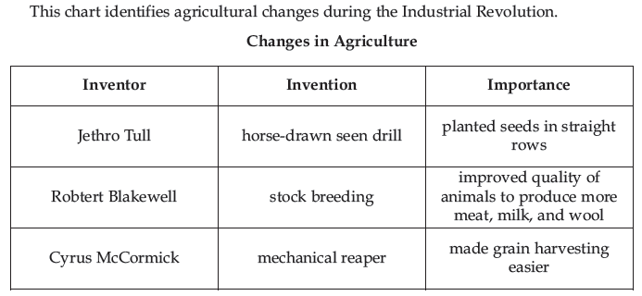
- Using the Agricultural Innovation placards and the document to the left, how did the Agricultural Revolution help the Industrial Revolution?____________ ___________________ ___________________ __________________
- What was the enclosure system? ______________________________________________________________________________________________________________________________________________________________________________
- How did the enclosure system “hurt” peasants? ______________________________________________________________________________________________________________________________________________________________________________

- Why did new agricultural inventions and new ideas lead to a decreased need for farm workers? ______________________________________________________________________________________________________________________________________________________________________________

What invention increased the number of seeds that germinated? And how did it accomplish this? ____________________________________________________________________________________________________________________________________________________________________________________
What is the purpose of stock breeding? ____________________________________________________________________________________________________________________________________________________________________________________
Where & Why did the Industrial Revolution Begin?

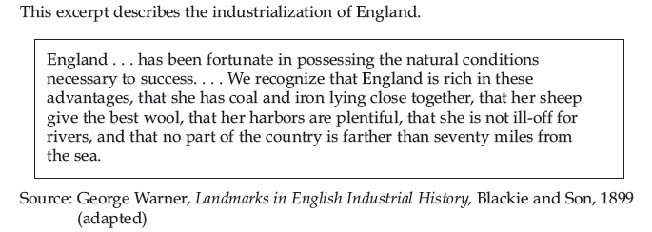
Economic Strength

Political Stability

Natural Resources

According to the document, how did geography help England industrialize?
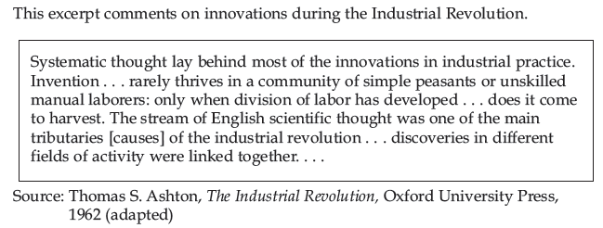
______________________________________________________________________________________________________________________________________________________________________________

Invention or Improvement and Purpose | illustration
Power Loom -

Invented by –
Cotton Gin -

Invented by –
Spinning Jenny-

Invented by-
Flying Shuttle

Invented by
Steam Engine -

Invented by –
Steamboat -

Invented by –
Railroad Locomotive -

Invented by –

What was the major advantage of the system of new roads created by John McAdam?
List FIVE ways the railroads of England revolutionized society:
1.

2.

3.

4.

5.

Every great town has one of more slum areas where the workers struggle through life as best they can out of sight of the more fortunate classes of society. The slums… are generally unplanned wildernesses of one- or two- storied houses. Wherever possible these have cellars which are also used as dwellings. The streets are usually unpaved, full of holes, filthy and strewn with refuse. Since they have neither gutters nor drains, the refuse accumulates in stagnant, stinking puddles. The view of Manchester is quite typical. The main river is narrow, coal-black and full of stinking filth and rubbish which it deposits on its bank… One walks along a very rough path on the river bank to reach a chaotic group of little, one-story, one-room cabins… In front of the doors, filth and garbage abound…

Source: The Conditions of the Working Class in England. 1831 Friedrich Engels
According to the document from Friedrich Engels what were 3 of the negative impacts of industrialization on living conditions?
____________________________ ___________________________ ____________________________ ____________________________ ____________________________ ____________________________
Define Urbanization:
What were two direct causes or urbanization?

Based on your knowledge of history and the documents below, why was coal in such great demand? _______________________________________________________
__________________________________________________________________________________________________________________________________________
What were 4 negative aspects of industrialization on Living conditions?

What were 4 Negative aspects of the factory industry on worker conditions?

“Different methods of mining coal were employed in various locales throughout England. All coal mining had one trait in common; the movement of coal was accomplished solely by muscle power—animal, man, woman and child, the latter being the most desirable for their size. The process of removing the coal was obviously as slow as it was dirty.”
Excerpt from yale.edu

Hannah Goode: "I work at Mr. Wilson's mill. I think the youngest child is about 7. I daresay there are 20 under 9 years. It is about half past five by our clock at home when we go in....We come out at seven by the mill. We never stop to take our meals, except at dinner. William Crookes is overlooker in our room. He is cross-tempered sometimes. He does not beat me; he beats the little children if they do not do their work right....I have sometimes seen the little children drop asleep or so, but not lately. If they are catched asleep they get the strap. They are always very tired at night....I can read a little; I can't write. I used to go to school before I went to the mill; I have since I am sixteen."
[Source; Factory Inquiry Commission, Great Britain, Parliamentary Papers, 1833. Found in Hellerstein, Hume & Offen, Victorian Women: A Documentary Accounts of Women's Lives in Nineteenth-Century England, France and the United States, Stanford University Press]

Describe the treatment of the mill’s child laborers? ____________________
Teams of women were employed to lift coal and workers.
Hauling a tub of coal by means of a rope and chain. The chain usually passed underneath the body between the legs.
- Excerpted from womeninworldhistory.com

____________________
____________________
____________________
____________________

Why do the little children fall asleep?
_____________________
_____________________
_____________________
_____________________
List FIVE positive effects of the Industrial Revolution using the document and your textbook.
You are surrounded, as we have constantly shown you throughout this book, with and infinite number of comforts and conveniences which had no existence two of three centuries ago and those comforts are not used only by a few, but are within the reach of almost all men. Every day is adding something to your comforts. Your houses are better build, you clothes are cheaper; you have an infinite number of domestic utensils. You can travel cheaply from place to place, and not only travel at less expense, but travel ten times quicker than two hundred years ago.

Source: The Working Man’s Companion 1831

What was the major way the new middle class transformed the social structure of Great Britain?
Define: Bourgeoisie

Who were the Luddites and what as their goal?

What was the accomplishment of the Factory Act of 1819?
Philosopher | Idea(s) | Explanation/Impact
Adam Smith | Define Capitalism:
Karl Marx and Frederick Engels  “The theory of Communism may be summed up in one sentence: Abolish all private property” | Define  Socialism:  Define Communism:

Do you agree with Smith that the government should not interfere in the market? Explain your answer but before you answer, consider this: Warning labels are on dangerous products because of government legislation and child labor laws are also a result of government intervention. _______________________________________________________________________________________________________________________________________________________________________________________________________________

An excerpt from The Wealth of Nations

“It is not from the benevolence of the butcher, the brewer, or the baker, that we expect our dinner, but from their regard to their own interest. We address ourselves, not to their humanity but to their self-love, and never talk to them of our necessities but of their advantages.”

~The Wealth of Nations, Book I Chapter II

An excerpt from The Wealth of Nations:

“The uniform, constant and uninterrupted effort of every man to better his condition…is frequently powerful enough to maintain the natural progress of things toward improvement, in spite both of the extravagance of government, and of the greatest errors of administration.”

~The Wealth of Nations, Book II Chapter III

Smith believed that the principles of self-interest, competition, supply, and demand created an “invisible hand” that led to the most efficient use of resources which inevitably benefited the most people. How do you think these principles combined to benefit all people? __________________________________________________________________________________________________________________________________________ _
“You are horrified at our intending to do away with private property. But in your existing society, private property is already done away with for nine-tenths of the population; its existence for the few is solely due to its non-existence in the hands of those nine-tenths. You reproach us, therefore, with intending to do away with a form of property, the necessary condition for whose existence is the non-existence of any property for the immense majority of society.”
~ Karl Marx, The Communist Manifesto

According to Marx, why is private property already done away with?

According to Marx, who owns private property?

Therefore, according to Marx, why is private property already abolished?

