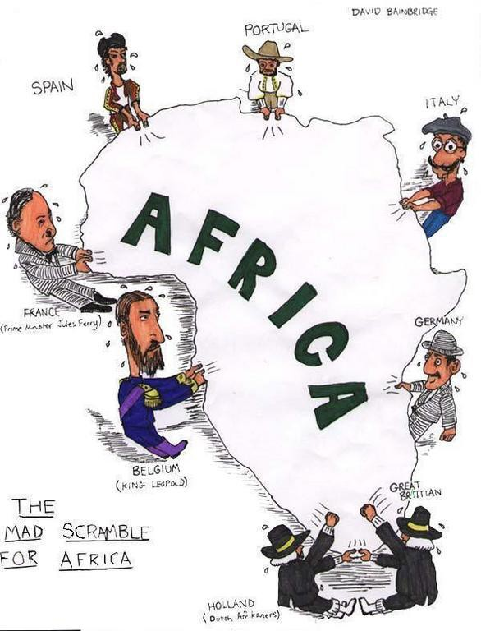World History Name

I. European Imperialism
- From 1850 to 1914, the strong, nations of Europe
used to seize colonies & dominate the local gov’ts
&__ in Africa & Asia
- Despite the independence of the ____________________ and
___________________________ European imperialism
continued in Africa and Asia.
- New European countries like Belgium, Germany, and Italy
wanted colonies.
- European countries also wanted to _____________________
the ______________________ of __________________ among
themselves. When one country acquired a colony, other countries
felt the same was necessary.

Reasons for European Imperialism
- Political: Nationalism & Power
  - ______________________________: takeover of a
country or territory by a stronger nation, with the
intent of dominating the political, economic, or
social life of the people of that nation
- Economic: Industrialization, New Markets, Raw Materials
- Social: Christianity & Ideology
  - ____________________: idea that one race is superior to others.
  - __________________________________: ideas of evolution or “survival of the fittest”
Forms of Imperialism
- 1. Colony: Europeans seize a territory & by sending governors to the colony
- Protectorate: a country or territory with its own ______________________________________. but under the control of an outside power
- Sphere of Influence: a country or territory with its own internal govt. but under the control of an ____________________________________________

Analyzing the Motives for Imperialism

Your symbol | ECONOMIC motives included the desire  to make money, to expand and control  foreign trade, to create new markets for products, to acquire raw materials and cheap labor, and to export industrial technology and transportation methods | Your symbol | POLTICIAL motives were based on a nation’s  desire to gain power, to compete with other  European countries, to expand territory, to exercise military force, to gain prestige by winning colonies, and to boost national pride
Your symbol | RELIGIOUS motives included the desire to  spread Christianity, to protect European missionaries in other lands, to spread European values and moral beliefs, to educate peoples of other cultures, and to end the slave trade in Africa | Your symbol | EXPLORATORY motives were based on a  desire to explore “unknown” or uncharted territories, to conduct scientific research, to conduct medical searches for the causes and treatment of diseases, to go on an adventure, and investigate unknown cultures
Your symbol | IDEOLOGICAL motives were based on the  belief that the white race was superior, other cultures were “primitive,” Europeans should “civilize” other peoples, great nations should have empires, and only the strongest nations survive

Placard | Describe What You See | Symbol for Motive(s) | Why You Chose This Motive(s)
A
B
C

Excerpts from Rudyard Kipling’s
O | N | M | L | K | J | I | H | G | F | E | D | Placard
 |  |  |  |  |  |  |  |  |  |  |  | Describe What You See
 |  |  |  |  |  |  |  |  |  |  |  | Symbol for Motive(s)
 |  |  |  |  |  |  |  |  |  |  |  | Why You Chose This Motive(s)

Whi te M a n’s B ur d en (1899)

Take up the White Man’s Burden-
--
Send forth the best you breed—
Send your sons into exile
To serve their captives’ need; To wait, with patience mighty, On folk ragged and wild—
Your new-caught depraved
people,
Half devil and half child

Take up the White Man’s Burden-
--
…To help another profit
And work for another’s gain.

Take up the White Man’s Burden-
--
The savage wars of peace— Fill full the mouths of Famine, And bid the sickness cease; And when your goal is nearest (The end for others sought) Watch sloth and heathen folly
Bring all your hope to naught.

Take up the White Man’s Burden-
--
And reap a sad reward— The blame of those ye better The hate of those ye guard…

1. According to the poem, what
is the “white man’s burden”?

2. According to Kipling, what is the white man getting involved in imperialism?

3. How does the poem express racism? Find specific examples from the poem

4. Do you think Kipling’s poem is
in favor of or against
European imperialism? Why?

