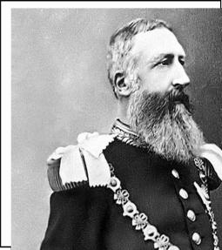World History ( Day 2 )

I. From 1880 to 1914 European nations used imperialism to dominate the continent of Africa
- The arrival of Europeans changed Africa
  - African peoples divided into hundreds of ______________ and __________________ groups
- European travel to ________________ impossible before steam engine (steam powered riverboats)
- Africans had trade networks and kept _______________________ from controlling trade

Imperialism in Africa in the mid-1800s
- The first Europeans to explore the of Africa were & explorers
- In the 1870s, the discoveries of a missionary named increased European in Africa
- Reports of large deposits of & the rise of in Europe set off a race for African colonies
- , steamboats, & industrial weapons encouraged the conquest of Africa

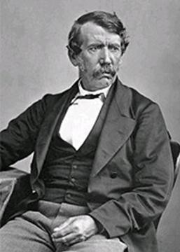Read Section 1 and answer the questions

Read Section
1 and answer the questions….
1. What were Dr. Livingstone’s motivations for
traveling Africa?

2. What was Livingstone’s impression of the area
that he visited?

3. What impact did Dr. Livingstone have on the
“Scramble for Africa?

The Berlin Conference, 1884
- The for African colonies was so fierce that Europeans became afraid ___________ would break out
- In 1884, 14 nations met at _________________the to “set the rules” for colonizing in Africa
- Agreed that any nation could claim land so long as they __________________ other nations of the claim (they had to show that they could ______________________________the area)
- No _______________________________ attended the meetings Conference sealed ____________________________________

Read Section 2 and answer the questions
1. What did European control of African land mean?

2. Which African countries remained independent of European control?

3. Which European country had the least amount
of colonies?

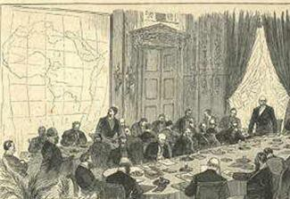By 1914, Europeans controlled 90% of Africa
1. took most of west Africa
2. Belgium claimed the in central Africa
3. had many colonies throughout Africa
4. These nations used African colonies to gain , tin,
, rubber & built cash-crop

Read Section 3 and answer the questions
1. Why was King Leopold interested in the Congo?
How did his forces gain control of the people?

2. What does ED Morel mean by “The Black Man’s
Burden?

3. Even though the white man had “massacred the Africans”, according to More, “The African has survived and it is well for the white settler that he has.” What do you think Morel means by this statement?

The most dominant imperial power in Africa was Great Britain
- British fueled demand for raw materials
- Britain claimed colonies in ______________ & in East Africa
- In 1882, Britain seized control of __________ from a French company
- Britain seized control of ________________ from the Dutch
- Many citizens in England dreamed of a British colony from
“ to ”

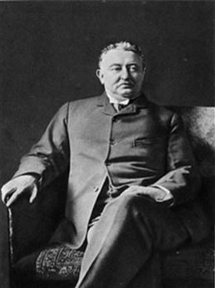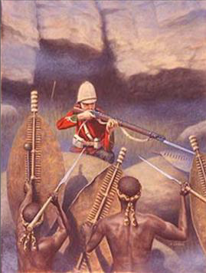The most important empire-builder in Africa was British businessman,

- His DeBeers Company created ____________________in South Africa
- Rhodes gained new for Britain in southern Africa
- Rhodes used his wealth to build &
lines in Africa

Read Section 4 and answer the questions
1. What were Rhodes’s motivations for imperialism?
There may be more than one.

2. Why did Cecil Rhodes feel that is was the English
“duty” to imperialize Africa?

3. What do you think is the meaning of the Political Cartoon featuring Cecil Rhodes. What is he doing in the cartoon?

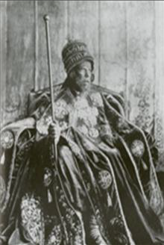Read Section 5 and answer the questions
1. Why is Emperor Menelik writing a letter to the king
of Sudan?

2. What specifically is Emperor Menelik warning the king of Sudan of?

3. What do you think Emperor Menelik means by “lest the Europeans enter our midst a great disaster will befall us and our children have not rest”?

B. African Resistance
1. Africans against European rule, but were
due to advanced European weaponry
2. Africa remained under the control of European imperialists from the
1880s until the &

II. What was the impact of European imperialism in Africa?
A. The Good and the Bad
1. Europeans introduced new technologies like ,
telegraph lines, & … but transportation routes only connected areas that benefited businessmen
2. Europeans brought an end to the …but
Africans were paid low & exploited
3. Europeans built , churches, & hospitals…but
Africans were taught European
4. Europeans profited off Africa’s raw materials &
African
5. Africans were unable to themselves, participate in
, or learn professional skills
6. In South Africa, the British society called which remained in place for over 100 years

Define Imperialism:
Read Section 6 & 7 and answer the questions
1. What African tribe in particular resisted European aggressors? Why weren’t they successful in their attempt?

2. Who were the Boers? Why were the British interested in Boer Land?

3. What were the British concentration camps for?
What were the conditions like in these camps?

