World History (Part 3) Name

Date
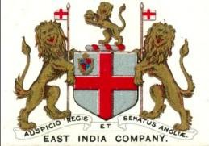
Pd

I. British Imperialism in India
A During the Age of Imperialism from 1850 to 1914 Europeans dominated ______________ & ____________
B. During this era, no nation cou d match the _____________________ mil tary or colonial power of ___________________
A. .
B
- Britain had so many colonies that it was said that the “_________________________________ on the British Empire”
  - Among all of Britain’s colonies, the most ___________________________ was _______________

- 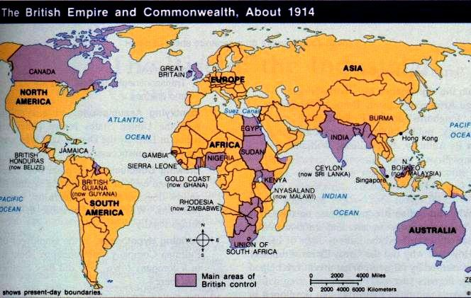The ________________________________________ was formed to trade
exotic Asian goods in ___________________________ & America
  - The East India Company set up _______________________________________________
in major port cities in India
  - By 1700, India’s ________________________________________ Empire was a
Decline & small states ruled by a maharajah were formed
  - Conflicts between ____________________________ & ____________________________
further weakened India
  - The East India Co gained more ______________________________ of India

- Company Rule of India (1757 to 1856)
  - The East India Company made huge profits creating plantations to harvest ___________, coffee, ______________, & opium
  - Raw materials like cotton helped fuel Britain’s _____________________________________________________
  - ________________________ was refined in India & smuggled into _______________ Opium addition helped the British gain access to Chinese trade
  - The East India Company sold cheap British-made ___________________ to Indian people

- From 1750 to 1850, the British East India Co ruled most of India with little ________________________ from Britain
  - To protect their trade & territories, British officials hired ___________________ soldiers called _________________

- The Sepoy Mutiny (1857)
  - By the 1850s, Indian _________________________________________ for the British was growing
  - In 1857, rumors spread that sepoy __________________________________________ supplied by the British by were greased with _____________________& _________________________ fat
  - Hindu & Muslim sepoys were outraged & _____________________________________ against the British
  - The ______________________________ lasted over 1 year; The British gov’t had to send ________________ to help the East India Co

- The British Raj (1858-1947) The Sepoy Mutiny was a Turning in Indian history
  - In 1858, the British gov’t took control from the East India Company & _________________________________________; British rule was called the __________ & lasted until 1947
Positive Effects in India Negative Effects in India

Directions: Examine the documents below and answer the questions that accompany each. Then, fill in the thesis template below, as if you were preparing to write an essay answering this question: “What was the IMPACT of Imperialism?”
The Age of Imperialism: Historical Background
Imperialism occurs when a strong nation takes over a weaker nation or region and dominates its economic, political, or cultural life. This type of foreign policy was practiced by European nations, the United States, and Japan throughout the 1800s & early
1900s.
Discuss the rise of imperialism and the changes it brought to Europe and conquered peoples. Be sure to discuss the following: •What factors led to the beginning of imperialism?
•How were Europeans impacted by imperialism?
•How were Africans impacted by imperialism?

What does this document say about the impact of imperialism?
Document A: Excerpt from “The White Man’s Burden” This document describes the rise of imperialism

Take up the White Man’s Burden— Send forth the best ye breed— Go bind your sons to exile—
To serve your captives’ need;
To wait in heavy harness, On fluttered fold and wild— Your new-caught, sullen peoples, Half devil and half-child.

--Rudyard Kipling, 1899
because

Document B: This document describes the impact of imperialism on Europeans because _

Document C:
…When the great scramble for Africa began in the last quarter of the nineteenth century, colonies had become a necessary extension for European capitalism…that needed territorial expansion to provide…sources of raw
materials, markets, and strategic points of imperial defense…
This document describes the impact of imperialism on the natives because

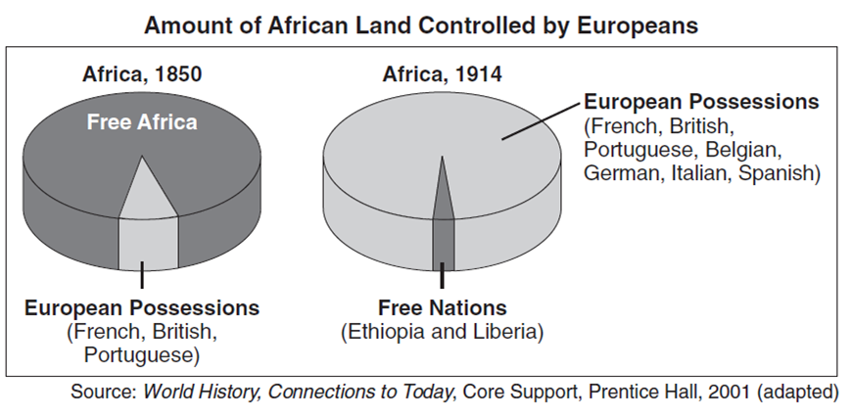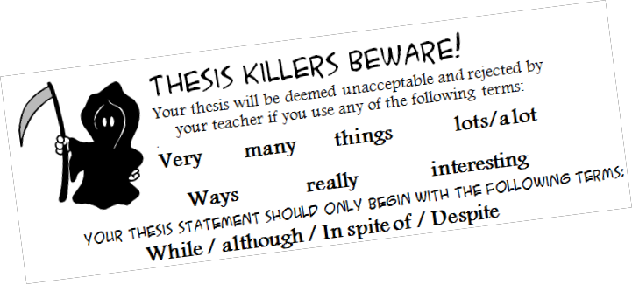
The imperialists were all greedy; they all subserved the needs of the subject
lands to their own demands; they all limited human rights and liberties; they all repressed and violated, degraded and oppressed. They took our lands, our lives, our resources, and our dignity. Without exception, they left us nothing but our resentment, and later, our determination to be free and rise once
more to the level of men and women who walk with their heads held high…
-Source: Kwame Nkrumah, Africa Must Unite, 1970

Thesis Statement: Use the documents above, as well as information learned throughout this unit, to create an academically appropriate and detailed thesis statement.

The BEST thesis statement:

