1. An effect of a mountainous topography on Inca and

Chinese civilizations was the development of

1) industrialization 3) desalinization projects

2) single-crop economy 4) terrace farming

2. The Himalaya Mountains, the Ghat Mountains, the Deccan Plateau, and the Thar Desert are similar in that they contribute to South Asia's

1) national unity 3) political stability

2) cultural diversity 4) rapid population growth

3. Which feature of Chinese agriculture led to the development of the other three?

1) growing rice and grains for their high food value

2) building of irrigation systems

3) scarcity of fertile land

4) intensive farming methods

4. Which geographic factor had the greatest influence on the early history of South Asia and China?

1) river valleys 3) vast coastlines

2) island locations 4) tropical rain forests

5. Which characteristic did the early civilizations that developed along the Nile, the Tigris-Euphrates, and the Huang Ho (Yellow River) have in common?

1) Each society's religious beliefs were based on monotheism.

2) Urban communities were built using iron and steel tools.

3) The form of government in each community was based on male suffrage.

4) Transportation and communication were promoted by a mild climate, fertile soil, and natural waterways.

6. A study of the Indus, Nile, Hwang Ho, Tigris, and Euphrates rivers would be most important in understanding the

1) causes for the decline of the Mayan Empire

2) role of geography in the development of early civilizations

3) reasons that ancient empires were based on nomadic civilizations

4) rise in power of the Muslim empire

7. The early civilizations of the Nile River Valley, Mesopotamia, and the Yellow River Valley were similar because they were

1) industrialized societies

2) monotheistic

3) dependent on fertile land

4) dependent on each other for trade

8. Which is the main reason for the heavy population concentration in the eastern regions of the People's Republic of China?

1) The Chinese capital is located in the east.

2) Most of China's fertile farmland is located in the east.

3) Most of China's oil resources are located in the

Yangtze River Valley.

4) Overland trade with China's neighbors declined.

9. Which statement best explains why most of the population of the People's Republic of China live in the eastern third of the nation?

1) The best agricultural land is in the east.

2) The largest forests are in the east.

3) The best fishing areas are off the eastern coast.

4) The largest oil deposits are in the east.

10. The river valleys of the Tigris-Euphrates, Huang Ho (Yellow River), and Indus were centers of early civilization because they

1) had rich deposits of iron ore and coal

2) were isolated from other cultural influences

3) contained rich soils from annual floods

4) were easy to defend from invasion

11. One way in which the Huang Ho, the Indus, and the Nile civilizations were similar is that they each

1) flourished by trading salt and gold

2) developed monotheistic religions

3) suffered repeated invasions

4) originated in river valleys

12. Hammurabi’s code of laws and Qin dynasty legalism are similar in that both promoted the idea that

1) worship of leaders will maintain the power of an empire

2) an informed citizenry will help maintain peace and prosperity

3) equality of the people is the most important goal of government

4) harsh punishments for crimes will lead to a more orderly society

13. Traditional Chinese values emphasized that the best society was one in which people

1) received equal treatment

2) tried to improve their status in life

3) carried out their assigned tasks and duties

4) shared political power with the emperor

14. The use of the Silk Road in Asia and caravan routes in northern Africa and southwestern Asia encouraged

1) self-sufficiency 3) ethnocentrism

2) cultural isolation 4) cultural diffusion

15. In which region did China’s earliest civilizations develop?

1) Gobi Desert 3) Yellow River Valley

2) Himalaya Mountains 4) Tibetan Plateau

16. One reason early civilizations developed in China, Egypt, and the Tigris-Euphrates Valley in Mesopotamia is because

1) vast mineral deposits existed for manufacturing

2) climate and geography favored agriculture

3) rivers contributed to nomadic lifestyles

4) natural barriers provided protection from invasions

17. Before the use of the Silk Road, how did geography affect early China?

1) The mountains and deserts in western and southwestern China slowed the exchange of ideas.

2) The northwestern region provided many fertile areas suitable for farming.

3) The three major river systems provided barriers against invasion.

4) The lack of deep-water ports on the eastern coast prevented China from developing trade with other nations.

18. Base your answer to the following question on the map below and on your knowledge of social studies.

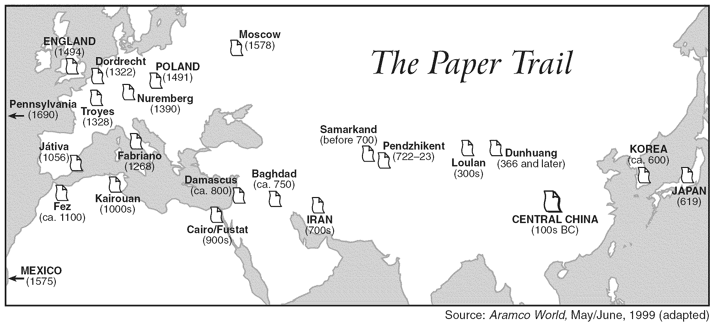

The technology of papermaking traveled from China to Baghdad along the

1) Saharan caravan trails 2) Trans-Siberian Railway 3) Silk Roads 4) Suez Canal

19. Which civilization first developed a civil service system, invented gunpowder, and manufactured porcelain?

1) Aztec 3) Japanese

2) Chinese 4) Roman

20. The Eightfold Path, the Four Noble Truths, and the concept of nirvana are associated with the religion of

1) Islam 3) Shinto

2) Jainism 4) Buddhism

21. The Buddhist religion teaches that salvation is earned by

1) following the Ten Commandments

2) worshiping Allah as the one true god

3) learning to give up selfish desire

4) being baptized and confirmed

22. A goal common to Confucianism, Taoism, and Buddhism is to

1) establish peace and harmony

2) provide the basis for democratic government

3) return the power of the emperors

4) promote individual artistic creativity

23. The introduction of Buddhism into China and of

Islam into Indonesia are examples of

1) social mobility 3) ethnocentrism

2) cultural diffusion 4) interdependence

24. Which term is used to describe the spread of Buddhism from India through Southeast Asia?

1) ethnocentrism 3) imperialism

2) isolation 4) cultural diffusion

25. Which values are most closely associated with the fundamental principles of Buddhism?

1) competition and financial success

2) maintaining the caste system and providing education for all people

3) practicing nonviolence and giving up worldly desires

4) self-determination and democracy

26.

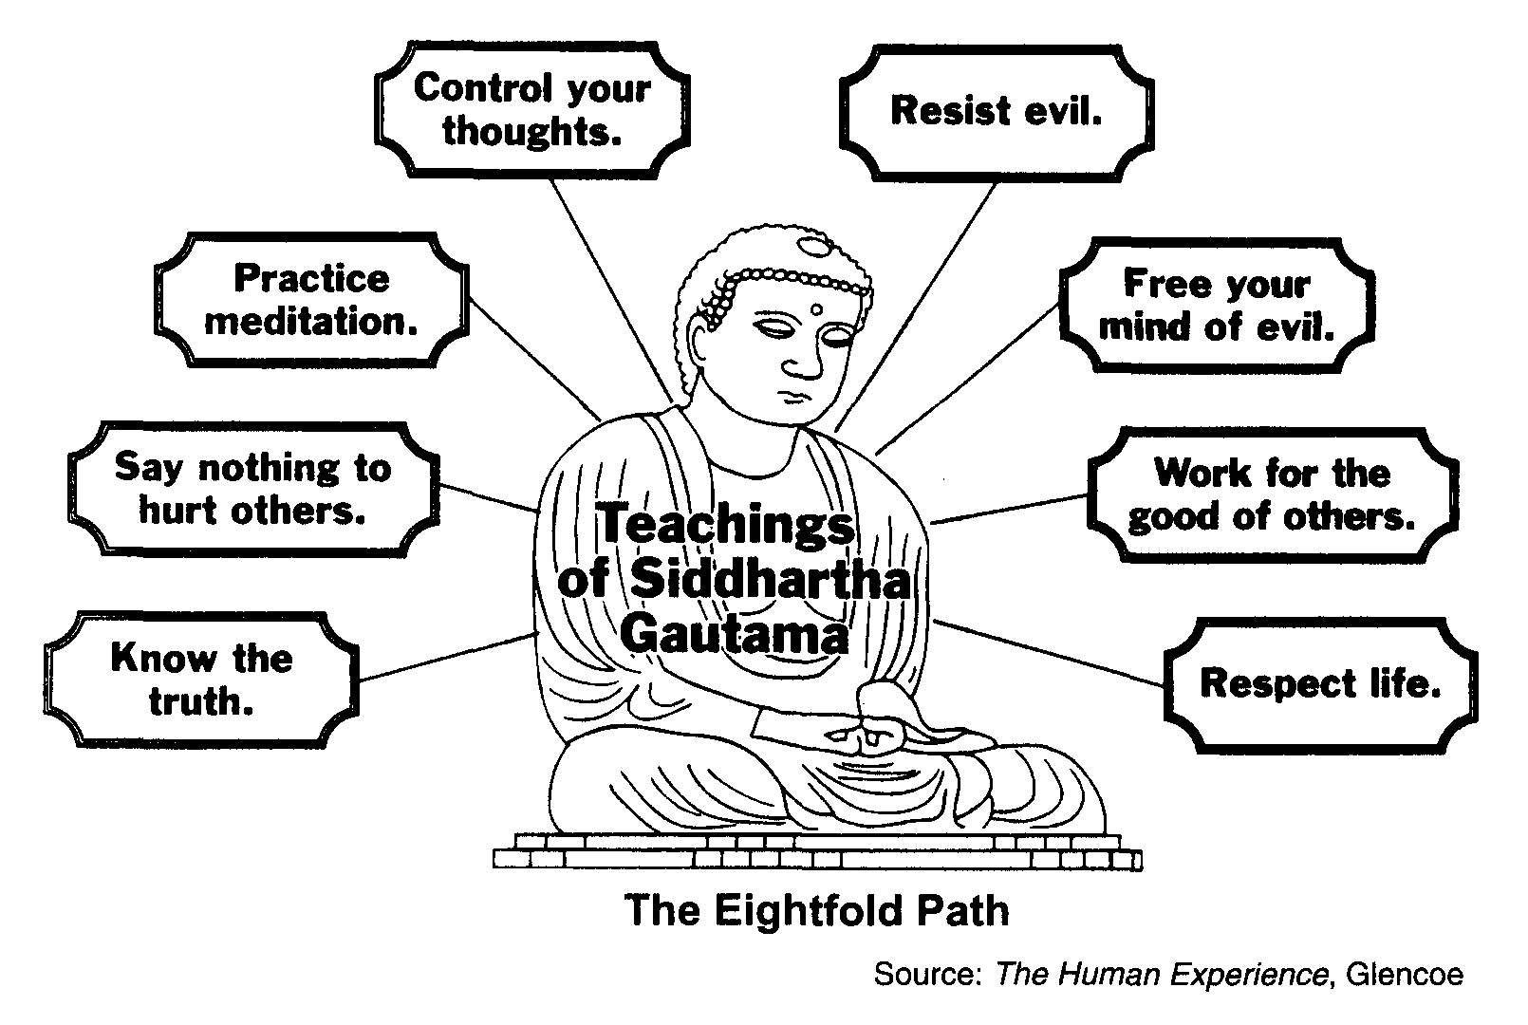

The diagram illustrates the key concepts of which religion?

1) Islam 2) Christianity 3) Hinduism 4) Buddhism

27. The religious terms Four Noble Truths, Eightfold Path, and

nirvana are most closely associated with

1) Judaism 3) Shintoism

2) Islam 4) Buddhism

28. The Silk Road was important to China because it provided

1) contact with other cultures through trade

2) a means of administering civil service examinations

3) a military route for the defense of the northern border

4) a means for the country to expand its borders

29. The Tang Dynasty in China, the Gupta Empire in India, and the city-state of Athens in Greece during their golden ages were known as eras of

1) major industrial development

2) intense nationalism

3) economic poverty and political upheaval

4) artistic and intellectual achievement

30. One similarity between the Gupta Dynasty (A.D. 320–550) in India and the Tang Dynasty (A.D. 618–907) in China is that each dynasty

1) promoted equality for women

2) made advances in the arts, sciences, and mathematics

3) gained overseas colonies

4) developed a representative government

31. The Tang dynasty of China, the Gupta Empire of India, and the Mali Empire of Africa were similar in that each experienced a period of

1) prosperity and artistic creativity

2) feudalism and oppression

3) war and constant invasion

4) mercantilism and industrial expansion

32. The Age of Pericles in Athens, the Gupta Empire in India, and the Tang dynasty in China all experienced a golden age with

1) advancements in the principles of democratic governments

2) outstanding contributions in the arts and sciences

3) the end of foreign domination

4) the furthest expansion of their borders

33. • Block printing, gunpowder, and the abacus were developed.

• Porcelain making and black-ink painting on silk paper were perfected.

• The compass was discovered and used to improve the determination of direction when sailing.

These advances are associated with the

1) Tang and Sung dynasties of China

2) Gupta Empire in India

3) Ghana and Mali civilizations of Africa

4) Byzantine Empire in the Middle East

34. Base your answer to the following question on the map below and your knowledge of social studies.

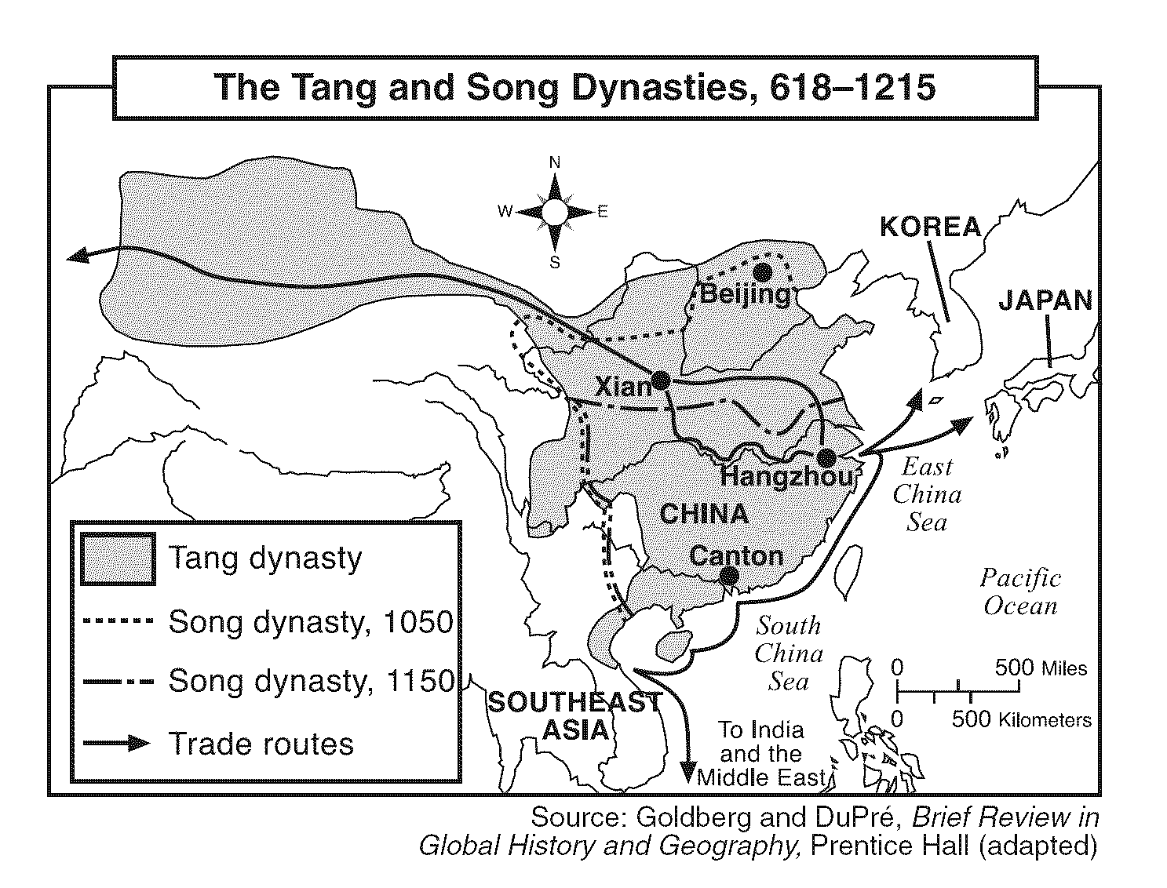

According to the map, which conclusion about China during the Tang and Song dynasties is accurate?

1) Most trade routes began in Beijing. 3) The areas under the control of these dynasties did not change.

2) China’s overland trade routes connected China to Japan. 4) China traded extensively with other nations and regions.

35. Which statement about the Tang dynasty is a fact rather than an opinion?

1) Technical advances would have been greater if the

Tang dynasty had lasted longer.

2) China’s best emperors came from the Tang dynasty.

3) The Tang emperors granted government jobs to scholars who passed examinations.

4) The culture of the Tang dynasty was superior to that of the Han dynasty.

36. One similarity between the cultures of traditional China and traditional Japan was that

1) the educated class was held in high esteem

2) religion played a minor role in society

3) social mobility was encouraged

4) the people elected the political leaders

37. Which statement about cultural diffusion in Asia is most accurate?

1) Byzantine traders brought the Justinian Code to China.

2) Roman legions introduced Christianity to India.

3) Indian monks brought Islam to the Middle East.

4) Chinese ideas and practices spread into Korea and

Japan.

38. Which two cultures most influenced the development of early Japan?

1) Greek and Roman

2) Chinese and Korean

3) Egyptian and Mesopotamian

4) Indian and Persian

39. Base your answer to the following question on the map below and on your knowledge of social studies.

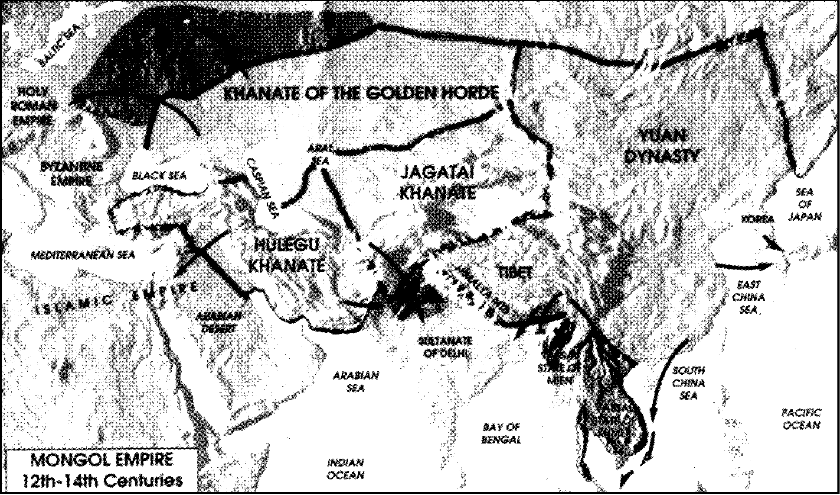

The map shows that the Mongol Empire stretched across

1) Africa and Southeast Asia 2) North America and Europe 3) Europe and Asia 4) South America and Asia

40. Which statement supports the claim that diversity was an important characteristic of the Mongol Empire (1200–1350)?

1) All people in the Mongol Empire were Hindu.

2) The Mongol Empire ruled peoples from China, Russia, eastern Europe, and India.

3) Genghis Khan organized a network of communication across the Empire.

4) The Mongol Empire covered only central Asia.

41. • Developed a tribute system

• Reestablished trade along the Silk Roads

• Created an empire from Eastern Europe to the Pacific coast of Asia

Which group was responsible for the results described above?

1) Huns 3) Koreans

2) Japanese 4) Mongols

42. • In less than 50 years, it was the largest unified land empire in history.

• In 1279, it was the first foreign group to gain complete control of China.

• It made the caravan routes across Asia safe for trade and travel.

• When attempting to conquer Japan in 1274 and 1281, its fleets were destroyed by storms.

Which empire is most closely associated with these statements?

1) Persian 3) Ottoman

2) Gupta 4) Mongol

43. The ethnocentric attitudes of various Chinese emperors can best be attributed to the

1) cultural isolation of China

2) failure of other nations to become interested in China

3) interest of Chinese scholars in other civilizations

4) great cultural diversity within China's borders

44. Despite increasing contact with the Chinese prior to the

19th century, Europeans had little impact on China's culture mainly because

1) the Chinese viewed their culture as superior to that of the Europeans

2) the Europeans had forbidden their missionaries from going to China

3) Japanese culture had become the dominant culture in

China

4) Confucian custom prohibited the Chinese from speaking to the Europeans

45. In ancient times, the Silk Road was important because it made possible the exchange of goods between

1) Korea and Japan

2) Egypt and Greece

3) Siberia and the Ottoman Empire

4) China and the Roman Empire

46. "They [Zheng He and his men] were directed to ... open trade contacts.... The densely populated regions of southern China were experiencing repeated epidemics ... and the herbs believed to be effective in controlling them had become impossible to obtain because of the earlier ban on foreign trade."

The issue under discussion in this passage is

1) urbanization 3) revolution

2) interdependence 4) immigration

49. In China, the development of ethnocentrism was most influenced by

1) its historic reliance on foreign nations

2) a long history of democratic government

3) a strong belief in Christianity

4) its geographic isolation

50. Both Japan and China decided to limit trade with Europe during much of the 16th and 17th centuries because the Japanese and the Chinese

1) had few products to sell to the Europeans

2) held religious beliefs that prohibited contact with foreigners

3) thought European technology would hinder any effort to modernize

4) believed they would receive no benefit from increased contact with the Europeans

51. Until the 1500's, China and Japan were similar in that both

1) were invaded by the Mongols

2) welcomed Christian missionaries

3) had little contact with western European nations

4) were developing democratic traditions

52. "Beginning with childhood, all of man's study is centered on one aim alone ‚ to emerge successfully from the three days' examination ‚ and all he has in his mind is what success can bring to him in terms of power, influence, and prestige."

47. Venice in Europe, Mogadishu in Africa, and Canton in China emerged during the 13th century primarily as important centers of

1) agriculture 3) manufacturing

2) trade 4) mining

48. What was a long-term impact of Marco Polo’s trips to

China?

1) The Silk Roads replaced the all-water route to Asia.

2) The Chinese forced the Europeans to trade only in

Peking.

3) China was isolated from other countries.

4) Trade increased between China and Europe.

– Ye Shih, Chinese scholar

This quotation refers to the Chinese

1) civil service system 3) contemplation of nature

2) social welfare system 4) religious practices

53. Both the Chinese Mandate of Heaven and the Japanese belief that the Emperor descends from the Sun Goddess are similar to the

1) "master race" theory of Adolf Hitler's Third Reich

2) natural rights theory of the Age of Reason

3) divine right theory of the French monarchy

4) Marxist theory of a workers' revolution

54. Zheng He contributed to the prosperity of China under the

Ming dynasty by

1) defeating the Manchu invaders

2) constructing the Great Wall along the northern frontier

3) expanding trade with nations of Asia and Africa

4) establishing colonies in Korea and Japan

55. Base your answer to the following question on the map below and on your knowledge of social studies.

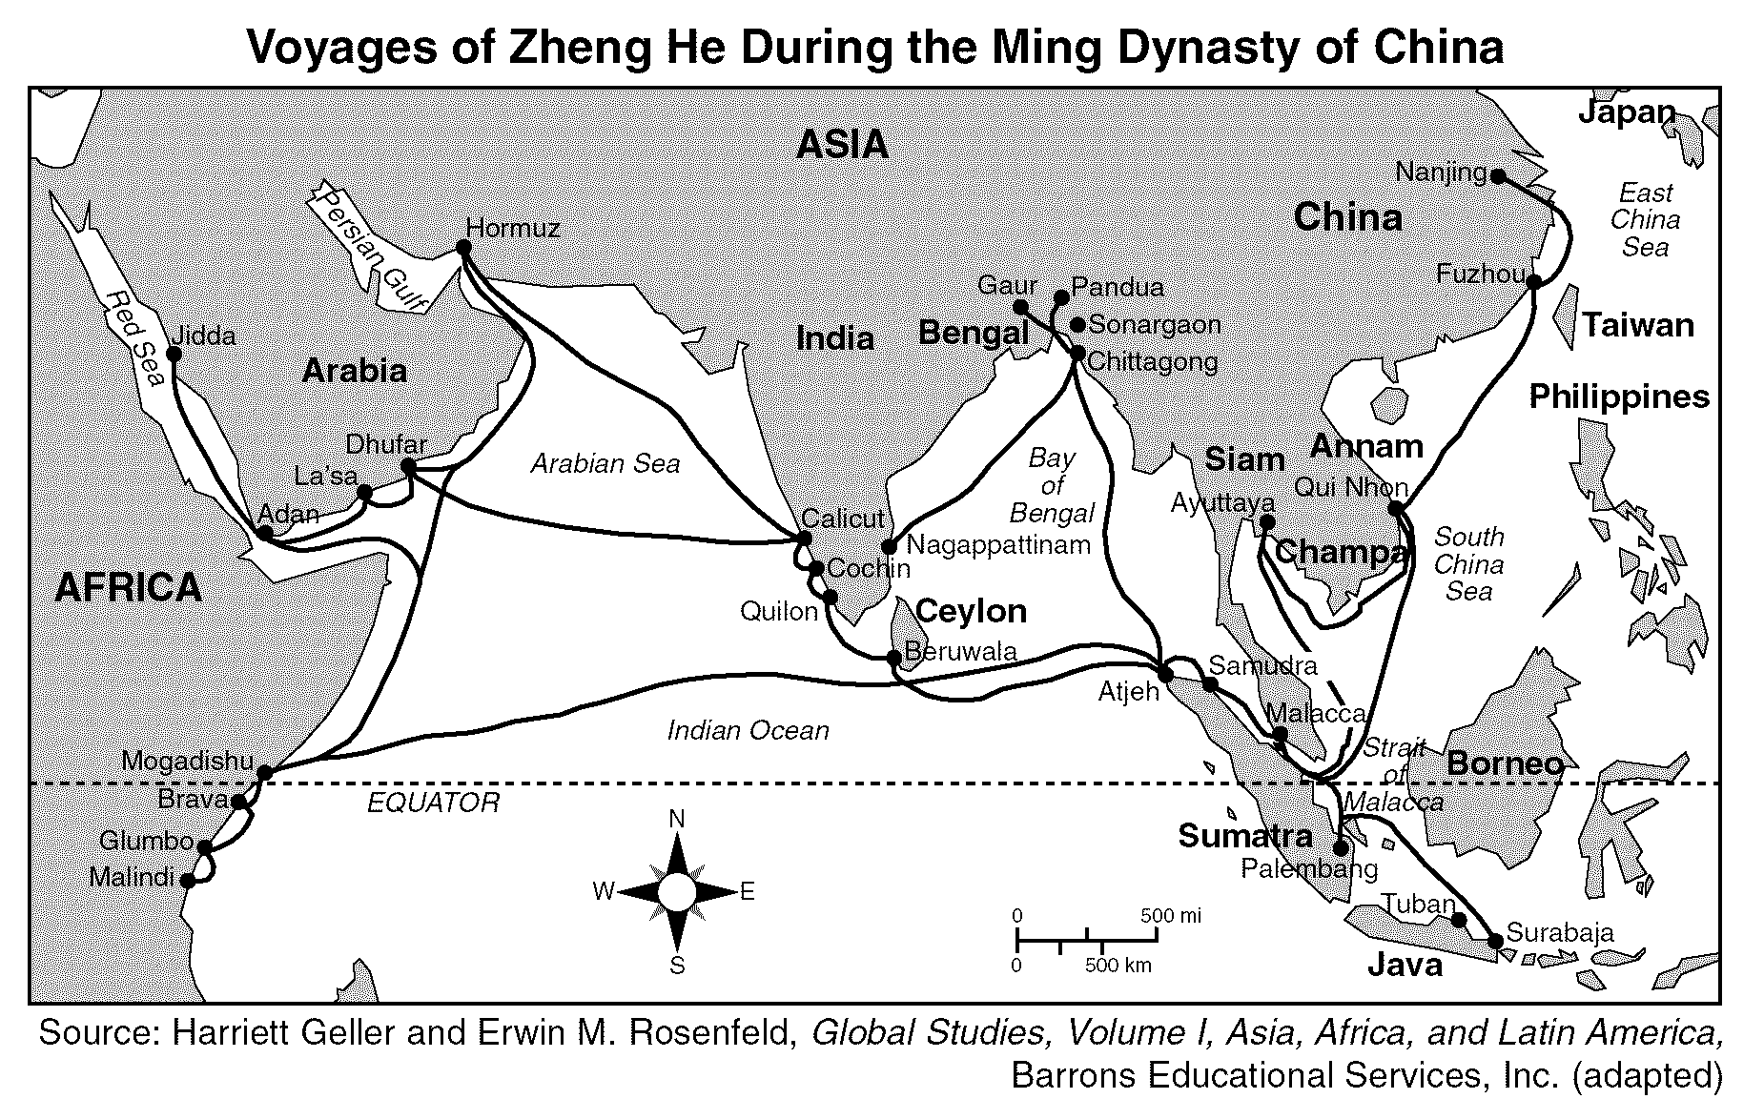

Which conclusion can be made about the Ming dynasty of China as a result of the travels of Zheng He?

1) China profited more from African trade than from Asian trade. 3) The Ming dynasty established trade routes to Europe.

2) Islam became the dominant religion of China. 4) Advanced navigation technology was available in China.

56. “The countries beyond the horizon and from the ends of the Earth have all become subjects and to the most western of the western or the most northern of the northern countries however far away they may be.”

— Ming dynasty official

The intent of this statement about the Ming dynasty was to

1) demonstrate supremacy and strength in China

2) control the Mongols

3) stop European imperialism

4) impose Chinese culture and slavery on neighboring countries

57. Base your answer to the following question on the map below and on your knowledge of social studies.

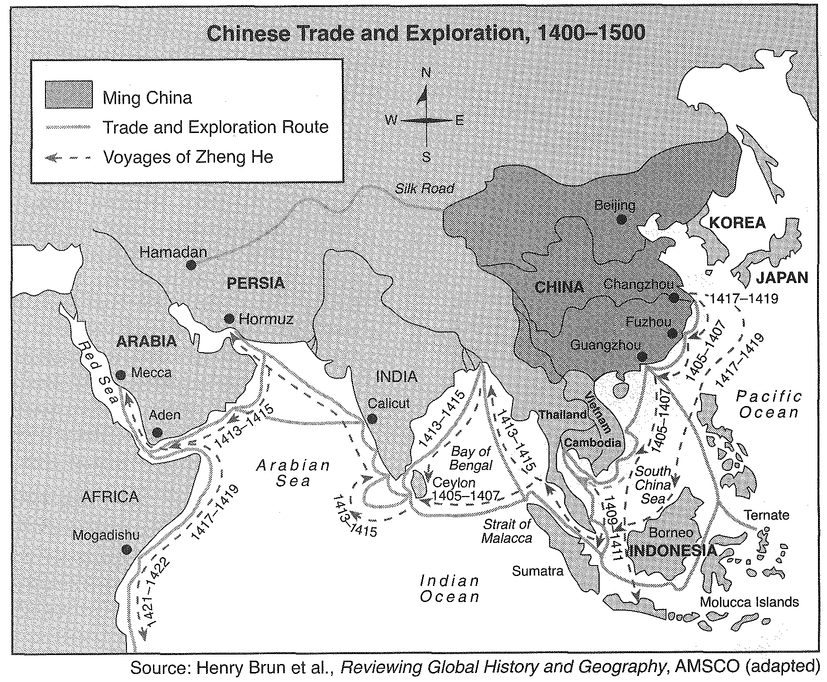

Based on this map, which statement is accurate concerning China between 1400 and 1500?

1) Most of China’s commerce was conducted on overland trade routes.

2) China remained isolated from outside contacts.

3) The Ming dynasty traded more with Persia than with any other culture.

4) China interacted and traded with many diverse cultures.

58. Base your answer to the following question on the map below and on your knowledge of social studies.

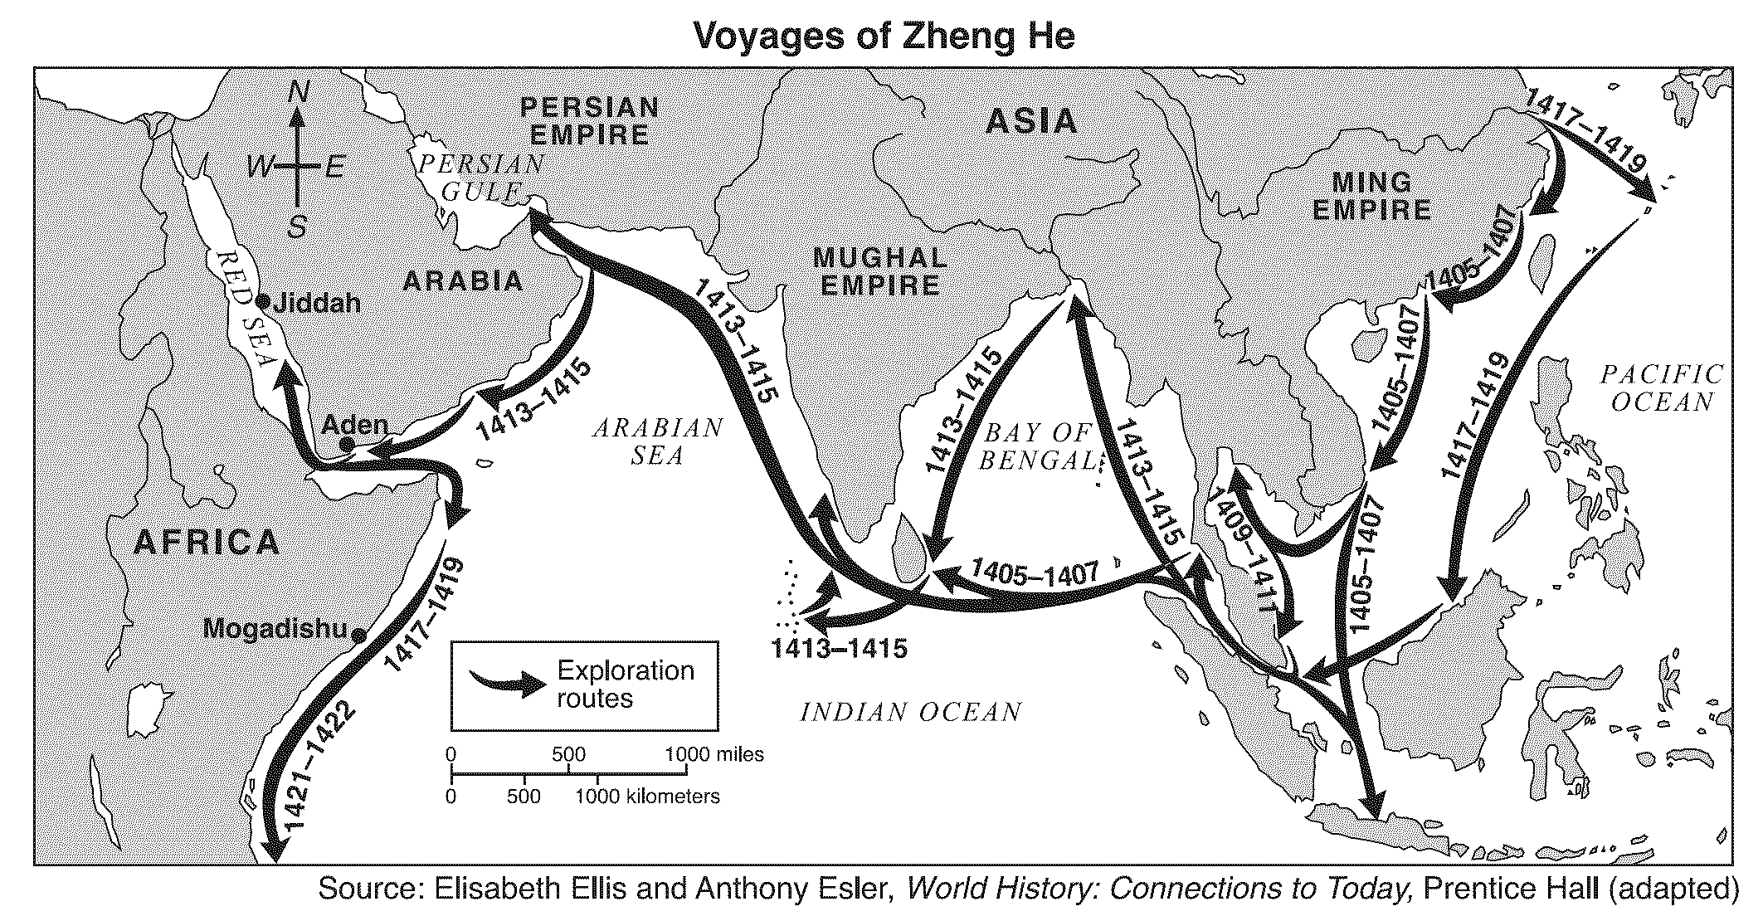

Which conclusion is best supported by the map?

1) Eastern Chinese cities had extensive contact with the Persian Empire in 1405.

2) Rivers and mountains prevented the expansion of overland Chinese trade.

3) The Chinese came into contact with peoples of other cultures between 1405 and 1422.

4) China was isolated from outside contact under the rulers of the Ming Empire.

Base your answers to questions 59 and 60 on 8 and 9 on the map below and on your knowledge of social studies.

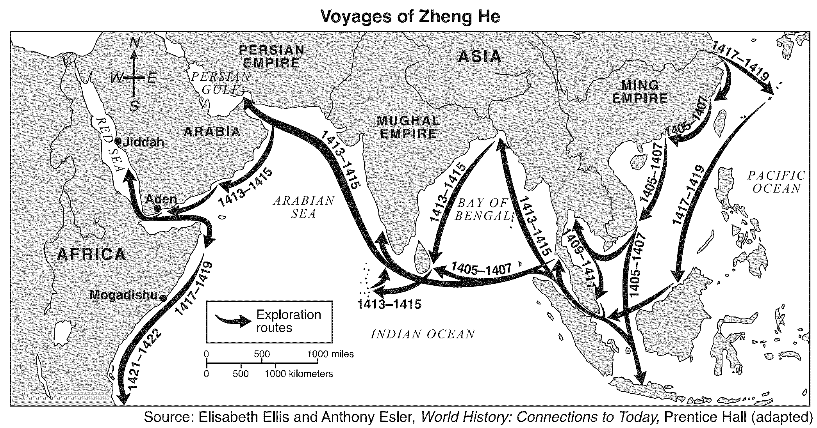

59. The map shows that on his voyages, Zheng He explored

1) both the Pacific and the Atlantic Oceans 3) lands in the Western Hemisphere

2) at the same time as the Spanish explorers 4) Arabia and the east coast of Africa

60. One result of the voyages of Zheng He was that

1) Chinese merchants began trading with Africa

2) Christian missionaries arrived in China

3) Indian artisans showed the Chinese how to make Ming porcelain

4) China set up colonies in Europe

61. Which statement best describes China's relationship with the rest of the world at the end of the 19th century?

1) China was divided into spheres of influence that gave preferential trading rights to Western nations.

2) China became a colony of Japan and provided that nation with needed resources.

3) After the Opium Wars, China was under the protection of the United States.

4) China isolated itself and had little contact with other nations.

62. In 19th-century China, the Opium War resulted in

1) the control of Hong Kong being returned to China

2) the removal of all British naval forces from China

3) an increase in European spheres of influence in China

4) the rejection of Buddhism by the Chinese people

63. Which statement best describes an effect of the Opium War on China?

1) The British expelled all Chinese from Hong Kong.

2) The British victory led to spheres of influence in China.

3) The British ended the importing of opium into China.

4) The British established a parliamentary democracy in

China.

64. The results of the Opium War (1839–1842) indicate that

China was

1) still a major military power

2) not strong enough to resist Western demands

3) rapidly building a modern industrial economy

4) accepting Western nations as equal trading partners

65. What effect did the Opium War and the Treaty of Nanjing have on China?

1) Chinese Nationalists increased their influence in rural areas.

2) The Manchu government expelled the Western powers.

3) China was divided into spheres of influence.

4) China adopted a democratic system of government.

66. During the 1840's, China signed "unequal treaties" with

Western nations mainly because

1) China had won the Opium War

2) Western nations had superior military technology

3) leaders in China favored expansion

4) China had requested economic assistance from the

West

67. The outcome of the Opium War showed that in the 19th century,

1) the Chinese Army was the most highly disciplined army in the world

2) China was no longer strong enough to resist Western demands for trading rights

3) the Chinese people were successful in eliminating foreign influence

4) the Chinese Government preferred to continue the opium trade

68. "When China wakes, it will shake the world."

— Napoleon, 1817

In this quotation, Napoleon was referring to the

1) European fear of Chinese culture and traditions

2) potential of China as a great world power

3) policy of rapid industrialization in China

4) ability of China to control world trade routes

69. A major result of the Opium War in China was

1) an increase in the power of the Emperor

2) the establishment of spheres of influence in China by

Europeans

3) the expansion of Chinese influence to India and the

Middle East

4) the expulsion of Europeans from China

70. Which was a major result of the Opium War (1839-1842)?

1) Great Britain forced China to open its ports for trade.

2) Japan formed an alliance with China.

3) Great Britain lost its influence in East Asia.

4) Confucian ideals were rejected by the Chinese people.

71. During the late 1800's, imperialistic nations divided China into

1) plantations 3) independent city-states

2) communes 4) spheres of influence

72. During the 19th century, Europeans were able to divide

China into spheres of influence mainly because the

1) Chinese were eager to adopt Western culture

2) Europeans had technologically superior military forces

3) Europeans were willing to adopt Chinese customs

4) Chinese lacked raw materials and resources

73. Which event is the best example of imperialism?

1) the Opium Wars in China

2) the Spanish Inquisition

3) the Yalta Conference

4) the Hundred Years' War

Base your answers to questions 74 and 75 on the cartoon below and on your knowledge of social studies.

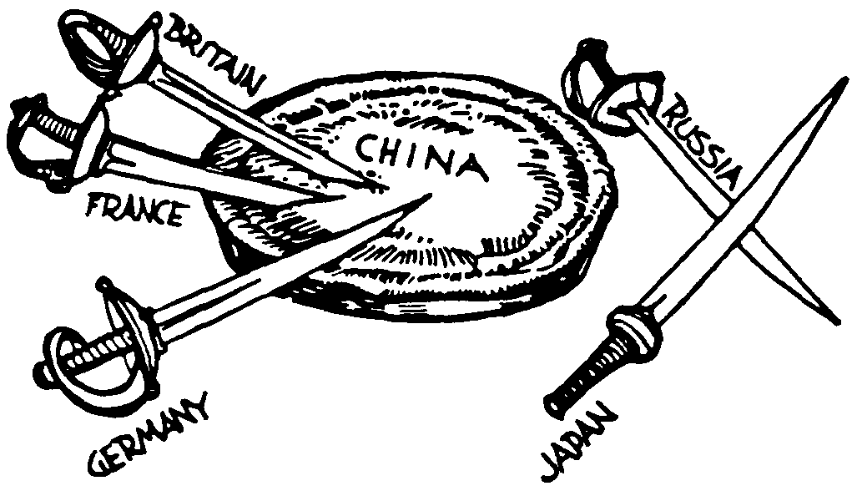

74. The cartoon depicts the

1) ethnocentrism of the Chinese during the Manchu

Ch'ing dynasty of the 17th century

2) separation of China into spheres of influence by 19th- century imperialist nations

3) military aid given to the Chinese revolutionaries by the

Soviet Union during the 1940's

4) favored trading-partner status awarded to China by many Western European countries in the1980's

75. The situation depicted in the cartoon was brought about by the

1) economic agreements with Western nations signed by

Deng Xiaoping

2) low level of cultural and economic development in

China throughout its history

3) military weakness of China and the European desire for expansion

4) alliance of the Soviet Union with the Communists and the aid given to the Nationalists by Western Europe

76. Which situation led to the defeat of China in the Opium

War (1839-1842)?

1) a civil war on the Sino-Tibetan border

2) the technological advantages of the European powers

3) a famine that weakened the Chinese military

4) the lack of support for the Manchu government from

Chinese scholars

77. The result of the Opium War in China was similar to the result of Commodore Perry's expedition to Japan in that both events

1) increased Western trade and influence in Asia

2) established European colonies in China and Japan

3) promoted democratic governments in Asia

4) increased the economic isolation of China and Japan

78. “. . . But after a long period of commercial intercourse [trade], there appear among the crowd of barbarians both good persons and bad, unevenly. Consequently there are those who smuggle opium to seduce the Chinese people

and so cause the spread of the poison to all provinces. Such persons who only care to profit themselves, and disregard their harm to others, are not tolerated by the laws of heaven and are unanimously hated by human beings. His Majesty the Emperor, upon hearing of this, is in a towering rage. He has especially sent me, his commissioner, to come to Kwangtung [Guangdong Province], and together with the governor-general and governor jointly to investigate and settle this matter. . . .”

— “Letter of Advice to Queen Victoria”

from Lin Zexu (Lin Tse-Hsü), Chinese Commissioner of Canton, 1839

This letter to Queen Victoria relates most directly to the outbreak of the

1) Chinese civil war 3) Communist Revolution

2) Sino-Japanese War 4) Opium Wars

79. One result of the Opium War was that China

1) adopted democratic reforms

2) gained control of Hong Kong

3) regained control of Manchuria

4) was divided into spheres of influence

80. The Opium Wars in China and the expedition of

Commodore Matthew Perry to Japan resulted in

1) the economic isolation of China and Japan

2) an increase in Chinese influence in Asia

3) the beginning of democratic governments in China and

Japan

4) an increase in Western trade and influence in Asia

81. The Sepoy Rebellion in India and the Boxer Rebellion in

China were similar in that both were

1) attempts to improve foreign trade

2) nonviolent resistance efforts

3) revolts against foreign influence

4) revolutions against traditional monarchs

82. "Compared to other peoples of the world we have the greatest [largest] population and our civilization is four thousand years old, . . . Today we are the poorest and weakest nation in the world and occupy the lowest position in international affairs. Other men are the carving knife and serving dish, we are the fish and the meat. As a

consequence . . . we are being transformed everywhere into a colony of the foreign powers."

Which events formed the basis for the ideas expressed in this early 1900's passage?

1) Opium War and Boxer Rebellion

2) Mau Mau uprising and adoption of apartheid

3) Sepoy Mutiny and the Salt March

4) Haitian Revolution and Cortes' march on Mexico City

83. In China, the building of the Great Wall, the use

of the tribute system, and the government's support of the Boxer Rebellion are examples of attempts by different dynasties to limit

1) foreign influence 3) communist expansion

2) nationalism 4) industrialization

Base your answers to questions 84 and 85 on the passage below and on your knowledge of social studies.

"Yesterday, your Ambassador petitioned my Ministers regarding your trade with China.... Our Celestial Empire possesses all things in great abundance and lacks no product within its own borders. There is, therefore, no need to import any product manufactured by outside barbarians in exchange for our own goods."

–Emperor Ch'ien Lung of China to

King George III of Britain, 1793

84. In the view of the Emperor, which foreign policy action was in the best interest of China in 1793?

1) maintaining economic isolation

2) expanding foreign trade

3) increasing international interdependence

4) developing into a colonial power

85. Based on this passage, which type of attitude does the

Emperor display?

1) empathetic 3) imperialistic

2) ethnocentric 4) militaristic

Base your answers to questions 86 and 87 on the statement below and on your knowledge of social studies.

Hitherto, all European nations, including your own country's barbarian merchants, have carried on trade with our Celestial Empire at Canton. Such has been the procedure for many centuries, although our Celestial Empire possesses all things in prolific abundance and lacks no product within its own borders. There is, therefore, no need to import the manufactures of outside barbarians in exchange for our own products.

Source: Letter from Ch'ien Lung to George III (1793)

86. The statement reflects a period of China's history characterized by

1) socialism 3) militarism

2) ethnocentrism 4) colonialism

87. This statement was made in reaction to

1) attempts by Western nations to expand their influence in China

2) Japanese militarism throughout East Asia

3) the development of Chinese communism

4) high European tariffs

88. The Boxer Rebellion of the early 20th century was an attempt to

1) eliminate poverty among the Chinese peasants

2) bring Western-style democracy to China

3) restore trade between China and European nations

4) remove foreign influences from China

89. During the 19th century, Western nations were able to gain control over parts of China mainly because

1) the Chinese had a strong tradition of nonviolence

2) China lacked the military technology needed to stop these ventures

3) China was promised aid for its industries

4) the Chinese lacked a strong cultural identity

90. Which event was an example of Asian reaction to European imperialism?

1) Boxer Rebellion 3) Boer War

2) Glorious Revolution 4) Congress of Berlin

91. The Boxer Rebellion, the Salt March, and the Iranian

Revolution were reactions against

1) Mongol rule 3) Western influence

2) rapid industrialization 4) economic depression

92. The Sepoy Mutiny in India and the Boxer Rebellion in

China were responses to

1) Mongol invasions 3) Japanese aggression

2) European imperialism 4) African slave trading

93. Base your answer to the following question on the diagram below and on your knowledge of social studies.

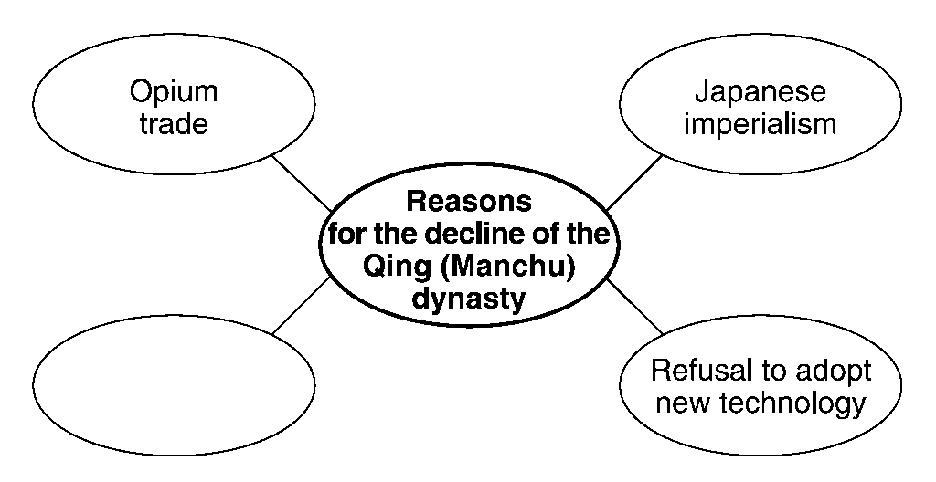

Which phrase correctly completes this diagram?

1) Chinese exports of tea to Europe

2) Spread of Confucian principles

3) Failure of the Boxer Rebellion

4) Expanding power of Mao Zedong

94. The Sepoy Rebellion was to India as the Boxer Rebellion was to

1) Russia 3) Japan

2) China 4) Italy

95. Base your answer on the cartoon below and on your knowledge of social studies.

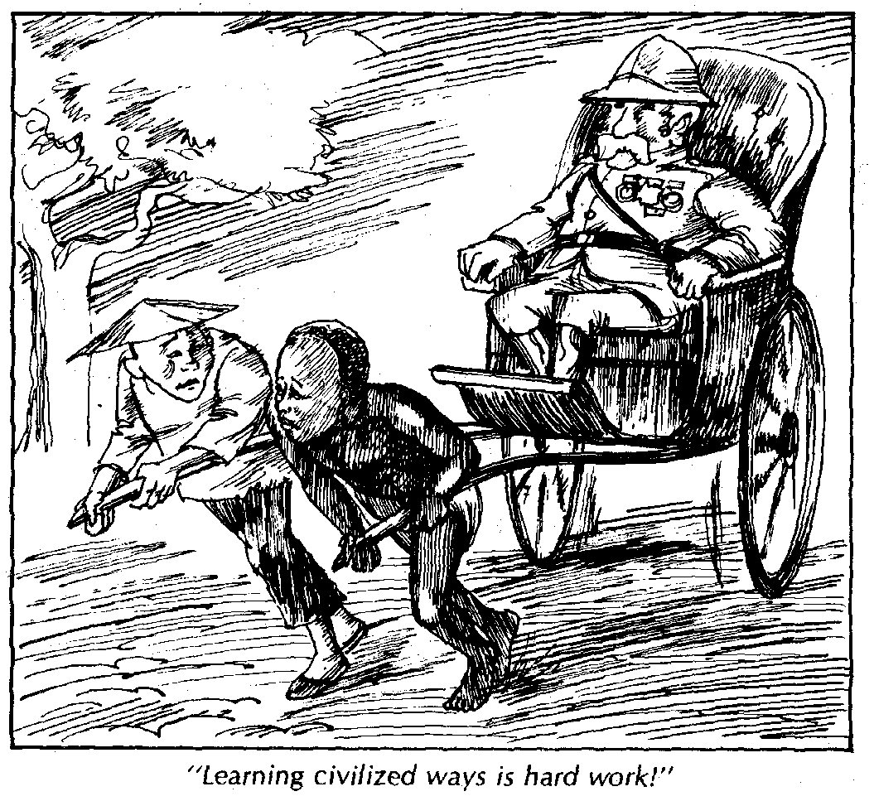

What is the main idea of the cartoon?

1) Many people assisted Western nations in acquiring overseas colonies.

2) Western imperialism led to the exploitation of people and resources in the colonies.

3) Many job opportunities were created by Western colonization.

4) Western imperialism improved the quality of life for people in the colonies.

96. Within their respective nations, both Ho Chi Minh and

Fidel Castro achieved their goals by

1) seeking aid and support from the European Union

2) using armed conflict to bring a Communist government to power

3) following a policy of nonalignment

4) working to build a capitalist system

97. During the Communist-Nationalist civil war, Chiang Kai- shek lost the support of the Chinese people mainly because he

1) refused to accept support from foreign nations

2) defeated the forces of Deng Xiaoping

3) signed an alliance with Great Britain

4) ignored the needs of the peasant population

98. The main reason the Chinese Communists gained control of mainland China in 1949 was that

1) they were supported by many warlords and upper class

Chinese

2) the United States had supported the Chinese

Communist Party during World War II

3) the dynamic leadership of Mao Zedong had the support of the peasant class

4) they had superior financial resources and were supported by Japan

99. A major reason for the success of the Communist revolution in China was that the Communists

1) stressed Buddhism in their military training

2) included important businessmen in their ranks

3) promised land and power to the peasant class

4) fought successfully against the United States during

World War II

100. What was a major reason for the Communist victory in the

Chinese civil war (1949)?

1) The Nationalists had been supported by the Japanese.

2) Many Chinese warlords supported the Communists.

3) The Communists had superior military equipment.

4) The Communists promised land to the peasants.

101. In the Chinese Civil War (1945 - 1949), support for Mao

Zedong's Communist forces came primarily from the

1) peasants 3) industrialists

2) landowners 4) Confucian scholars

102. Which idea did Napoleon Bonaparte, Sun Yat-sen, and

Simón Bolívar have in common?

1) divine right 3) totalitarianism

2) nationalism 4) nonviolence

103. The French Revolution (1789), the Bolshevik Revolution (1917), and the Chinese Revolution (1949) were similar in that each led to

1) military defeat by foreign powers

2) the rise of dictatorships

3) governments that were based on Communist principles

4) rule by a parliamentary government

104. The French Revolution, the Bolshevik Revolution in Russia, and the Communist Revolution in China were similar in that all three

1) brought about few political changes

2) were influenced by the peasants' desire for more land

3) were inspired by Marxism

4) were supported primarily by the nobility

105. After World War II, the Chinese Communists were successful in their revolution mainly because the

1) United States refused to support the Nationalists

2) Communists had the support of the peasants

3) Communists had more technologically advanced weapons

4) Nationalists had been defeated by Japan

106. During the 1970s and 1980s India and China attempted to improve the quality of life for their people and to increase economic growth by

1) changing the political structure

2) adopting policies to limit population growth

3) encouraging farmers to move to the cities

4) seeking overseas colonies

107. During the Communist Revolution in China, many farmers supported the Communists because the Communists promised

1) land reform

2) a peace treaty with Japan

3) a federal republic

4) aid from the industrial nations

108. The political ideas of Ho Chi Minh, Fidel Castro, and Pol

Pot were strongly influenced by the writings of

1) Confucius 3) Desmond Tutu

2) Mohandas Gandhi 4) Karl Marx

109. Which factor most helped Communist Party forces gain control of China after World War II?

1) The United States sent weapons to the Communists.

2) The Japanese gave economic aid to the Nationalists.

3) The Communists gained the support of China’s peasant class.

4) The Chinese Nationalists set up their own government in Taiwan.

110. One reason the Chinese Communists were able to gain control of China was primarily due to the support of the

1) peasants 3) foreigners

2) landed elite 4) warlords

111. During China's Cultural Revolution, a major goal of the

Red Guard was to

1) revive traditional loyalty to the emperor

2) promote trade and free enterprise

3) enforce the teachings of Mao Zedong

4) encourage cooperation with the Soviet Union

112. "A wind has been blowing from the West; now it will begin to blow from the East."

—Mao Zedong, 1949

Which idea was Mao Zedong expressing in this quotation?

1) The monsoons will soon shift and bring destruction to the mainland of Asia.

2) Chinese culture will no longer influence the people of

Asia.

3) European power will decline as a new center of power emerges in Asia.

4) The Asian people have much to learn from the Western

Europeans.

113. In China, the terms "commune," "Great Leap Forward," and

"Cultural Revolution" are associated with the

1) economic success of the Manchu dynasty

2) Mandate of Heaven

3) Confucian emphasis on the five human relationships

4) leadership of Mao Zedong

114. The Confucian view of government and the Chinese Communist view of government were similar in that both stressed

1) loyalty to the government

2) the need for filial piety

3) a civil service system

4) equality of men and women

115. Which action by the Chinese Government since 1949 best reflects the influence of Confucianism?

1) Dissidents have been allowed to criticize the government.

2) Education has been discouraged at all levels of society.

3) Democratic policies have been encouraged.

4) Respect for and allegiance to rulers has been promoted.

116. In China, the Great Leap Forward and the Cultural Revolution promoted by Mao Zedong were similar in that both plans

1) ended dynastic rule

2) disrupted industrial development

3) encouraged capitalism

4) guaranteed human rights

117. Base your answer on the cartoon below and on your knowledge of social studies.

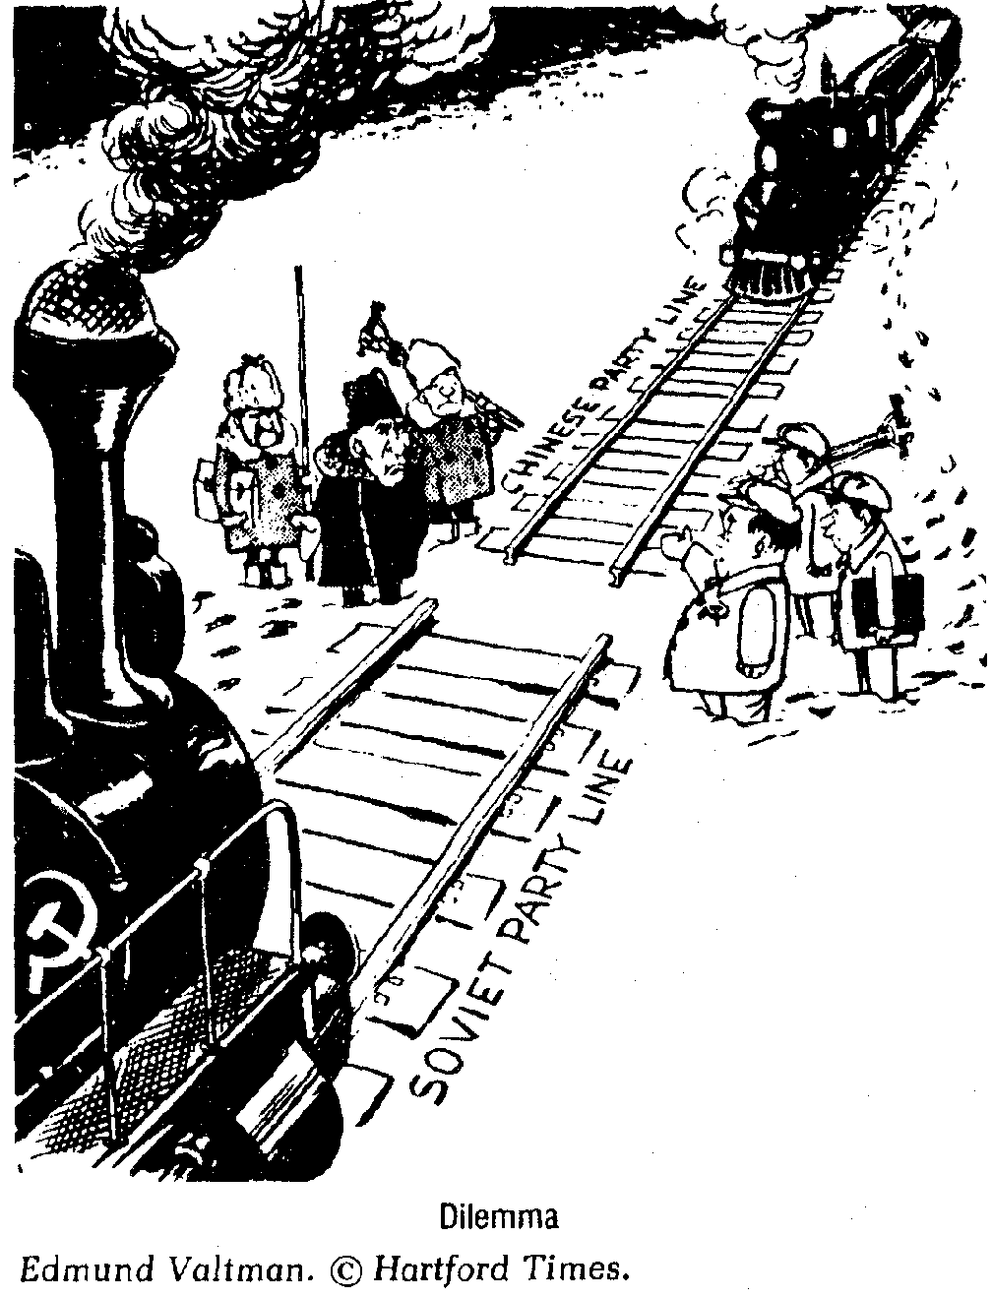

After 1956, strained relations between the Soviet Union and the People's Republic of China were often caused by

1) disagreements over the meaning and goals of communism

2) difficulties encountered in constructing the trans- Siberian railroad

3) technological differences between the two nations

4) China's reluctance to admit Russian workers into

Manchuria

118. The Great Leap Forward in China and the five-year plans in the Soviet Union were attempts to increase

1) private capital investment

2) religious tolerance

3) individual ownership of land

4) industrial productivity

119. In China, the Great Leap Forward was an attempt to

1) promote democratic reform

2) end the private ownership of land

3) strengthen economic ties with Europe

4) increase agricultural and industrial production

120. One similarity between the culture of traditional China under dynastic rule and the culture of modern China under Communism is that both stress

1) a state-supported religion

2) loyalty to the authority of leaders

3) the importance of a matriarchal society

4) limits on population growth

121. An immediate result of the Cultural Revolution in China was that it

1) helped to establish democracy in urban centers in China

2) led to economic cooperation with Japan and South

Korea

3) disrupted China's economic and educational systems

4) strengthened political ties with the United States

122. The Cultural Revolution in China was Mao Zedong's attempt to

1) renew the ideas and enthusiasm of the Communist revolution

2) increase the industrial output of China

3) promote artistic exchanges with the United States

4) encourage foreign investment in China

123. Base your answer to the following question on the statements below and on your knowledge of social studies.

Speaker A: Nationalism, democracy, and socialism are the goals of my party.

Speaker B: We must rid our country of all foreign influences and return to the true principles of communism.

Speaker C: A good ruler will rule by example, not by decree.

Speaker D: The laws of nature, not government, should rule society.

Which speaker's statement best reflects the ideas of China's

Cultural Revolution?

1) A 3) C

2) B 4) D

124. In China and the former Soviet Union, the Communist governments discouraged organized religion because religions

1) compete for the loyalties of the people

2) support the principles of laissez-faire

3) favor anarchy over organized government

4) stress economic rather than political values

125. The Great Leap Forward in China was an attempt to

1) introduce democratic principles of government

2) reduce the power of the military

3) increase agricultural and industrial output

4) remove restrictions on emigration

126. One way in which Confucian philosophy and Communist ideology are similar is that both

1) are Western in origin

2) emphasize the importance of the group over the individual

3) focus on national economic development

4) have a strong religious base

127. A major goal of the Cultural Revolution in China during the

1960s was to

1) restore China to the glory of the Han dynasty

2) reemphasize Confucian traditional values

3) weaken Communist ideas

4) eliminate opposition to Mao Zedong

128. In the People's Republic of China, which factor best reflects

Marxism?

1) communal work teams on farms

2) ownership of small farms by individuals

3) small family-owned businesses in villages

4) foreign influence on the economy

129. Gamal Abdel Nasser, Mao Zedong, and Simón Bolívar were similar because they

1) promoted nationalism among their peoples

2) believed in Marxist principles

3) modeled their political actions on religious doctrine

4) encouraged terrorism and violence in their revolutions

Base your answers to questions 130 through 132 on the passage below and on your knowledge of social studies.

When I was young, the Chairman promised us all food. He promised that we would never go hungry again or be without work; my family was led to a village where we became members of a production team. We worked hard, long hours but we were fed every day. The commune prospered at first, but soon people did not meet their quotas and we did not increase our production. We all received the same amount of rice; it didn't matter how

much work we did. With the new Chairman, things are different in our village. The government has given us plots of land to work as our own, though I still put in time as a commune worker. We can now keep the amount we produce above the quota set by the government. This has made most of us work harder and the government quotas are being met for the first time.

––Conversations with a Farmworker (1986)

130. The Chairman mentioned in the first paragraph was most likely

1) Fidel Castro 3) Mohandas Gandhi

2) Gamal Abdel Nasser 4) Mao Zedong

131. According to the first paragraph, which is most likely the reason agricultural production quotas were not met?

1) The workers felt threatened by the government.

2) The workers had little to gain by working hard.

3) The workers were hungry and could not work.

4) The workers were young and inexperienced.

132. Under the new Chairman mentioned in the second paragraph, which economic idea was introduced to increase production?

1) scarcity 3) private benefit

2) tax reform 4) collectivism

133. In China the terms "Long March," "Little Red Book," and

"Great Leap Forward" are most closely associated with the

1) economic policies of the Kuomintang

2) expulsion of foreigners during the Boxer Rebellion

3) foreign policy under Deng Xiaoping

4) leadership of Mao Zedong

134. The philosophies of Confucius and Mao Zedong both emphasized

1) individual rather than cooperative gain

2) industry rather than agriculture

3) group rather than individual welfare

4) religious values rather than economic profits

135. The goal of Mao Zedong's policy known as the Great Leap

Forward was to

1) develop foreign export industries in China's coastal urban centers

2) eliminate state-owned industries in rural China

3) modernize China's economic system by dividing China into communes

4) introduce capitalism to the Chinese economy

136. What was one reason for the victory of the Communists over the Nationalists in China in 1949?

1) The Nationalists received no foreign aid.

2) The Communists promised land reform to the peasants.

3) Mao Zedong was an imperialistic leader.

4) Japan gave military support to the Communists.

137. A factor that contributed to the success of both Ho Chi Minh in Vietnam and Mao Zedong in China was their ability to combine

1) imperialism and traditionalism

2) nationalism and Communism

3) ethnocentrism and democracy

4) isolationism and Capitalism

138. Which development took place in China under Mao

Zedong?

1) The family became the dominant force in society.

2) The Four Modernizations became the basis for economic reform.

3) The people adopted the practice of ancestor worship.

4) Communist teachings became required learning in all schools and universities.

139. Since the late 1970s, which measure has the Chinese government taken to reduce the effects of overpopulation?

1) supported a policy of forced migration to other nations

2) reduced food production

3) emphasized the teachings of Confucius

4) imposed a one-child policy that limits family size

140. One similarity between Stalin’s five-year plans and Mao Zedong’s Great Leap Forward was that both programs attempted to

1) increase industrial production

2) privatize the ownership of land

3) correct environmental pollution

4) strengthen international trade

141. One similarity between the Reign of Terror during the French Revolution and the Cultural Revolution in China was that both

1) limited the power of absolute leaders

2) illustrated the power of public opinion in forming national policy

3) established social stability and economic growth

4) used violent methods to eliminate their opponents

142. "It doesn't matter if the cat is black or white as long as it catches mice."

—Deng Xiaoping

In this quotation, Deng Xiaoping implies that to achieve success, China should

1) adhere to strict Marxian socialism

2) continue Mao Zedong's elimination of Western cultural influences in China

3) establish a policy of mercantilism

4) use whatever means necessary to improve its economy

143. During the 1980s and 1990s, the economic policies of

China, supported by Deng Xiaoping, have led directly to

1) an expansion of China's colonial empire

2) an increase in trade with the West

3) a return to a strict command economy

4) the success of the commune system

144. Which change occurred in China's economy in the 1980s and 1990s under the leadership of Deng Xiaoping?

1) Economic policies were based on the ideas of the

Cultural Revolution.

2) Collectivization of agriculture was introduced into the economy.

3) Foreign investment in the economy was encouraged.

4) Privatization of industry was outlawed.

145. Deng Xiaoping's economic reforms in China differ from the previous economic policies of Mao Zedong in that Deng's reforms

1) discourage private ownership of businesses

2) promote further collectivization

3) include elements of capitalism

4) decrease trade with the United States

146. Base your answer on the cartoon below and on your knowledge of social studies.

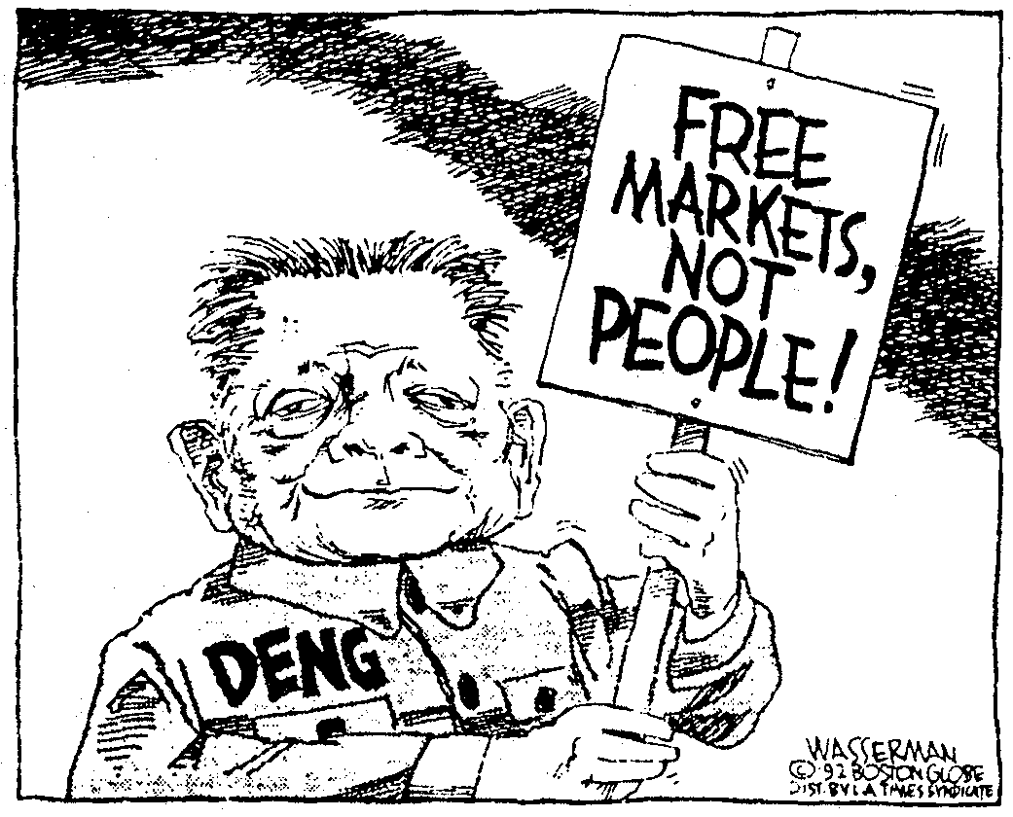

What is the main idea of this 1992 cartoon?

1) China's government opposes free-trade agreements with Western nations.

2) Deng Xiaoping personally opposed the introduction of capitalism to China.

3) The Chinese Government is more interested in improving trade than in respecting human rights.

4) China's economic system is meeting the needs of its people.

147. Economic development in Japan after World War II and in Communist China since the 1980s is similar in that both nations have sought to

1) end foreign investment

2) develop their vast natural resources to achieve economic growth

3) utilize the concepts of capitalism to improve their economies

4) nationalize most major industries and restrict competition

148. Which statement best explains China's economic shift toward capitalism in the 1980s and early 1990s?

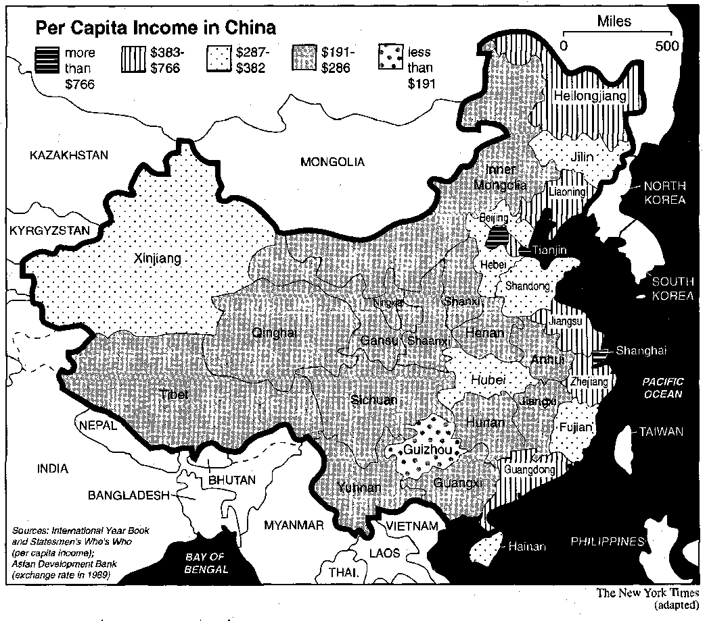

1) China's economic policies were directly influenced by the success of the Soviet economic system.

2) The Tiananmen Square massacre resulted in major economic reforms in China.

3) The success of the Cultural Revolution resulted in the increased westernization of China.

4) Communist economic policies were not meeting the needs of the society.

149. Base your answer on the map below and on your knowledge of social studies.

The map shows that the

1) economics of all the regions of China are developing at the same rate

2) distribution of income in China is unequal

3) economies of the interior provinces of China are developing faster than those of the coastal provinces

4) economic development in China is dependent upon the cash crops of Xinjiang and Tibet

150. In China during the 1980's, government efforts to adapt

Western economic ideas resulted in

1) increased dependence on the Soviet Union

2) a slowdown of economic growth

3) increased trade with many industrialized nations

4) military confrontations with other Asian nations

151. Since the death of Mao Zedong, relations between China and the United States have improved because

1) both nations see an economic advantage to increased trade

2) the new Chinese leadership has adopted a democratic government

3) illegal Chinese immigration to the United States has decreased

4) the United States has increased oil imports from China

152. In present-day China, the major goal of the government is to

1) increase the freedom of the Chinese press

2) reduce its control over the economy

3) increase Chinese control over Southeast Asia

4) decrease Chinese trade with the United States

153. To improve economic conditions during the late 1980s and early 1990s, China adopted policies that

1) restricted agricultural and industrial exports

2) led to a Chinese military invasion of Korea

3) moved China toward a modified form of private enterprise

4) prohibited involvement by foreign corporations in

Chinese industries

154. Base your answer on the cartoon below and on your knowledge of social studies.

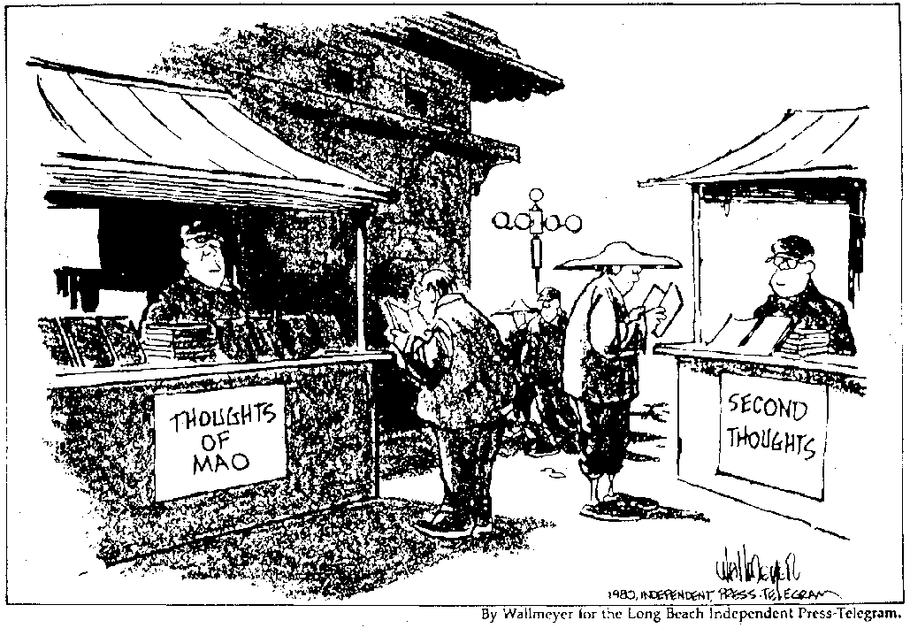

What is the main idea of the cartoon?

1) The Chinese people are reconsidering their commitment to Communist principles.

2) Educational opportunities are improving in China.

3) The Chinese Government is encouraging the growth of small businesses.

4) The literacy rate of the Chinese people needs to be improved.

155. In China, a major achievement of the Communist government has been

1) an improved standard of living for many people

2) an increase in democratic reforms

3) a strengthening of the landlord system

4) a greater respect for Confucian scholars

156. Which is a valid generalization about the Communist Party in China during the 1980s?

1) Most Chinese people were members of the Party.

2) The new leadership of the Party experimented with greater economic flexibility.

3) The Party rejected the philosophies of Marx and Lenin.

4) The pro-democracy movement resulted in greater political freedom within the Party.

157. During the 1980s, the Chinese government adopted policies designed to

1) increase industrial productivity

2) reestablish Confucian traditions and values

3) gain colonies throughout east Asia

4) maintain its isolation from world events

158. Which segment of Chinese society gave the most support to the Communists during the Revolution?

1) peasants 3) landowners

2) religious leaders 4) bureaucrats

159. During the 1980s, a major goal of China was to

1) accelerate economic growth

2) encourage the growth of traditional religions

3) establish a federal system of government

4) protect individual liberties

160. Which statement about the economy of China in the 1980s is most accurate?

1) China surpassed the Soviet Union in steel production.

2) China's economy slowed down because of a lack of natural resources.

3) China increased its industrial capacity and foreign trade.

4) China's economy suffered from overproduction of consumer goods.

161. Which statement about reforms in China during the 1980s and 1990s is most accurate?

1) Political reforms resulted in the overthrow of communism.

2) Economic reforms were more successful than political reforms.

3) Political reforms increased individual rights.

4) Economic reforms forced China to return to a policy of isolationism.

162. Base your answer to the following question on the cartoon below and on your knowledge of social studies.



What is the main idea of the cartoon?

1) The majority of people in China do not support the recent changes.

2) China is improving its record on human rights.

3) Economic freedom in China has not led to political reforms and freedom.

4) China's system of criminal justice is based on Western traditions and laws.

163. Which statement best expresses the change in economic policy between Deng Xiaoping and Mao Zedong?

1) A more favorable attitude toward a market economy existed under Deng Xiaoping than under Mao Zedong.

2) Deng Xiaoping and Mao Zedong rejected Western capitalism.

3) Both Deng Xiaoping and Mao Zedong encouraged peaceful protest.

4) Deng Xiaoping wanted greater government control of the economy than Mao Zedong did.

164. Since the 1980s, Chinese leaders have tried to improve

China’s economy by implementing a policy of

1) isolation

2) collectivization

3) limited free enterprise

4) representative government

165. A similarity between Peter the Great of Russia and Deng

Xiaoping of the People’s Republic of China was that each

1) resisted economic and social reforms in his country

2) rejected the culture of his country in favor of a foreign culture

3) promoted economic and technological modernization of his country

4) experienced foreign invasions of his country that almost succeeded

166. An analysis of the Chinese student demonstrations in

Tiananmen Square in 1989 would show that

1) communist governments continue to have little control over the actions of their citizens

2) totalitarian governments frequently survive by the use of force

3) peaceful demonstrations often succeed in achieving democratic reforms

4) negative global reaction sometimes leads to economic decline

167. The Tiananmen Square massacre in China was a reaction to

1) Deng Xiaoping's plan to revive the Cultural Revolution

2) student demands for greater individual rights and freedom of expression

3) China's decision to seek Western investors

4) Great Britain's decision to return Hong Kong to China

168. Which statement best describes a result of the student demonstrations in Beijing's Tiananmen Square in 1989?

1) Pro democracy protectors were successful in achieving their goals

2) A state-controlled education program was begun.

3) The government further restricted freedom of expression in China.

4) Collectivization programs were started in China.

169. Sun Yat-sen's "Three Principles of the People" (1911) and the demonstrations in Tiananmen Square (1989) were similar in that they both demanded that the Chinese Government

1) achieve global interdependence

2) restore dynastic rule

3) introduce democratic reforms

4) end foreign influences in China

170. Which statement best characterizes events in China since the 1980's?

1) Political reform has kept pace with economic development.

2) Pro-democracy movements have been repressed by the

Communist leaders of China.

3) The government has passed laws to assure that Chinese women remain in their traditional roles.

4) A new constitution was enacted that granted freedom of political expression.

171. One way in which the Tiananmen Square massacre in China, the Amritsar massacre in colonial India, and Bloody Sunday in czarist Russia are similar is that they were

1) government responses to citizen protest

2) pro-Communist demonstrations against government policies

3) protests against the imperialism of foreign nations

4) attempts by the military to overthrow the governments in power

172. A major cause of the Tiananmen Square demonstrations in

June 1989 was the

1) influence of Western ideas on university students

2) memories of the Japanese invasion of China

3) teachings of Confucius

4) Chinese tradition of youthful rebellion

173. In China, the Revolution of 1911 and the demonstrations in

Tiananmen Square in 1989 were similar in that each event

1) succeeded in overthrowing the existing government

2) resulted in foreign military intervention

3) sought to bring about democratic reforms

4) made land reform a major goal

174. Base your answer on the cartoon below and on your knowledge of social studies.

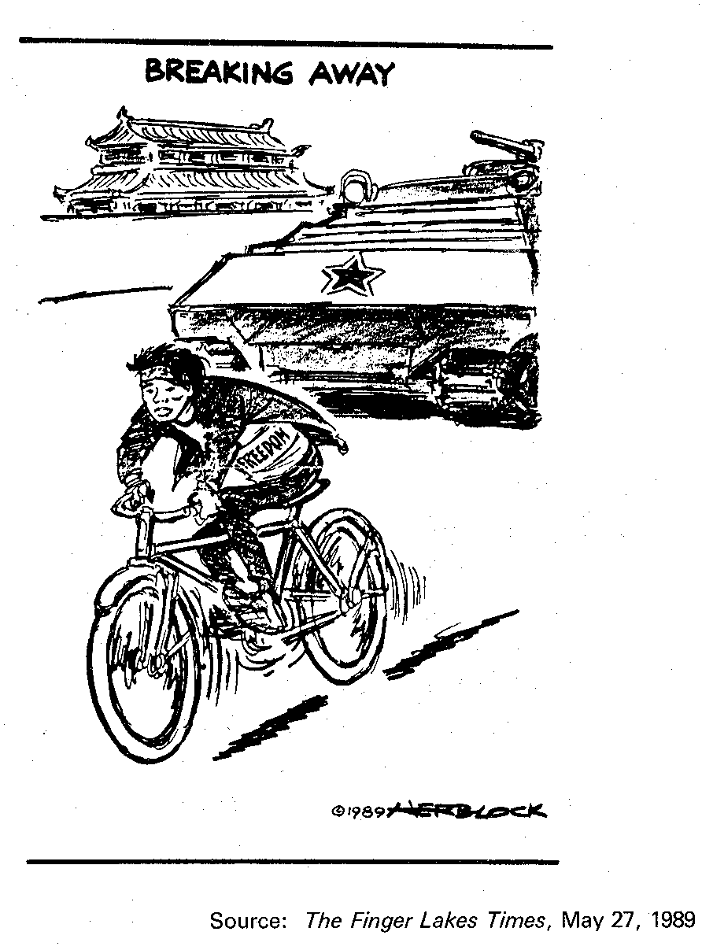

What is the main idea of the cartoon?

1) Chinese students have succeeded in achieving their demands for democratic reform.

2) The government of China has encouraged dissent in the hope that criticism will quickly fade away.

3) The Chinese Army has opposed student pro-democracy demonstrations.

4) Human rights have not been repressed by the government of China.

Base your answers to questions 175 and 176 on the cartoon below and on your knowledge of social studies.

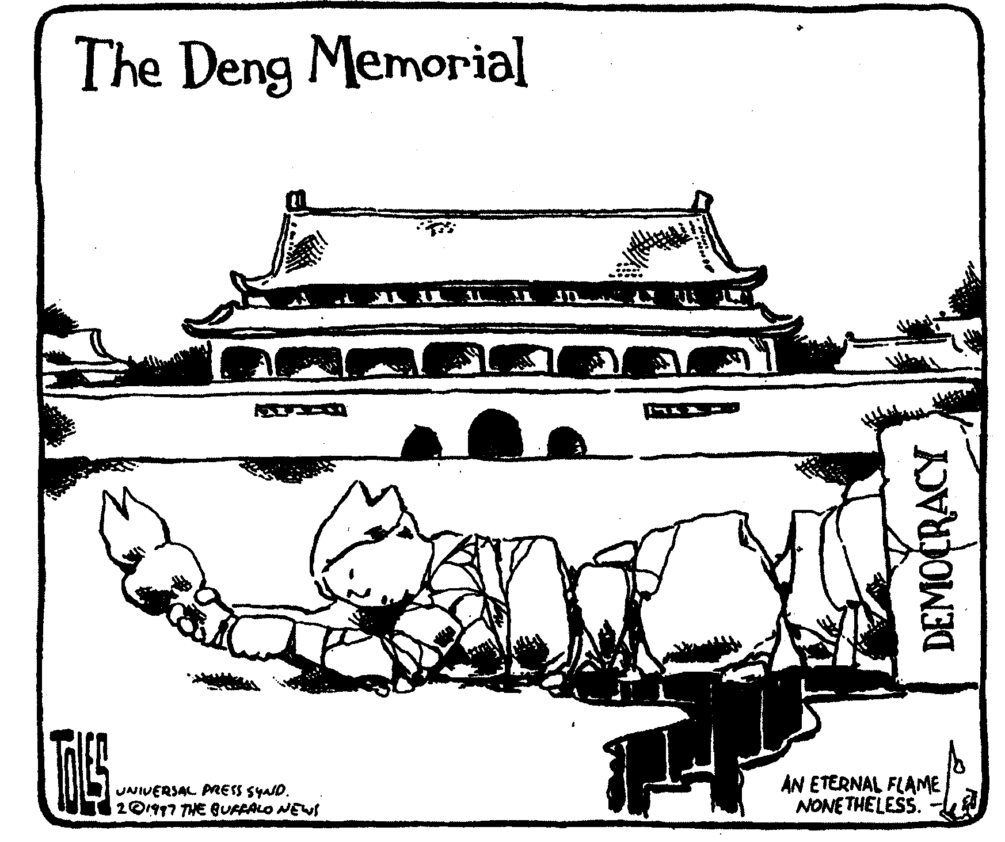

175. The main idea of this cartoon is that Deng Xiaoping will be remembered most for the

|  |  |  |
| --- | --- | --- |
| 1) destruction of Western art | 3) | preservation of Chinese historical sites |
| 2) bloodshed in Tiananmen Square | 4) | adoption of a capitalist economy |

176. Which global issue is addressed in this cartoon?

1) human rights 2) environmental pollution 3) ethnic strife 4) Cold War tensions

177. Which statement is accurate about the Hungarian Revolution in 1956 and the Tiananmen Square demonstrations in 1989?

1) These events led to democratic reforms.

2) Repressive action was taken to end both protests.

3) Strong action was taken by the United Nations.

4) Both events brought communist governments to power.

178. Within the past decade, the decision of the United States Government to grant China "most favored nation" status was important to China because this decision

1) allowed China to join the Southeast Asia Treaty

Organization (SEATO)

2) increased China's ability to trade with the United States

3) helped protect China from a possible Japanese invasion

4) eliminated Russian influence in East Asia

179. One similarity between the Kurds in Iraq, the Tibetans in

China, and the Tamils in Sri Lanka is that they

1) have adopted the religion of Islam

2) are attempting to achieve self-determination

3) have rejected the use of force

4) have been banned from membership in the United

Nations

180. Which nation had the greatest influence on the recent histories of Taiwan, Hong Kong, and Tibet?

1) India 3) China

2) South Korea 4) Russia

181. Base your answer on the cartoon below and on your knowledge of social studies.

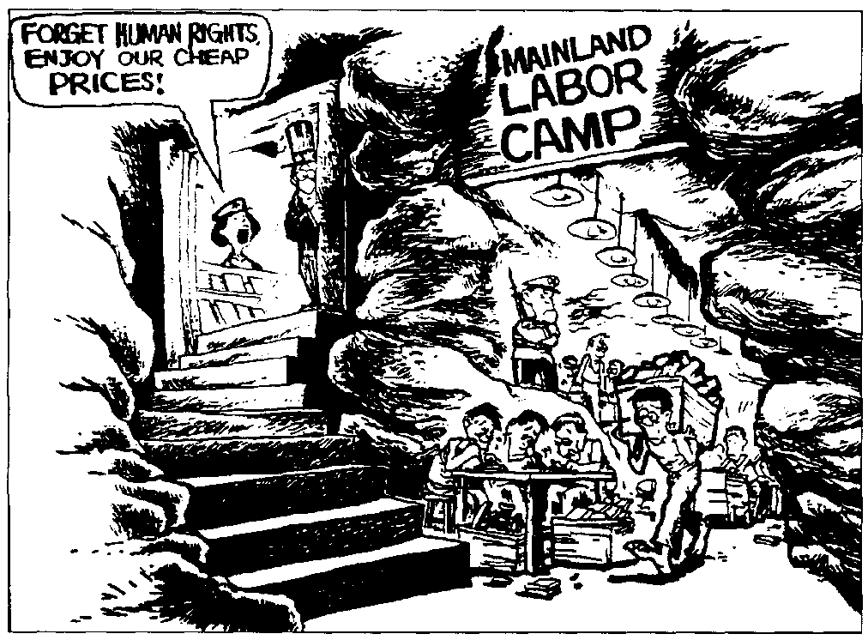

What is the main idea of the cartoon?

1) Labor camps remain China's primary method of punishing political prisoners.

2) The Chinese consider the United States an imperialistic power.

3) Economic development in modern China has sometimes been achieved by ignoring human rights issues.

4) The Chinese believe that human rights abuses are also an issue in the United States.

182. Base your answer to the following question on on the graph below and on your knowledge of social studies.

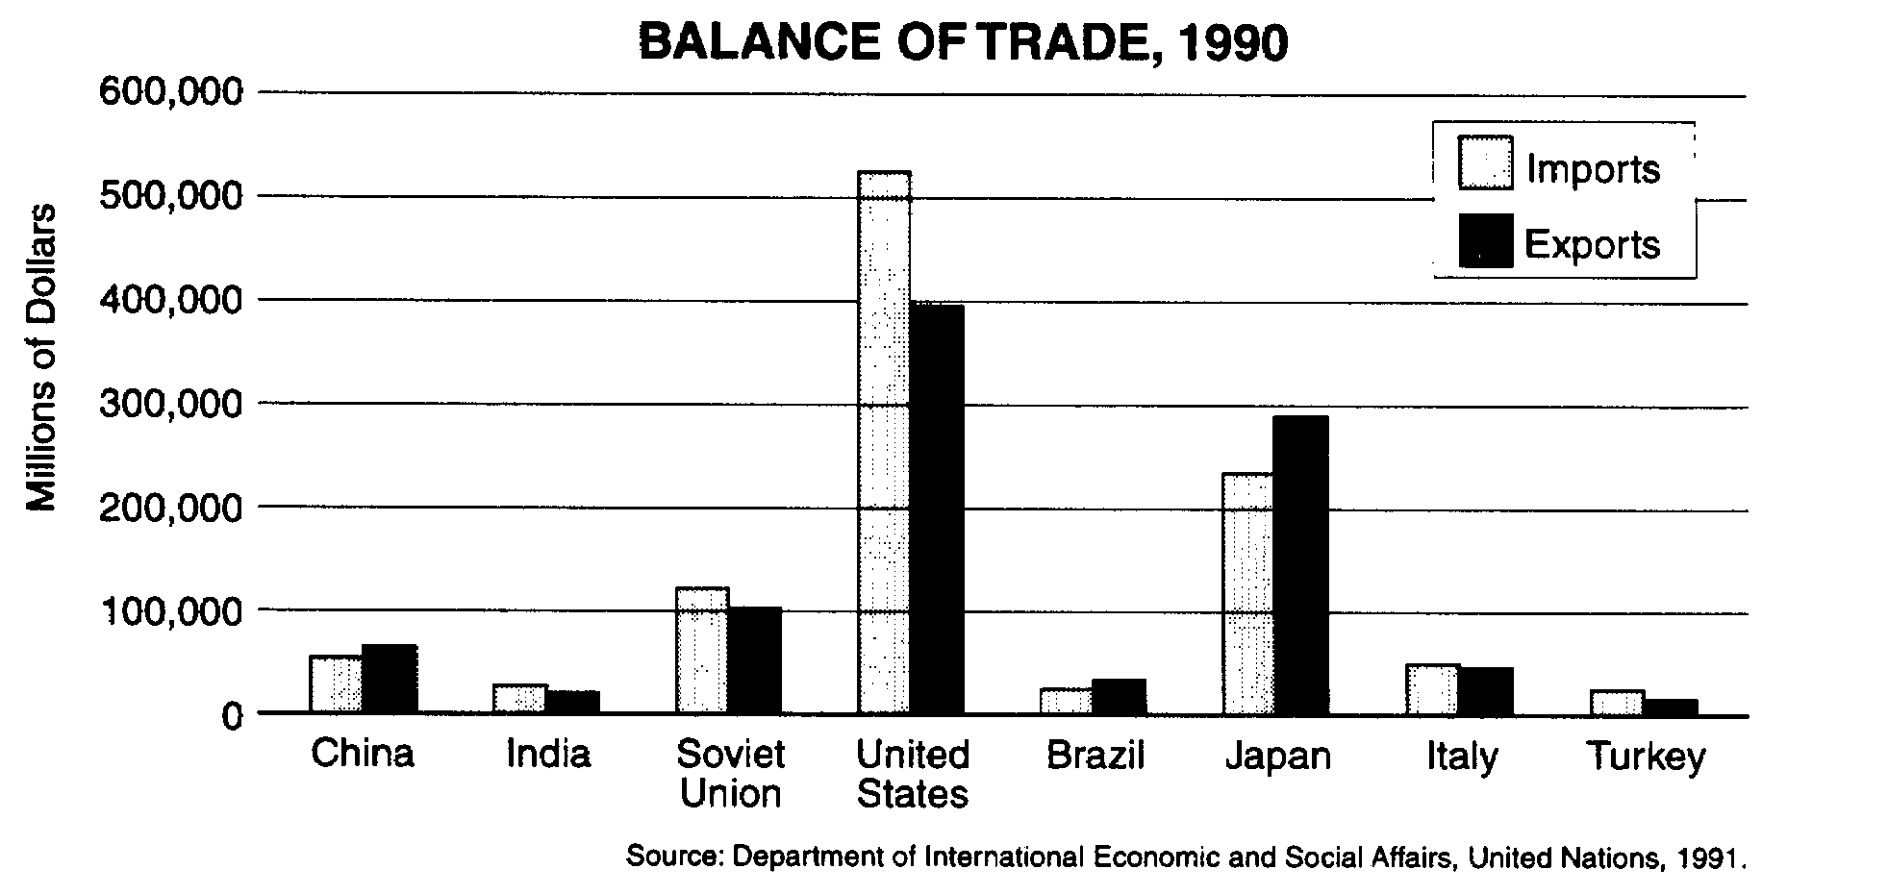

According to the graph, which of these nations had a favorable balance of trade in 1990?

1) India 2) Soviet Union 3) United States 4) China

183. Over the last 20 years, the Chinese Government's policy on population growth has been to

1) leave decisions on family size to individual villages

2) allow religious groups to determine family size for their members

3) limit family size and punish those who ignored these limits

4) encourage population growth by offering subsidized day care to large families

184. Base your answer to the following question on the bar graph below and on your knowledge of social studies.

185. Which fact about China has been the cause of the other three?

1) The economy of China has trouble providing for all the needs of the people.

2) The Chinese government has set limits on the number of children families may have.

3) Chinese cities have a severe shortage of housing.

4) China's population exceeds one billion.

186. A major obstacle to economic development in China has been

1) the size of its population

2) a scarcity of mineral resources

3) a lack of nationalistic feelings among its people

4) its refusal to accept aid from other Asian nations

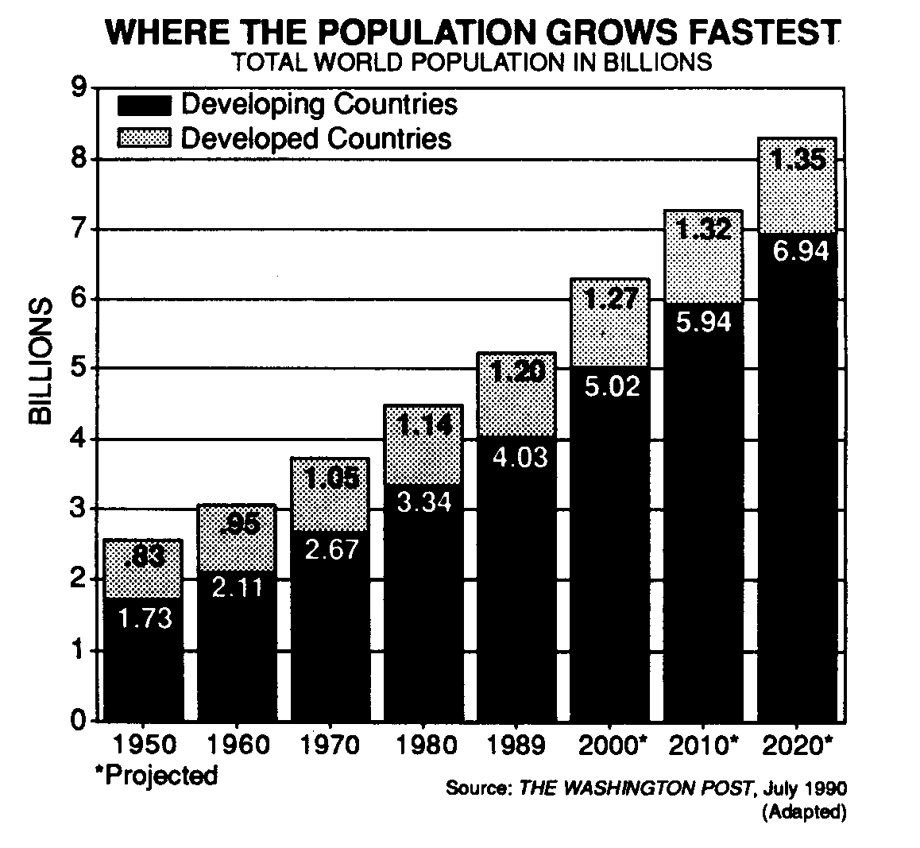

Which statement is best supported by the data shown in the graph?

1) The rate of world population growth has begun to decrease.

2) The world's population tripled between 1970 and 1989.

3) Most of the world's population lives in economically developing countries.

4) The population of economically developed countries consumes most of the world's resources.

187. Base your answer to the following question on the charts below and on your knowledge of social studies.

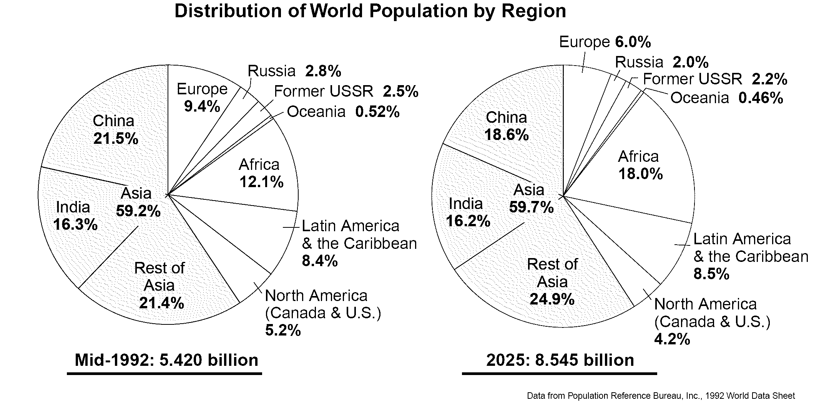

Which factor best explains the projected change in China's population by 2025?

1) increased immigration to China 3) government limits on family size

2) religious doctrines discouraging birth control 4) increased agricultural production in China

188. Base your answer to the following question on the graph below and on your knowledge of global history.

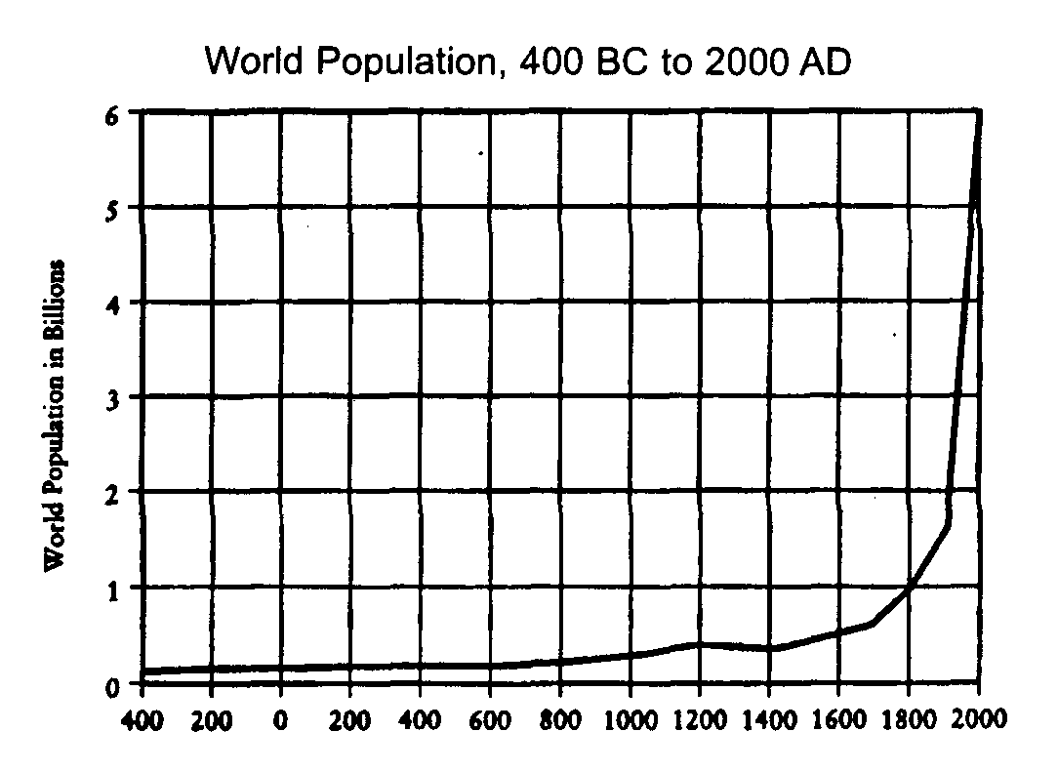

Which conclusion about the world's population can be drawn from the information provided by this graph?

1) It has increased steadily since 400 BC.

2) It has increased sharply between 1200 AD and 1400

AD.

3) It grew slowly until about 1700 AD and then increased rapidly.

4) It will decrease rapidly after 2000 AD.

189. Base your answer on the chart below and on your knowledge of social studies.

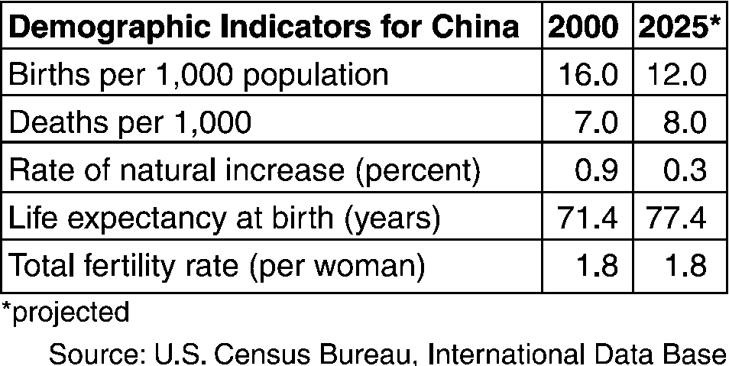

Which conclusion about the population of China between

2000 and 2025 can be drawn from the information provided by this chart?

1) The fertility rate of Chinese women is expected to increase.

2) Chinese life expectancy will likely decrease.

3) The rate of population growth is expected to decline.

4) By 2025, the birthrate in China will probably double.

190. Base your answer to the following question on the graph below and on your knowledge of social studies.

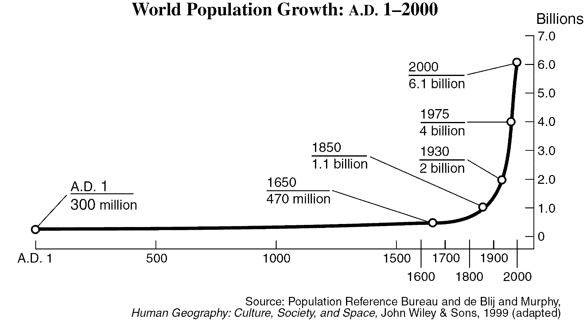

Which statement can be supported by the information in the graph?

1) The population of the world remained the same from A.D. 1 to A.D. 1650

2) Most of the world’s population growth took place during the period from 1000 to 1500.

3) The population growth rate decreased during the period from 1650 to 1800.

4) The world’s population tripled between 1930 and 2000.