Technological – Aztecs

Social – Aztecs

Economic – Aztecs

Political – Aztecs

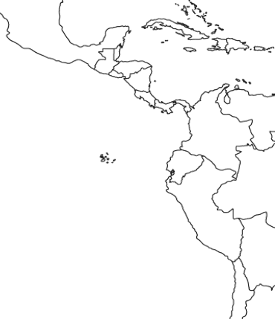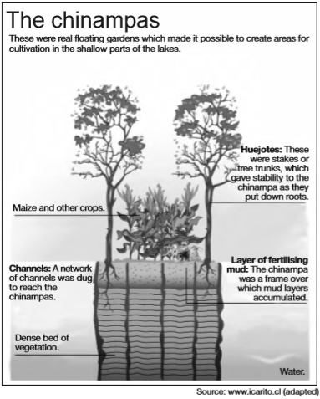

**AZTEC - Vocabulary (400- 406)**

Toltecs

Quetzacoatl

Obsidian

Triple Alliance

Chinampas

Tenochtitlan

**Shade Orange**

**Aztec Empire**

**1325 – 1519**

**Label**

**Tenochtitlan**

**Tula**

**Tlacopah**

**Lake Texcoco**

**Which situation was an immediate cause**

**for the collapse of the Aztec civilization?**

(1) disruption of overseas trade networks

(2) conquest by foreigners

(3) a series of crop failures

(4) a lack of military training

**AZTEC - Processing Questions**

**Based on the information in the Diagram to the right**

**why did Aztecs build chinampas? Explain why this change**

**to their environment was needed and discuss how this**

**change affected the society and region.**

**______________________________________________________________**

**______________________________________________________________**

**______________________________________________________________**

**Accoring to Sabloff, what was one way building out into the lake**

**benefited the Aztec Empire and its capital city of Tenochtitlan?**

__________________________________________________________________________________________________________________________________________________________________________________________________________________________________________________

*… The capital city, which may have had a population as high as 200,000 to 300,000 in the early 16th century, was a superb example of planned growth. By building out into the lake, the Aztecs consolidated and enlarged the original two islands which in turn were linked to the mainland by three large causeways. Fresh water was brought to the city from the mainland by aqueduct…*

***Source: Jermy A Sabloff, The cities of ancient Mexico: Reconstructing a Lost World, Thames and Hudson***

**AZTEC - Geographcy (Atlas 74)**