Document A
Treaty of Versailles , June 28, 1919
SECTION VIII SHANTUNG

Article 156
Germany renounces, in favour of Japan, all her rights, title and privileges¯particularly those concerning the territory of Kiaochow, railways, mines and submarine cableswhich she acquired in virtue of the Treaty concluded by her with China on March 6 1898, and of all other arrangements relative to the Province of Shantung.
All German rights in the Tsingtao-Tsinanfu Railway, including its branch lines together with its subsidiary property of all kinds, stations, shops, fixed and rolling stock, mines, plant and material for the exploitation of the mines, are and remain acquired by Japan, together with all rights and privileges attaching thereto.
The German State submarine cables from Tsingtao to Shanghai and from Tsingtao to Chefoo, with all the rights, privileges and properties attaching thereto, are similarly acquired by Japan, free and clear of all charges and encumbrances.

Article 157
The movable and immovable property owned by the German State in the territory of Kiaochow, as well as all the rights which Germany might claim in consequence of the works or improvements made or of the expenses incurred by her, directly or indirectly, in connection with this territory, are and remain acquired by Japan, free and clear of all charges and encumbrances.

Article 158
Germany shall hand over to Japan within three months from the coming into force of the present Treaty the archives, registers, plans, title-deeds and documents of every kind, wherever they may be, relating to the administration, whether civil, military, financial, judicial or other, of the territory of Kiaochow.
Within the same period Germany shall give particulars to Japan of all treaties, arrangements or agreements relating to the rights, title or privileges referred to in the two preceding Articles.

Document B
Map of China (Kia-chow and Shantung)

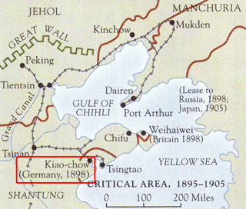

Document C

Su Kaiming, Modern China (1985)
In February 1923, Sun Yat-sen returned to Guangzhou where he immediately set up a headquarters of a new revolutionary government. Soviet Russia sent Michael Borodin (1884-1951) and some military advisers to help him, and a provisional central committee of the Kuomintang which included a number of Communists was organized.
The Chinese Communist Party held its Third National Congress in Guangzhou in June 1923, and the question of forming a revolutionary united front with the Kuomintang was discussed. The congress affirmed Sun Yat-sen's contribution to the Chinese revolution and resolved to help him in reorganizing the Kuomintang and establishing cooperation between the two parties.
The gap between Sun Yat-sen and the West continued to widen. When he threatened in December to seize the customs revenues in the port of Guangzhou, the powers staged a naval demonstration to preserve the status quo. Thwarted, Sun angrily stated, "We no longer look to the Western powers.
Our faces are turned toward Russia."
In January 1924, Sun Yat-sen called the First National Congress of the reorganized Kuomintang in Guangzhou. Among the Communists who attended were Li Dazhao, Mao Zedong and Qu Qiubai (Chu Chiu-pai, 1899-1935). The congress adopted the anti-imperialist, anti-feudal policy advanced by the Communists, agreed to absorb individual Communists and Socialist Youth League members into the Kuomintang, and decided to reorganize the Kuomintang into a revolutionary alliance of workers, peasants, the petty-bourgeoisie and national bourgeoisie. In this way, new blood was infused into the ranks of the Kuomintang and Sun Yat-sen became the leader of a revitalized revolutionary movement
Document D
Sun Yat-sen, letter to Joseph Stalin and the Soviet Communist Party (1925)
I leave behind me a party which, as has always been my wish, will be bound up with you in the historic work of the final liberation of China and other exploited nations from the imperialist order. By the will of fate, I must leave my work unfinished and hand it over to those who, remaining true to the principles and teachings of the party, will show themselves to be my true followers.
Taking leave of you, dear comrades, I want to express the hope that the day will come when the U.S.S.R. will welcome a friend and ally in a mighty, free China, and that in the great struggle for the liberation of the oppressed peoples of the world, both these allies will go forward to victory hand in hand.
Document E
Photos of Chinese peasantry
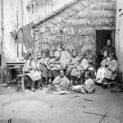
Peasants in Fujian province, China, photographed in the late 19th century

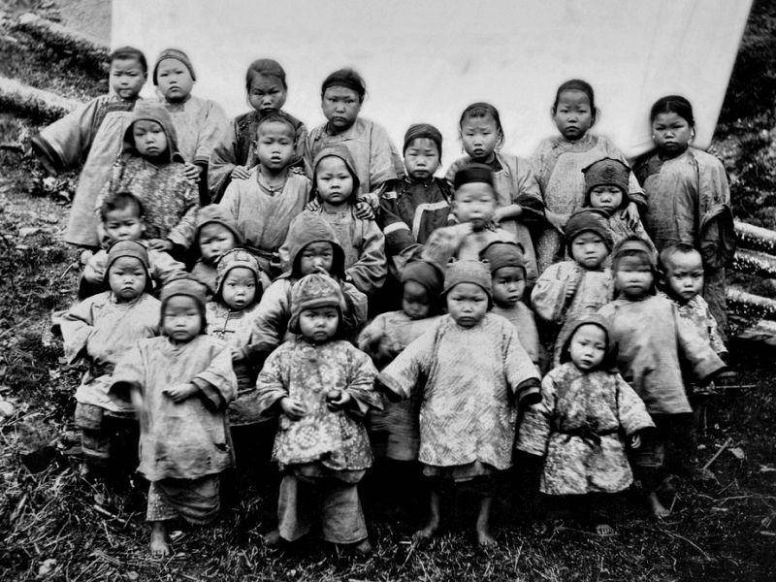

This is reportedly a group of very young children, both boys and girls, ready to be sold as slave in Fuzhou, China during 1904. These were presumably peasant children whose parents were forced to sell because of debts. The Imperial Government abolished slavery (1909), but the abolition law was not strictly enforced, in part because the Imperial regime was beginning to collapse.

