In the second year of the reign of Valens (366 CE)… the Roman world was shaken by a violent and destructive earthquake… The shores of the Mediterranean were left dry by the sudden retreat of the sea… but the tide soon returned with the weight of an immense flood which was severely felt on the coasts of Sicily… Greece, and of Egypt… fifty thousand persons has lost their lives in the flood [in the city of Alexandria alone]… this calamity… astonished and terrified the subjects of Rome… and their fearful vanity was disposed to [see a connection between] the s symptoms of a declining empire and a sinking world.

Document 1: Economic Decline of the Roman Empire. Source : Edward Gibbon, *The History of the Decline and Fall of the Roman Empire,* Strahan & Cadell, 1776-1788.: 1999, pp. 160-162.

DBQ Question 1:

What natural disaster struck the Roman Empire in 366 C,E, ?

[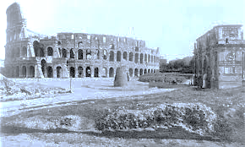](http://www.google.com/url?sa=i&rct=j&q=roman+economics+after+earthquake&source=images&cd=&cad=rja&docid=UNuTinW_1T9i0M&tbnid=tl2g56fM4GNQFM:&ved=0CAUQjRw&url=http://romanculture.org/tag/colosseum/page/3/&ei=EvP0UsPDC4jGqwHLi4HABw&bvm=bv.60799247,d.aWM&psig=AFQjCNHuS0-irqtY7BgM9h1dZonp4xMp1Q&ust=1391871091260643)

DBQ Question 2:

How did this natural disaster effect roman economics?

First the economic factor,,l, While the empire was expanding, its prosperity was fed by plundered wealth and by new markets in the semi-barbaric provinces,. When the empire ceased to expand, however, economic progress soon ceased…

The abundance of slaves led to the growth of the latifundia, the great estates that ,,. Came to dominate agriculture and ruin the free coloni (farmers) who drifted to the cities, to add to the unemployment there. The abundance of slaves likewise kept wages low.

Document 3: Economic Decline of the Roman Empire. Source **:** exerpt from the “Uses of the Past” by Herbert J. Muller

[](http://www.google.com/imgres?q=roman%20economics&safe=active&biw=1280&bih=897&tbm=isch&tbnid=3_AmXJ-Nw6OkgM:&imgrefurl=http://www.richeast.org/htwm/greeks/romans/slavery/slavery2.html&docid=x6yRqRMTstH2xM&imgurl=http://www.richeast.org/htwm/greeks/romans/slavery/farmers2.gif&w=550&h=430&ei=0PH0UpbUIIW4qAHNqoHIBQ&zoom=1&ved=0CHYQhBwwDA&iact=rc&dur=1429&page=1&start=0&ndsp=20)

DBQ Question 2:

How did Latifundias ruin free coloni, and what affect did that have on the Roman Economy?

DBQ Question 1:

What economic issues does muller identify as causes for the decline of the roman empire?

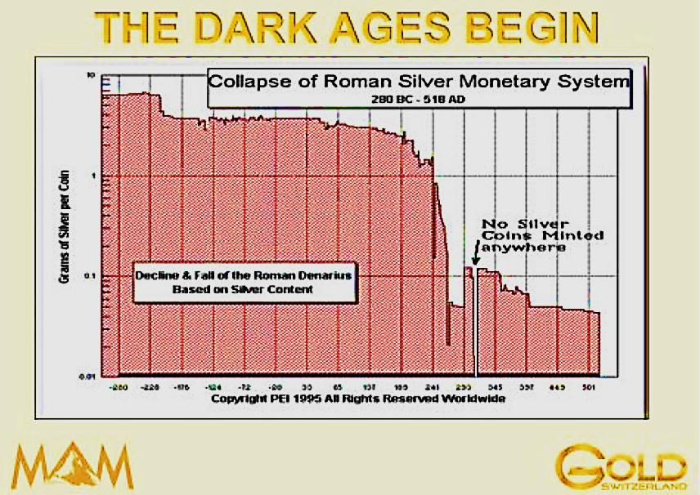

Document 4: Economic Decline of the Roman Empire. Source : PEI / Switzerland Gold 1995



DBQ Question 2:

Why was there such a sharp drop in the amount of coin minted around 250 BCE in the Roman Economy?

DBQ Question 1:

What economic issues does this chart identify as a cause for the decline of the roman empire?

DBQ Question 1:

What deadly illness arrived in the roman empire from southern Asia?

DBQ Question 2:

In what ways was disease at fault for the economic decline of the roman empire?

Document 2: Economic Decline of the Roman Empire. Source **:** Peter Stearns, Michael Adas, Stuwart Schwartz, Marc

Lason Gilbert, *World Civilizations: The Global Experience*, Pearson Education, 2000.