**Fascists and the Power of the State**

**Excerpt adapted from bbc.co.uk**

**“Benito Mussolini (1883-1945) was the founder of Fascism and leader of Italy from 1922 to 1943. In March 1919, Mussolini formed the Fascist Party, galvanizing the support of many unemployed war veterans. He organized them into armed squads known as Black Shirts, who terrorized their political opponents. In 1921, the Fascist Party was invited to join the coalition government.**

**By October 1922, Italy seemed to be slipping into political chaos. The Black Shirts marched on Rome and Mussolini presented himself as the only man capable of restoring order. King Victor Emmanuel invited Mussolini to form a government. He gradually dismantled the institutions of democratic government and in 1925 made himself dictator, taking the title 'Il Duce'. He set about attempting to re-establish Italy as a great European power. The regime was held together by strong state control and Mussolini's cult of personality.”**

[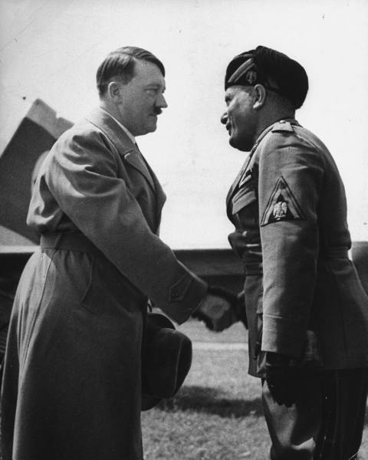](http://images.google.com/hosted/life/f?q=hitler+and+mussolini&prev=/images?q%3Dhitler%2Band%2Bmussolini%26hl%3Den%26safe%3Dactive%26um%3D1&imgurl=94d5897f88716eaf)

**Excerpt adapted from fordham.edu**

**“Benito Mussolini (1883-1945) over the course of his lifetime went from Socialism - he was editor of Avanti, a socialist newspaper - to the leadership of a new political movement called "fascism" [after "fasces", the symbol of bound sticks used as a totem of power in ancient Rome]…**

**“Fascism conceives of the State as an absolute, in comparison with which all individuals or groups are relative, only to be conceived of in their relation to the State…For Fascism, the growth of empire, that is to say the expansion of the nation, is an essential manifestation of vitality, and its opposite a sign of decadence …” ~Mussolini**

**Questions:**

**1: Who was Benito Mussolini?**

**2: How did Mussolini come to power?**

**3: What problems did many nations face after WWI (from previous lesson)?**

**4: What did Mussolini and the Black Shirts promise the Italian people?**

**5: According to Fascists, what is the role of the State?**

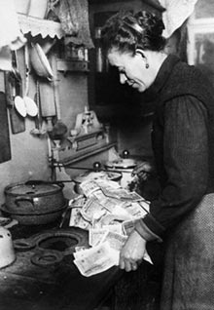

**Excerpt adapted from junobeach.org**

**“The economic depression that follows the 1929 stock market crash has a dramatic impact on European and American nations …Germany, humiliated by the** [**Treaty of Versailles**](http://www.junobeach.org/e/2/can-eve-eve-fas-ver-e.htm)**, stripped of its colonies and forced to compensate the allies for war damages, is also facing a major crisis. The economic situation results in a severe depression, which for many exemplifies the failure of capitalism. The National Socialist Party of German Workers (National-Sozialistische Deutsche Arbeiterpartei or NSDAP ) strikes an alliance with extreme-right industrialists to counter the rise of communism. The NSDAP, or Nazi Party, is ruled by a charismatic leader,** [**Adolph (Adolf) Hitler**](http://www.junobeach.org/e/3/can-pep-ger-hitler-e.htm)**, who inflames the crowds by promising a strong Germany, freed from the humiliation of the Treaty of Versailles and reconciled with its past military grandeur. Through propaganda, manipulation and terror, Hitler eliminates all forms of opposition and on January 30, 1933, is named Chancellor. The following year, after a bloody repression, he takes on the title of Fuehrer (Supreme Leader) of the Third Reich and seeks popular approval of the move through the August 19 referendum…**

**In 1935, Hitler proclaims the Nuremberg Racial Laws that deprive Jews of their civil rights and pave the way to their persecution. The brutality and intolerance of the Fascist and Nazi regimes are now blatant but their action still restricted to their national territories. Starting in 1935, both dictators will launch attacks beyond their borders and threaten the whole of Europe…”**

**German money being used for cooking fuel in 1924**

**"Demoralize the enemy from within by surprise, terror, sabotage, assassination. This is the war of the future."**

**-Adolf Hitler**

**Questions:**

**6: Why would any sane person burn money?**

**7: What problems faced Germans after WWI?**

**8: Who was Adolf Hitler and what did he promise the German people?**

**9: How did Adolf Hitler come to power?**

**10: What were the Nuremberg Laws?**

**11: How did Fascist dictators eventually affect countries beyond their borders?**

**12: Why did Fascism appeal to many people after WWI?**

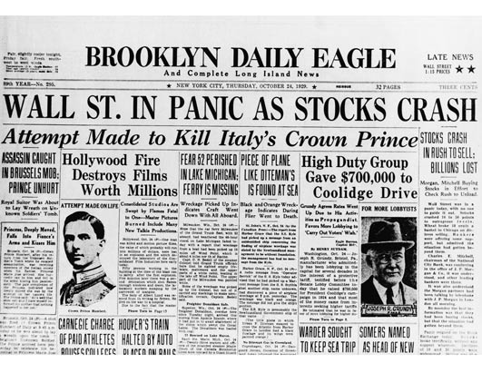

**Excerpt adapted from bbc.co.uk**

**“Causes of the Depression”**

**As early as 1926, there were signs that the boom was under threat:**

**13.…Collapse of land prices in Florida**

**14.… Too many goods being made and not enough people to buy them**

**15. Farmers had produced too much food in the 1920s, so prices…became…lower**

**16. There were too many small banks - these banks did not have enough funds to cope with the sudden rush to take out savings…**

**17. Too much speculation on the stock market - the middle class had a lot to lose and they had spent a lot on what amounted to pieces of paper.**

**The Wall Street Crash of October 1929 was a massive psychological blow…America had lent huge sums of money to European countries. When the stock market collapsed, they suddenly recalled those loans. This had a devastating impact on the European economy.**

**Excerpt adapted from bbc.co.uk**

**“When the Wall Street stock market crashed in October 1929, the world economy was plunged into the Great** [**Depression**](http://www.bbc.co.uk/schools/gcsebitesize/history/mwh/usa/walldepressionrev1.shtml)**. By the winter of 1932, America was in the depths of the greatest depression in its history.**

**The number of unemployed people reached upwards of 13 million. Many people lived in primitive conditions close to famine. One New York family moved into a cave in Central Park. In St Louis, more than 1,000 people lived in shacks made from scrap metal and boxes. There were many similar Hoovervilles all over America. Between 1 and 2 million people travelled the country desperately looking for work. Signs saying 'No Men Wanted' were displayed all over the country…”**

**Questions:**

**18: What were the causes of the Great Depression?**

**19: What were the effects of the Great Depression?**

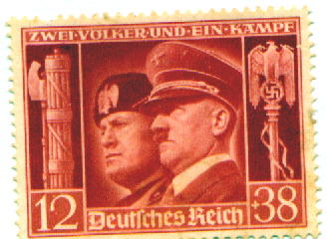

**Critical Thinking Question:**

**20. Could Fascism ever become a powerful force in world history again?**

**Excerpt adapted from wwnorton.com**

**“Against individualism, the Fascist conception is for the State; and it is for the individual in so far as he coincides with the State…It is opposed to classical Liberalism, which arose from the necessity of reacting against absolutism, and which brought its historical purpose to an end when the State was transformed into the conscience and will of the people.**

**Liberalism denied the State in the interests of the particular individual; Fascism reaffirms the State as the true reality of the individual. And if liberty is to be the attribute of the real man, and not of that abstract puppet envisaged by individualistic Liberalism, Fascism is for liberty. And for the only liberty which can be a real thing, the liberty of the State and of the individual within the State. Therefore, for the Fascist, everything is in the State, and nothing human or spiritual exists, much less has value, outside the State. In this sense Fascism is totalitarian, and the Fascist State, the synthesis and unity of all values, interprets, develops and gives strength to the whole life of the people.”**

**21: According to the passage, what concept does Fascism oppose?**

**22 According to the passage, what do Fascists believe is the true reality of the individual?**

**23: What concept matters most to Fascists, according to the passage?**

**24: How does Fascism differ from democracy?**

**25: Why would some people willingly give up their rights to the Fascist state?**

**26: What do you think happened to those individuals who did not willingly give up their rights in Fascist states?**

**27: What economic conditions increased the popularity of Fascists?**

**28: What can happen in a society where the State is all-powerful?**

**29: How did the Treaty of Versailles encourage the growth of Fascism?**