Technological – INCA

Social – INCA

Economic – INCA

Political – INCA

[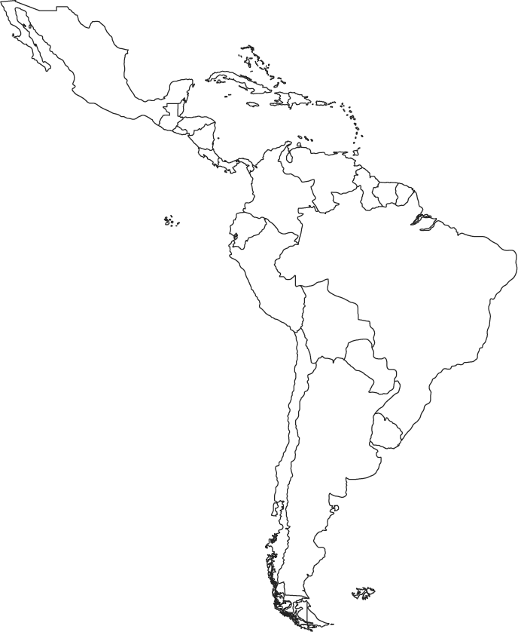](http://www.google.com/url?sa=i&rct=j&q=&esrc=s&frm=1&source=images&cd=&cad=rja&uact=8&ved=0CAcQjRw&url=http://www.calendariu.com/tag/blank-printable-paper-with-dark-lines&ei=0RuTVNi_F8TZggTjioSQDg&bvm=bv.82001339,d.cWc&psig=AFQjCNElB71xwS9SbrrHYhNxT8pI2EaP2A&ust=1419013456339734)

**Which achievement played an important role in pre-Columbian Mesoamerican civilizations?**

(1) use of gunpowder

(2) production of corn

(3) domestication of horses

(4) development of sugar plantations

**Q: Based on the statement above, what engineering technique was described by this sixteenth-century author?**

**Q: Why was this a significant achievement for the Inca?**

**__________________________________________________________________**

**__________________________________________________________________**

**__________________________________________________________________**

*As soon as the Incan ruler had conquered any kingdom and set up his government, he ordered that the farmland used to grow corn be extended. For this purpose, he ordered irrigation channels to be constructed. The engineers showed great cleverness and skill in supplying water for the crops, since only scattered sections of the land could grow corn. For this reason, they endeavored to increase its fertility as much as possible.* ***Garciasco de la Vega1539***

**Q: Based on the information in the Diagram to the right, how did the Incan government unite its empire in the Andes Mountains?**

**Q: What is the significance of this accomplishment?**

**______________________________________________________________________**

**______________________________________________________________________**

**______________________________________________________________________**

**INCA - Processing Questions**

**______________________________________________________________**

**INCA - Vocabulary (407- 411)**

Pachacuti

Mita

Ayllu

Quipu

Cuzco

**Shade Green**

**Inca Empire**

**1438 – 1532**

**Label**

**Cuzco**

**La Paz**

**Machu Picchu**

**Andes Mountains**

**INCA - Geographcy (Atlas 75)**