Technological – Mayan

Social – Mayan

Economic – Mayan

Political – Mayan

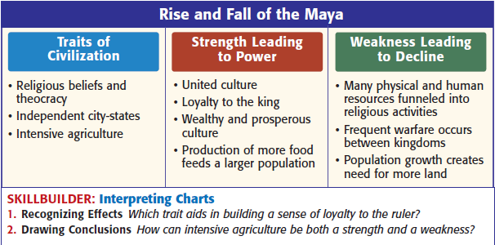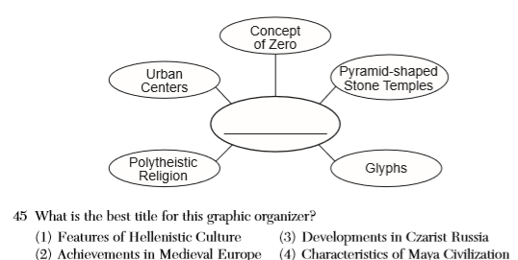

**Mayan - Vocabulary (395-399)**

Tikal

Glyph

Codez

Popol Vuh

Chichen Itza

**Shade Pink**

**Mayan Empire**

**250ce - 900ce**

**Label**

**Chichen Itza**

**Yucatan Peninsula**

**Tikal**

**Copan**

**Palenque**

**One way in which the ancient Sumerians, Egyptians, and Mayas are similar is that these civilizations developed**

(1) irrigation systems

(2) iron weapons

(3) wheeled vehicles

(4) block printing systems

____________________________________________________________________________________________________________________________________

**Maya- Processing Questions**

**Mayan - Geographcy (Atlas 71)**

