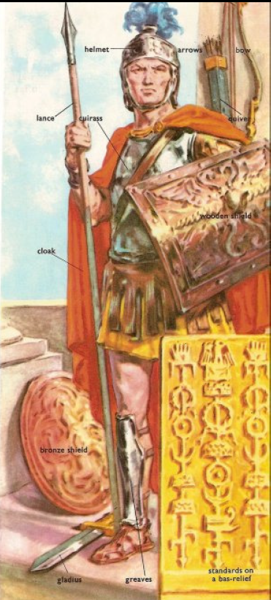

[Before the year 400 CE] foot soldiers wore breastplates and helmets. But when, because of negligence and laziness, parade ground drills were abandoned, the customary armor began to seem heavy since the soldiers rarely ever wore it. There-fore, they first asked the emperor to set aside the breastplates … and then the helmets. So our soldiers fought the Goths without any protection for chest and head and were often beaten by archers. Although there were many disasters, which led to the loss of great cities, no one tried to restore breastplates and helmets to the infantry. Thus it happens that the troops in battle, exposed to wounds because they have no armor, think about running and not about fighting.

Document 1: Military Causes Decline of the Roman Empire. Source : An excerpt from the ancient book *Concerning Military matters by the Roman historian Vegtius, c. 450 CE.*

DBQ Question 1:

How did the change in breastplates and helmets contribute to the decline of the Roman Empire??

DBQ Question 2:

According to Vegetius, what led to changes in the Roman military armor and training techniques??



Document 3: Military Causes Decline of the Roman Empire. Source **:** St. Jermone on Rome’s Decline

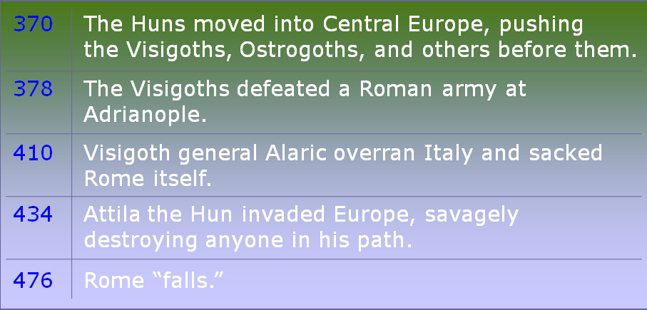

DBQ Question 1/2:

What became of Rome according

to the Source ? Do you agree or disagree with that Conclusion?

[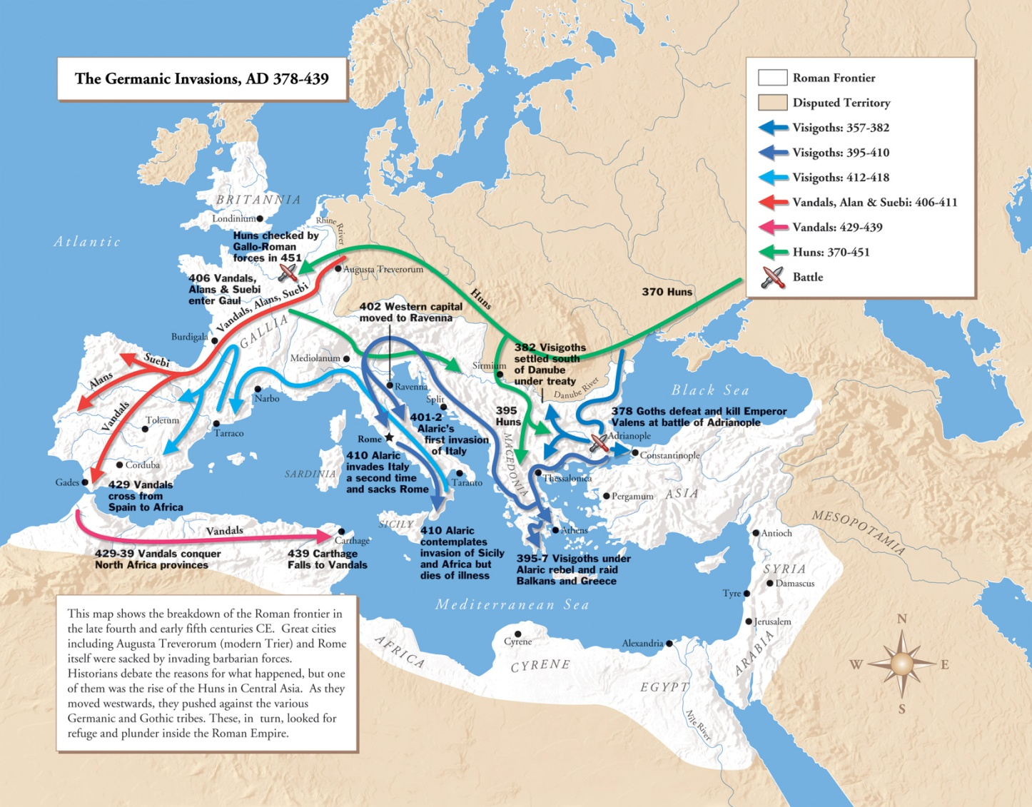](http://www.zonu.com/detail-en/2009-12-30-11527/The-Germanic-Invasions-of-the-Roman-Empire-378-439-AD.html)

Document 4: Military Causes Decline of the Roman Empire. Source : Edward Gibbon: General Observations on the Fall of the Roman Empire in the West

DBQ Question 1:

In what ways did the roman legions stop performing their duty?

The victorious legions, who, in distant wars, acquired the vices of strangers and mercenaries, first oppressed the freedom of the republic, and afterwards violated the majesty of the purple. The emperors, anxious for their personal safety and the public peace, were reduced to the base expedient of corrupting the discipline which rendered them alike formidable to their sovereign and to the enemy; the vigour of the military government was relaxed, and finally dissolved, by the partial institutions of Constantine; and the Roman world was overwhelmed by a deluge of Barbarians.

[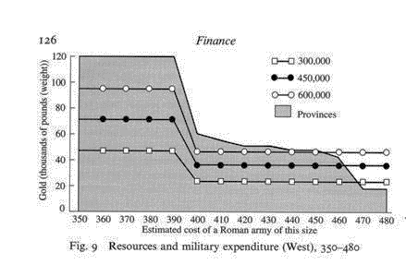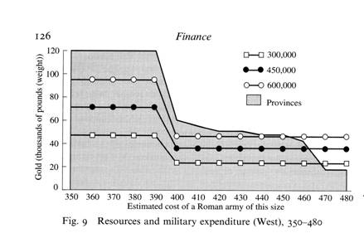](http://www.google.com/url?sa=i&rct=j&q=social+classes+roman+empire&source=images&cd=&cad=rja&docid=J9dEdfZ_UvvGJM&tbnid=sjDxc_sqXGrlAM:&ved=0CAUQjRw&url=http://usna.edu/Users/history/abels/hh381/late_roman_barbarian_militaries.htm&ei=5PT0UqPwJMONygHyz4HwCw&bvm=bv.60799247,d.aWM&psig=AFQjCNGQHQOyypzQAIQ4sP8NuE1THFN4Qg&ust=1391871409640569)

DBQ Question 1:

In what ways could the failure to enforce conscription weaken Rome??

DBQ Question 2:

What class of society, or types of people, were left to serve as roman soldiers?

There can be little doubt that the weakness of the late Roman army were largely due to the eventual failure … to enforce regular conscription [draft of soldiers] … The exempted categories were … numerous. Hosts of senators, bureaucrats, and clergymen were entitled to avoid the draft; and among other groups who escaped were cooks, bakers, and slaves.

Document 2: Military Causes Decline of the Roman Empire. Source **:** Michael Grant, *The Fall of the Roman Empire: A*

*Reappraisal*, Crown Publishing, 1982.