Name: ___________________________________ Date: ___________________

The Munich Conference

To: Cypress Ranch High School
From: Munich, Germany
Date: September, 1938

Dear Reader,

We need your help! We know that you are sitting across the pond (the Atlantic) unconcerned, but we need your assistance. Hitler has gone mad with these claims and actions that violate the Treaty of Versailles. Now he wants more land!

In 1919, millions of ethnic Germans were forced beyond the borders of Germany and into the new state of Czechoslovakia. Three million of the displaced Germans lived just over the border in the mostly German territory called the Sudetenland. Following his reacquisition of the Rhineland and the Anschluss (union) with Austria, Hitler has now turned his attention toward the Germans living in Czechoslovakia. He is demanding that it be given to Germany!

Its 1938 now and we are here at a conference in Munich, Germany with Mussolini, Hitler and the leaders of France and Britain. On the one hand Czechoslovakia is a new democracy and a new friend. However, would the British and French citizens be willing to go to war for Czechoslovakia? Can we defeat the Germans? Does Hitler have a valid argument for acquiring Czechoslovakia? Will he ever stop or will he want more? That is why we are reaching out to you for help. Please read the following enclosed, top-secret, documents and evidence to help us come up with an answer. What would you do if you were in our position based on the documents and evidence? We wish you the best of luck.

Cheers,
Neville Chamberlain, the British Prime Minister

(Document #1)
Below is the military aircraft production and defense spending in Britain, France, and Germany.

Defense spending (millions) Military Aircraft Production (thousands)
Year | Germany | France | Britain | Year | Germany | France | Britain
1936 | 2,332 | 995 | 892 | 1936 | 5112 | 890 | 1877
1937 | 3298 | 890 | 1245 | 1937 | 5603 | 743 | 2153
1938 | 7415 | 919 | 1863 | 1938 | 5235 | 1382 | 2827

Question:
- In 1938, which nation was best prepared for war? Why?

(Document #2)
Census Data for Czechoslovakia from 1921 and the German Population of Germany’s Neighbors

Ethnic Group | Population | Germany’s Neighbor | German Population
Czechs | 6.7 million | Belgium | 1.5 million
Sudeten Germans | 3.1 million | Czechoslovakia | 3.1 million
Slovaks | 2.0 million | Denmark | 2.5 million
Hungarians | 0.7 million | France | 3.5 million
Ruthenians | 0.5 million | Lithuania | 1.5 million
Jews | 0.3 million | Poland | 4.5 million
Poles | 0.1 million

Questions:
- Which of the following best describes the percentage of Germans living in Czechoslovakia in 1921?
- 44% German B) 23% German C) 77% German D) 55% German

2.) Is Czechoslovakia the only nation with a sizeable German population?

(Document #3)
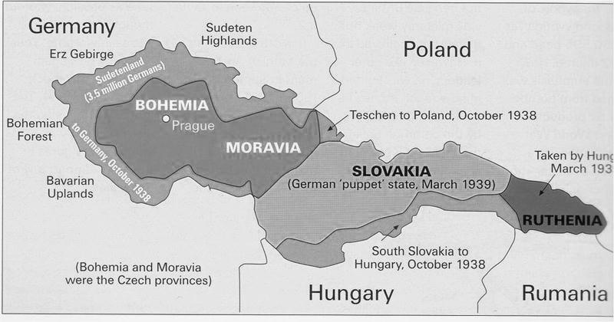
Ethnic map of the disputed territory (the Sudetenland)

(The lightly shaded areas on the map represent areas with a German majority)
Question:
- In which part of Czechoslovakia do the Sudeten Germans live?

(Document #4)
The following is a letter from German foreign minister Ribbentrop to the British Prime Minister requesting the Sudetenland.

Dear Minister Chamberlain:

“… As you know the people of the Sudetenland had only know German rule since the days of the Holy Roman Empire. It was the Treaty of Versailles that took these people beyond the comfortable touch of the rule of their own. Versailles was meant to punish the warmongering Germany of Bismark and the Kaisers of Germany that no longer exists. How does it help keep the peace of Europe to keep these Germans outside the borders of Germany while the rest of Eastern Europe enjoys self-determination. It is time for us to right the wrong of 1919 and return the Sudeten Germans to their rightful nation….” -German Prime Minister Ribbentrop

Questions:
- What is the wrong of 1919 that the author refers to?

2.) What two reasons does the author give for returning the Sudetenland to Germany?

Now that you have seen the documents and assessed them, please help us make a decision. If you were here at the Munich Conference in 1938 how would you handle the Czechoslovak Crisis and Adolf Hitler? (Provide you answer in 8-10 sentences)
____________________________________________________________________________________________________________________________________________________________________________________________________________________________________________________________________________________________________________________________________________________________________________________________________________________________________________________________________________________________________________________________________________________________________________________________________________________________________________________________________________________________________________________________________________________________________________________________________________________________________

