Document 1: Political Causes Decline of the Roman Empire. Source : *World History: Patterns of Interaction.* McDougal-Littell: 1999, pp. 158-160.



Diocletian believed that the empire had grown too large and too complex for one ruler. In his most significant reform, he divided the empire into the Greek-speaking East (Greece, Anatolia, Syria, and Egypt) and the Latin-speaking West (Italy, Gaul, Britannia, and Spain). He took the eastern half for himself and appointed a co-ruler for the West, General Maximian. Each emperor also selected an assistant, who was to be his successor. While Diocletian shared

authority, he kept overall control. His half of the empire, the East, included most of the empire's great cities and trade centers and was far wealthier than the West.

DBQ Question 1:

How did the Emperor Diocletian attempt to reform Rome?

Constantine Moves the Capital:

Constantine gained control of the western part of the empire in 312 C.E. and continued many of the social and economic policies of Diocletian, In 324 C.E., Constantine also secured control of the East, thus restoring the concept of a single ruler.

In 330 C.E., Constantine took a step that would have great consequence for the empire. He moved the capital from Rome to the Greek city of Byzantium (bih-ZAN-shee-uhm), in what is now Turkey. The new capital stood on the Bosporus Strait, strategically located for trade and defense purposes on a crossroads between West and East.

With Byzantium as its capital, the center of power in the empire shifted from Rome to the East. Soon the new capital was protected by massive walls and filled with imperial buildings modeled after those in Rome. The city was given a new name—Constantinople (KAHN-stan-tuhn-OH-puhl), city of Constantine. After Constantine’s death, the empire would again be divided. The East would survive; the West would fall.

Document 3: Political Causes Decline of the Roman Empire. Source **:**  *World History: Patterns of Interaction.* McDougal-Littell: 1999, pp. 158-160.

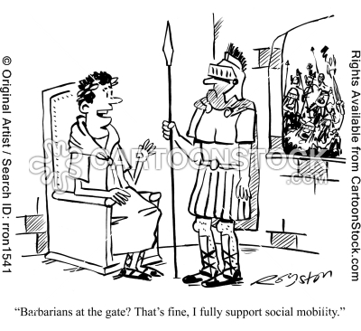

DBQ Question 1/2:

What attraction did the city of Byzantium have over Rome by the early 4c?

Why was the word Caesar synonymous with roman emperors?

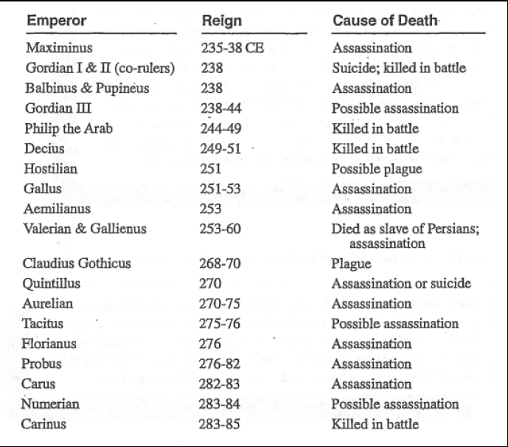

Document 2: Political Causes Decline of the Roman Empire. Source : Chart compiled from various sources, Roman Emperors, 235-285 CE.

DBQ Question 3

How many Roman emperors ruled during the 50 year period covered by this chart?

DBQ Question 2:

According to the document why would emperors be targeted for assassination or possible assassination?

**Causes for the Fall of the Roman Empire - Antagonism between the Senate and the Emperor**  
One of the main causes for the Fall of the Roman Empire was the Antagonism between the Senate and the Emperor. The Roman Emperor had the legal power to rule Rome’s religious, civil and military affairs with the Senate acting as an advisory body. The emperor had power over life and death. The powerful, spoilt, wealthy Roman Emperors inevitably became corrupt and many lived a debauched, deluded and immoral lifestyle. The Roman Empire saw many examples of antagonism between the Senators and the Emperors. Either the Senators didn't like the Emperor or the Emperors was at odds with the Senators.

DBQ Question 1:

What message might these frequent and violent changes in leadership might have sent to the people of the Roman Empire?

Rome’s first two centuries as an empire were years of relative stability, increasing power, and great imperial wealth. It was a time known as the Pax Romana, the time of Roman peace. Rome was clearly top dog in the western world. But as Rome was to discover, size has its problem. The empire acquired new subjects who were not Roman and who often did not want to be Roman-in Gaul, in England, beyond the Danube River, in the Middle East. Controlling this expanded empire meant a larger army, which in turn meant a need for more food, clothing, weapons and supplies. Political strains developed at home. Leaders in Rome focused less on debate and compromise and more on force to get their way. Having existed for centuries as a republic, Rome eventually became a dictatorship.

As Rome drifted through the 3rd century, survived the 4th century, and staggered into the 5th century, one general problem was apparent-life at the top was getting soft. Upper class Romans were losing their edge. When a country is on the make, when energy and hope are high, leaders and their people are more willing to work hard and to sacrifice. When the goal appears to have been reached, it is easy to get lazy. The evidence for this was a love of luxury, a decline in literature, even a decision by upper class Romans to have fewer children because child-raising was a bother.

But there was more to Rome’s decline than developing a soft belly. By the 5th century CE, when the city was sacked by outside invaders, Rome had been badly weakened by a number of problems. Parts of the empire would survive, particularly Constantinople and the East, but the old heart of the empire-Italy and the West-was shattered.

DBQ Question 2:

How did the attitude and motivation of the people, particularly the upper class, change?

DBQ Question 1:

How had government and leadership changed between the first two centuries of Rome and the last two centuries?

Document 4: Political Causes Decline of the Roman Empire. Source **:** Excerpt from the passage “What Were the Primary Reasons

for the Fall of Rome?” The DBQ Project, 2011.