[](http://www.google.com/url?sa=i&rct=j&q=&esrc=s&frm=1&source=images&cd=&cad=rja&uact=8&ved=0CAcQjRw&url=http://www.learnnc.org/lp/editions/ww1posters/4964&ei=1Z8MVYr2MM6NyATWh4HoBg&bvm=bv.89060397,d.aWw&psig=AFQjCNHtMJuJabed82oETEMZ6jBV90ZBKQ&ust=1426977107219349)

[](http://www.google.com/url?sa=i&rct=j&q=&esrc=s&frm=1&source=images&cd=&cad=rja&uact=8&ved=0CAcQjRw&url=http://www.twcenter.net/forums/showthread.php?478839-WWI-Propaganda-Posters&ei=36IMVf3oNISqyQTG5oKICg&bvm=bv.89060397,d.aWw&psig=AFQjCNHtMJuJabed82oETEMZ6jBV90ZBKQ&ust=1426977107219349)

[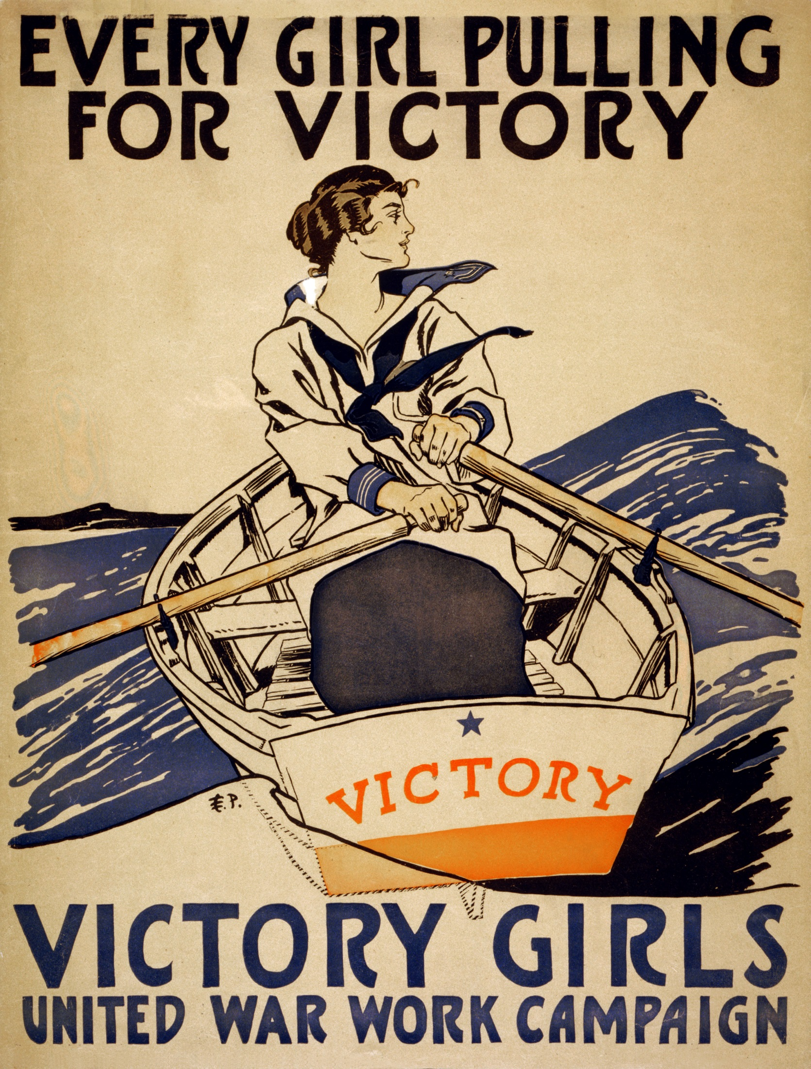](http://www.google.com/url?sa=i&rct=j&q=&esrc=s&frm=1&source=images&cd=&cad=rja&uact=8&ved=0CAcQjRw&url=http://commons.wikimedia.org/wiki/File:Every_girl_pulling_for_victory,_WWI_poster,_1918.jpg&ei=AqMMVY3AIMGBygSDl4D4Aw&bvm=bv.89060397,d.aWw&psig=AFQjCNHtMJuJabed82oETEMZ6jBV90ZBKQ&ust=1426977107219349)

[](http://www.google.com/url?sa=i&rct=j&q=&esrc=s&frm=1&source=images&cd=&cad=rja&uact=8&ved=0CAcQjRw&url=http://www.learnnc.org/lp/editions/ww1posters&ei=TaMMVaLkKMenyAT2-IGQAQ&bvm=bv.89060397,d.aWw&psig=AFQjCNHtMJuJabed82oETEMZ6jBV90ZBKQ&ust=1426977107219349)

1. [](http://www.google.com/url?sa=i&rct=j&q=&esrc=s&frm=1&source=images&cd=&cad=rja&uact=8&ved=0CAcQjRw&url=http://www.ww1propaganda.com/world-war-1-posters/irish-ww1-propaganda-posters&ei=hqMMVYKLE4ubyASwxoLIBQ&bvm=bv.89060397,d.aWw&psig=AFQjCNHtMJuJabed82oETEMZ6jBV90ZBKQ&ust=1426977107219349)

[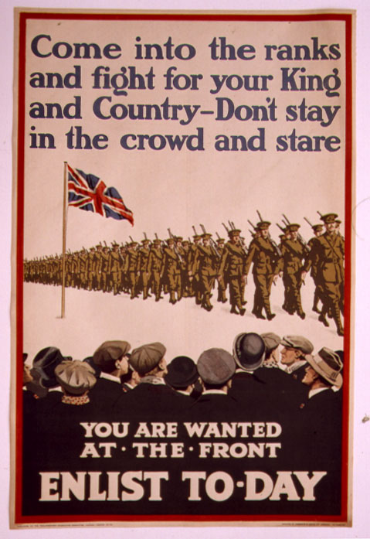](http://www.google.com/url?sa=i&rct=j&q=&esrc=s&frm=1&source=images&cd=&cad=rja&uact=8&ved=0CAcQjRw&url=http://pixshark.com/propaganda-posters-ww1.htm&ei=q6MMVfqeEIOqyQTOxYCQBg&bvm=bv.89060397,d.aWw&psig=AFQjCNGNHqNc7VPk6zLVepcWDHeXMsD9LQ&ust=1426978087766055)

[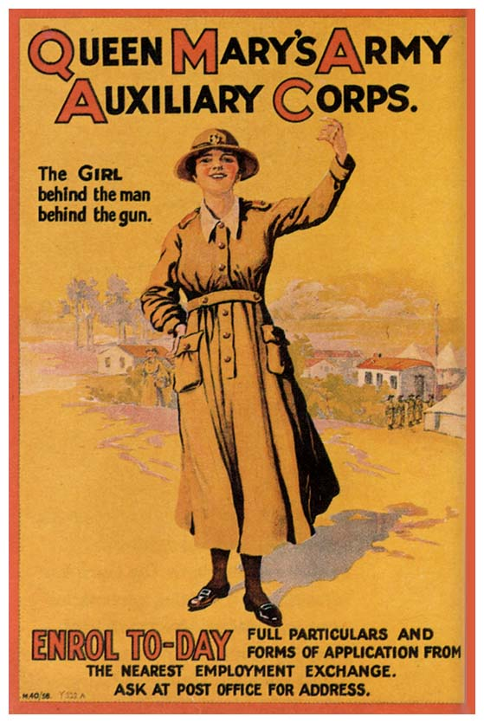](http://www.google.com/url?sa=i&rct=j&q=&esrc=s&frm=1&source=images&cd=&cad=rja&uact=8&ved=0CAcQjRw&url=http://cdn.preterhuman.net/texts/politics/propaganda/british_posters/&ei=36MMVfisG9ieyAS4_YHYAw&bvm=bv.89060397,d.aWw&psig=AFQjCNHtMJuJabed82oETEMZ6jBV90ZBKQ&ust=1426977107219349)

[](http://www.google.com/url?sa=i&rct=j&q=&esrc=s&frm=1&source=images&cd=&cad=rja&uact=8&ved=0CAcQjRw&url=http://www.authentichistory.com/1914-1920/2-homefront/1-propaganda/&ei=KaQMVZ6uCcGKyATJx4KYDQ&bvm=bv.89060397,d.aWw&psig=AFQjCNG70fUanE-baewvCFEAKAmKm4dLYw&ust=1426978202098891)

[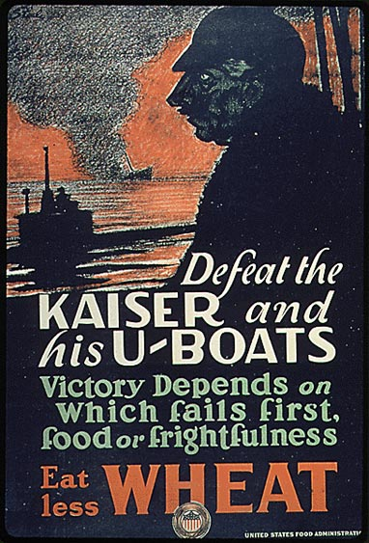](http://www.google.com/url?sa=i&rct=j&q=&esrc=s&frm=1&source=images&cd=&cad=rja&uact=8&ved=0CAcQjRw&url=http://tsaamericahistory.wikispaces.com/American%2BPosters%2Bof%2BWorld%2BWar%2BI&ei=TaQMVYajDMGmyATRvILQCQ&bvm=bv.89060397,d.aWw&psig=AFQjCNG70fUanE-baewvCFEAKAmKm4dLYw&ust=1426978202098891)

[](https://www.google.com/url?sa=i&rct=j&q=&esrc=s&frm=1&source=images&cd=&cad=rja&uact=8&ved=0CAcQjRw&url=https://www.pinterest.com/source/ww1propaganda.com/&ei=eqQMVarlE8qsyAS08oHYCw&bvm=bv.89060397,d.aWw&psig=AFQjCNG70fUanE-baewvCFEAKAmKm4dLYw&ust=1426978202098891)

[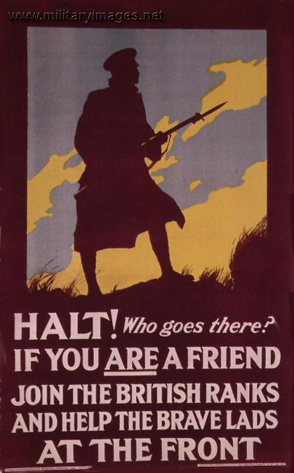](http://pixgood.com/propaganda-ww1-britain.html)