RENAISSANCE & REFORMATION GUIDED NOTES

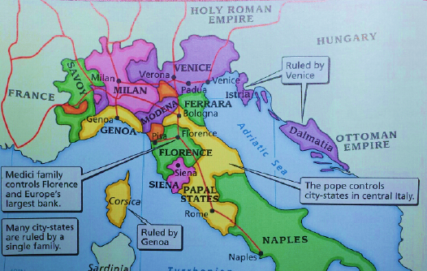
What were the leading causes for the beginning of the Renaissance?
- After the devastation of the _________ ___________ Western European Society changed.
- In _______________ce- people began to look to the past to the Glories of earlier classical civilizations
- Renaissance thinkers believed
  - People of the Middle Ages were ________________
  - The “ ______________ of ________________” which had gone out during the Dark Ages needed to be rediscovered.

When & Where and Why did the Renaissance?

- The Renaissance began around ______ in ________________ - _______________ in northern Italy.
- The renaissance began in Italy because of it’s location
  - Italian city-states grew _________ from ____________ between __________ and _________________.
  - Artists could find wealthy patrons to ______________________ and _______________ their work.

What did Renaissance Art Look Like?

- ____________________ artists rendering the world in three dimensions
- ____________________ reflected reality rather than idealistic views

Who were Renaissance Artists?

- _________________________ Italian Painter, Sculptor, architect and poet – Painted the ceiling of the Sistine chapel.
- _________________________ ideal Renaissance Man – Painter, Sculptor, designer, inventor

What were the challenges and changes created during the Renaissance?

- Renaissance thinkers wanted to learn new things, ______________________ new information and began to questions old _____________________________.

- ____________________________ non- religions view point – Secularists look to _______________ ____________ for answers as opposed to religion.
- ________________________ belief that human actions, ideas and works are important

What Happened When the Renaissance Movement Spread to England from Italy?
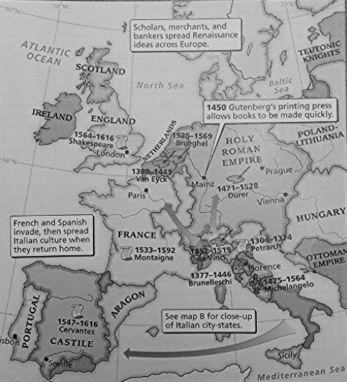
- ________________________ artists and writers migrated to Northern Europe.
- ____________________ _______________ 1550’s Renaissance ideas reached England and Queen Elizabeth supported the development of English art and literature.

Who were Renaissance Men?

- __________ _____________ emerged as the greatest playwright of all time and displayed a deep understanding of _____________ _____________________
                - _________________ wrote “The Prince” which encouraged rulers to do anything to keep power. “ the _______ justify the ________”
- ___________________ was a great scientist who challenged the authority of the _____________ _____________ by finding answers in science.

What happened as a result of the demand for Renaissance Knowledge?
- ____________________ __________________ developed the printing press in 1440.
  - The printing press made books _____________ _____________ and ______________ enough for people to afford.

The Reformation Guided Notes
What was the Reformation?

- Movement for _________ ___________ started by Martin Luther a catholic monk and his ________ Theses

  - Formal statements ___________ church ____________________
  - Challenged the selling of __________ or selling of pardons to buy ones way into heaven

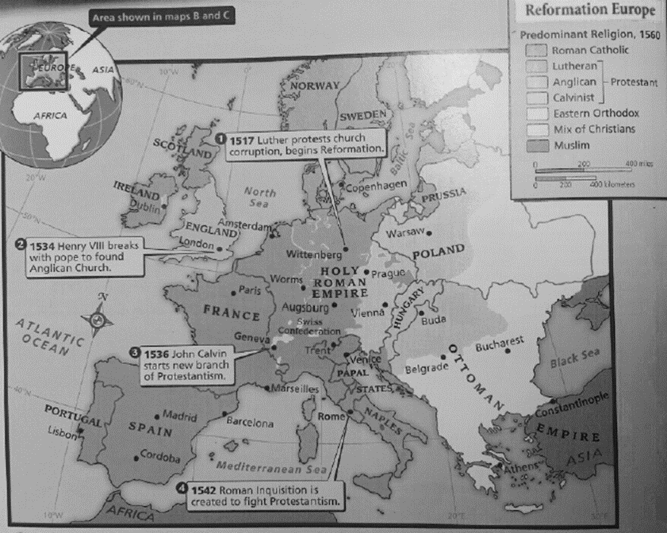
What were Martin Luther’s Ideas?
- Only through personal ____________ could a person be saved.
- All church teachings should be based solely on the bible; ____________ & ___________ traditions were false authorities.
- All people with faith were _______________ and did not need priests to ____________________ the bible for them.

Other problems with the church

  - _________________________ art, pleasures, wars
  - __________________ (illiterate) Marrying, Gambling, Drinking

How did Reformation ideas spread?

- Focus on individual, not ____________.
- Secularism – focus on _______________ ____________ instead of spiritual
- ______________ ______________ helped spread ideas because it was faster, cheaper to spread ideas.

How did the Church react to Luther’s 95 Thesis?

- Edict of Worms
  - Declared Luther a _______________ & __________________
  - All his books were burned
  - No one was to feed or provide ________________ for him
  - Luther was ____________________ by the Pope.

How did Lutheranism and Protestantism originate in Europe?

- Luther returned to ______________ a year later to witness the __________ of many of his ideals.
  - No longer __________ ________ now separate religion called “____________”
- _________ German princes who remained loyal to the Pope agree to rise up against __________________.
- Princes who supported Luther signed an agreement ___________________ the uprising ; became known as “___________________”

What was the peace of Augsburg?

- Holy ______________ ____________ Charles V won against Protestant princes but couldn’t force them back into _______________ ___________.
- Met in _________________ to end war over religion in ________________ in 1555
  - Agreed that each ____________ would choose the religions for their respective states
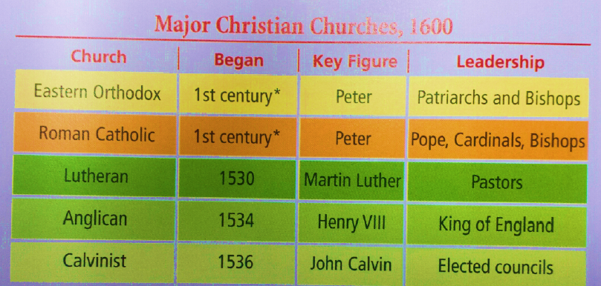
What were the impacts of changes within Protestantism?
- __________________ is used to refer to Christians that belong to non-Catholic Churches
- As people interpreted the bible for themselves, new _______________ groups formed over _____________ in beliefs.
What were the impacts of the Reformation in England?

- ___________________________, King of England was a devout Catholic
- ______________________________, but had a daughter named Mary with wife Catherine of Aragon.
  - _________________________, but the __________________ ___________, as not to offend Catherine’s nephew Charles V ( Holy Roman Emperor)
- Henry called “____________________ _________________” into session ending the Pope’s power in England.
  - Parliament legalized his divorce and he married Anne Boleyn.
- ______________ of _________________ made the king of England the official head of the church not the Pope.
  - Henry closed all ____________; seized wealth & lands, increasing the royal __________ & _______________
  - Beheaded Anne Boleyn and married 4 more times
  - Third wife produced son ___________________

How did Henry’s heir rule after him?

- ________________ rule for 6 years & ___________________ gained power
- __________________ restored _______________ to England, returned Then rule of the church to the Pope and killed ______________ became known as _____________ _______________
- Mary restored Catholicism to England.
- __________________ ruled next and restored _______________________

What was life like during the Elizabethian Age?

- Set up ____________________ church, like her father.
  - People required to __________ or pay a fine.
- ______________________declares Elizabeth head of the Church of England the ______________ _______________
  - State church for moderate ______________ and moderate ________________ to attend.
  - Protestant __________ could marry
  - _________________ kept golden crucifixes and rich robes
  - Revised book of ________________ _______________

What were the origins of Calvinism?

- John Calvin gave order to the _________ Luther had begun.
  - Published _________________ of the __________ __________ expressing beliefs about God, salvation & human nature.
- Calvinism – Humans sinful by _________
  - Cannot earn ______________.
  - God has selected those saved already “ ____________”
- __________________________ God has known since the beginning of time who will be saved.
- Calvinism Spread – became the official religion of _____________.
  - Churches governed by a few elders or “ ________________” leading to _________________
  - In France followers were called ______________________.

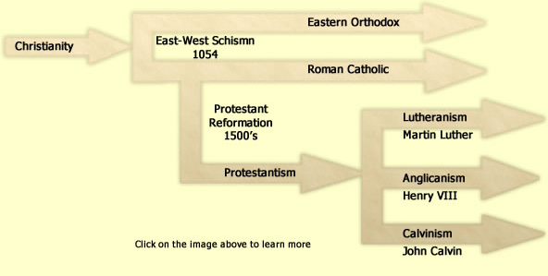

What did the Catholic Church decided to do as a result of the Protestant Reformation?

- Catholic Reformation – church had lost members and land, but attempted to stop the Protestant Reformation.
- _______________ of ________________ wrote the _________ _____________ which became the basis for the Society of Jesus referred to as the _____________.
  - Pope had decided that they would be their own religious order.
- 3 Activities of the Jesuits
  - ________________ superb schools throughout Europe
  - ________________ non- Christians to Catholicism by sending out ____________________.
  - Stopped ______________________ from spreading in Poland and Southern Germany.
- Council of Trent – Catholic Reform
  - Church’s ____________________ of the Bible was final.
  - Faith and good works were needed for _________________; not saved by faith alone.
  - Bible & Church traditions were _____________ ________________ authorities for guiding Christian life.
  - __________________ were valid expressions of faith.
- Inquisition – Catholic Reform
  - Court set up to punish __________________ or those who went against the Catholic Church.
  - People were afraid of the being tortured if found guilty of heresy during the Inquisition and were careful about what they read and thought.

What were the effects of the Reformation?
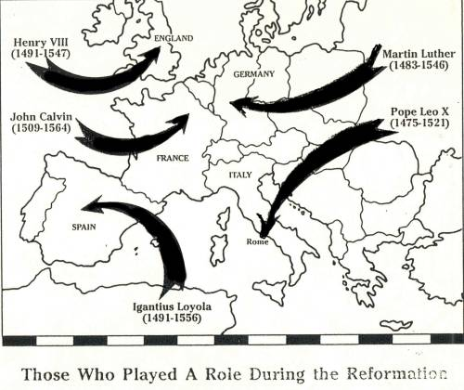
- Protestant churches ________________; despite wars and __________________.
- Religion no longer _____________________ _______________
- As the Church’s power_________________, monarchs & states gained power paving the way for modern ________________-__________________
- Reformers successful revolt against Church authority laid the groundwork for a __________________ of ____________________ _____________that occurred in Western culture in later centuries.

