Document 1: Social Causes Decline of the Roman Empire. Source : Excerpt from the passage “What Were the Primary Reasons for the Fall of Rome?” The DBQ Project, 2011.

DBQ Question 1:

According to the source what replaced Ethics and Values?

**Causes for the Fall of the Roman Empire - Decline in Ethics and Values 3 Century.**One of the main causes for the Fall of the Roman Empire was the Decline in Ethics and Values. Life became cheap - blood shed led to more blood shed and extreme cruelty. The values, the ideals, customs, traditions and institutions, of the Romans declined. The basic principles, standards and judgments about what was valuable or important in life declined. The total disregard for human and animal life resulted in a lack of ethics - a perverted view of what was right and wrong, good and bad, desirable and undesirable. Any conformity to acceptable rules or standards of human behavior were being lost.

[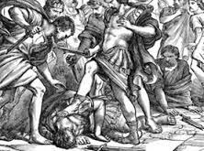](http://www.google.com/imgres?q=crime%20in%20ancient%20roman%20empire&safe=active&biw=1280&bih=897&tbm=isch&tbnid=5nuPL2Hss7G6CM:&imgrefurl=http://selcoodurchdis1980.blogdetik.com/free-download-crime-and-punishment-in-ancient-rome/&docid=nLuRHs7icYizzM&imgurl=http://www.friendsofantiquity.org.au/images/event/81/81-1-large.jpg&w=278&h=207&ei=GlH5UrLqD4z_yQHhjYG4Aw&zoom=1&ved=0CJwBEIQcMBY&iact=rc&dur=3236&page=2&start=20&ndsp=26)

DBQ Question 2:

What were some of the causes of the weakening of the Roman Empire in the 3c C.E.?

Document 3: Social Causes Decline of the Roman Empire. Source : Textbook, The Course of Civilization by Trayer, Gatzke, Harbison ( Harcour, brace and World, Inc., 1961)

The basic trouble was the very few inhabitants of the empire believed that the old civilization was worth saving… the overwhelming majority of the population had been systematically excluded form political responsibilities. They could not organize to protect themselves; they could not serve in the army… Their economic plight was hopeless. Most of them were serfs bound to the soil, the small urban groups saw their cities slipping into uninterrupted decline.

DBQ Question 1:

What were basic problems facing the citizens of the Western Roman Empire according to these authors?

The basic trouble.e

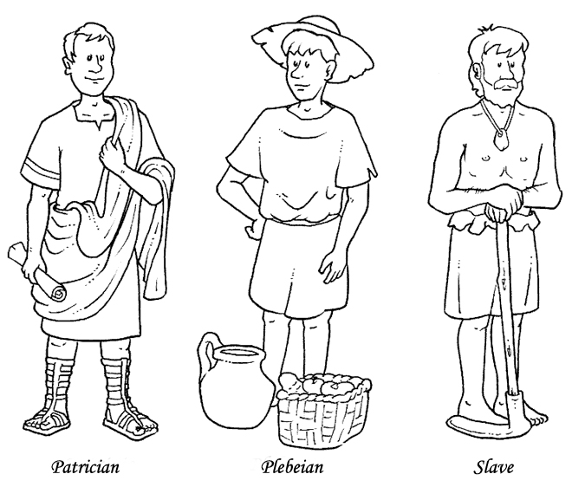

Document 4: Social Causes Decline of the Roman Empire. Source : Edward Gibbon, *The Decline and Fall of the Roman Empire.* B. Bury, ed.) London. Methuen, 1898, IV, 161-63; VII, 308.

DBQ Question 2:

Why was loyalty to Rome and the pride of its citizens in the Empire declining by the 3century?

DBQ Question 1:

Why does the historian Edward Gibbon feel that Christianity was to blame for the decline of the Roman Empire?

|  |
| --- |
| As the happiness of a *future* life is the great object of religion, we may hear without surprise or scandal that the introduction, or at least the abuse, of Christianity, had some influence on the decline and fall of the Roman empire. The clergy successfully preached the doctrines of patience and pusillanimity [faint-heartedness]; the active virtues of society were discouraged; and the last remains of military spirit were buried in the cloister; a large portion of public and private wealth was consecrated to the demands of charity and devotion; and the soldiers' pay was lavished on the useless multitudes of both sexes who could only plead the merits of abstinence and chastity [monks and nuns] ... the Church, and even the State, were distracted by religious factions, whose conflicts were sometimes bloody and always implacable [unforgiving]; . . . the Roman world was oppressed by a new species of tyranny; and the persecuted sects became the secret enemies of their country  . . The sacred indolence [laziness] of the monks was devoutly embraced by a servile and effeminate age . . . the decline of the Roman empire was hastened by the conversion of Constantine to Christianity. |

**Causes for the Fall of the Roman Empire - Christianity**One of the main causes for the Fall of the Roman Empire was Christianity. Life and the future seemed hopeless for the millions of people who were ruled by Rome where an early death was almost inevitable. Christianity taught the belief in an afterlife which gave hope and courage to the desperate. Eventually the Roman Emperor, [Constantine the Great](http://www.tribunesandtriumphs.org/roman-emperors/constantine.htm), proclaimed himself a Christian and issued an edict promising the Christians his favor and protection. Attitudes in the Roman Empire changed from being antagonistic to becoming pacifistic.

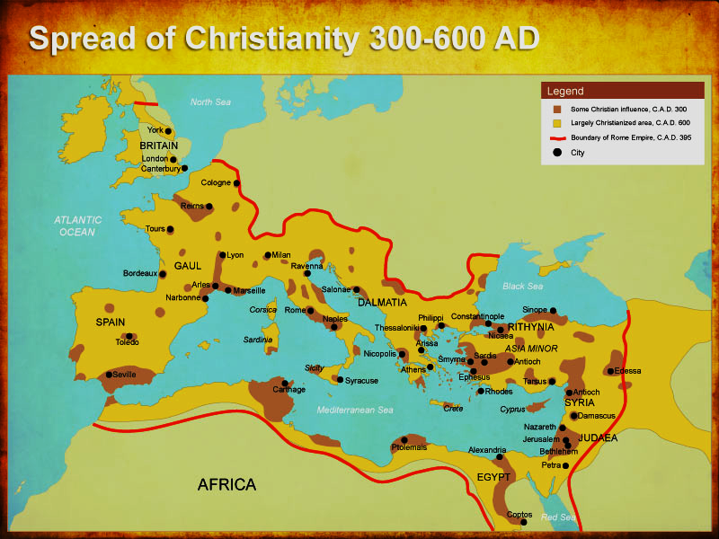

DBQ Question 1:

How would you compare Rostovtzeff’s arguments to those of Gibbon in explaining the reasons for the fall of the Roman Empire?

Every reader of a volume devoted to the Roman Empire will expect the author to express his opinion on what is generally, since Gibbon, called the decline and fall of the Roman Empire. . . In the sphere of politics we witness a gradual barbarization of the Empire from within, especially in the West. The foreign, German, elements play the leading part both in the government and in the army, and settling in masses, displace the Roman population . . . the ruling classes were replaced.. by Germans.

The cities ... gradually decayed, and the majority of them practically disappeared from the face of the earth. Only small islands of civilized life are left, . . . but . . . are gradually swallowed up by the advancing tide of barbarism. Another aspect . . . is the development of a new mentality among the masses of the population. It was the mentality of the lower classes, based exclusively on religion (Christianity) and not only indifferent but hostile to the intellectual achievements of the higher classes.

DBQ Question 2:

How does Rostovtzeff explain the fall of the Western Roman Empire as a process of decay?

Document 2: Social Causes Decline of the Roman Empire. Source **:** Michael Rostovtzeff, *The Social and Economic History of the*

*Roman Empire.* Of the Clarendon Press, Oxford.1957, 1, 532-34, 541.