Primary Sources DBQ: The Fall of the Han and Roman Empires
CLASS SET

Document 1:
“It was the height of political wisdom for the emperor not to neglect even actors and the other performers of the stage, the circus, and the arena, since he knew that the Roman people is held fast by two things above all, the grain supply and the shows, that the success of the government depends on amusements as much as on serious things. Neglect of serious matters entails the greater detriment, of amusements the greater unpopularity. The money largesses are less eagerly desired than the shows, the largesses appease only the grain-doled plebes singly and individually, while the shows keep the whole population happy.”

- Fronto, “Breads and Circuses”

- How did the grain doles help keep order?
- Why was it important for emperors not to neglect actors? Why was this more important than the grain doles?
- Why were circuses/shows important in the Roman Empire?

Document 2:

4. What do you think was happening to the economy of the empire as people stopped using the official money?
“Whereas the public officials have assembled and have accused the bankers of the exchange banks of having closed them because of their unwillingness to accept the divine coin of the emperors, it has become necessary to issue an order to all owners of the banks to open them and to accept and exchange all coin except the absolutely spurious [false] and counterfeit – and not alone to them but to those who engage in business transactions of any kind.”
- “Distrust of Imperial Coinage,”
Oxyrhynchus Papyrus, no. 1411,Vol. 2,
A.S. Hunt, trans.

Document 3:
Didius Julianus…when he heard of the death of Emperor Pertinax, hastily made his way to the (Praetorian) camp and, standing at the gates of the enclosure, made bids to the soldiers for the rule over the Romans…For, just as if it had been in some market or auction room, both the city and its entire Empire were auctioned off. The sellers were the ones who had slain their emperor and the would-be buyers were Sulpicianus and Julianus, who vied to outbid each other….They gradually raised their bids up to 20,000 sesterces per soldier. Some of the soldiers would carry word to Julianus, “Sulpicanus offers so much; how much more do you bid?” And to Sulpicianus in turn, “Julianus promises so much; how much do you raise him?” Sulpicianus would have won the day….had not Julianus raised his bid no longer by a small amount but by 5,000 at one time….So the soldiers, captivated by this extravagant bid…received Julianus inside and declared him emperor.”

- Dio Cassius, “Empire for Sale”
Born circa 173 CE

“

- How did Julianus become emperor?
- What does this process of choosing an emperor say about the loyalty and power of the soldiers?

Document 4:

“Book I, Chap. 33

Oh infatuated men, what is this blindness, or rather madness, which possesses you?... Depraved by good fortune, and not chastened by adversity, what you desire in the restoration of a peaceful and secure state, is not the tranquility of the commonwealth, but the impunity of your own vicious luxury. Scipio wished you to be hard pressed by an enemy, that you might not abandon yourselves to luxurious manners; but so abandoned are you, that not even when crushed by the enemy is your luxury repressed. You have missed the profit of your calamity; you have been made most wretched, and have remained most profligate.

Book I, Chap. 34
And that you are yet alive is due to God, who spares you that you may be admonished to repent and reform your lives. It is He who has permitted you, ungrateful as you are, to escape the sword of the enemy, by calling yourselves His servants, or by finding asylum in the sacred places of the martyrs....”
- St Augustine, “City of God”, 426 CE

- According to St. Augustine, why do the people want the restoration of a peaceful, secure state?
- According to Book I, Chap. 33, what is the biggest concern of the people, bigger than being defeated by an enemy?
- According to Book I, Chap. 34, what could be the cause of Romans’ downfall?

Document 5:
[Before 400 CE] footsoldiers wore breastplates and helmets. But when, because of negligence and laziness, parade ground drills were abandoned, the customary armor began to seem heavy since the soldiers rarely ever wore it. Therefore, they first asked the emperor to set aside the breastplates…and then the helmets. So our soldiers fought the Goths without any protection for chest and head and were often beaten by archers. Although there were many disasters, which led to the loss of great cities, no one tried to restore breastplates and helmets to the infantry. Thus it happens that troops in battle, exposed to wounds because they have no armor, think about running and not about fighting.
- Roman historian Vegetius, “Concerning Military Matters”,
Circa 50 CE
- Why were Roman armor and military techniques changed?
- How did the change in breastplates and helmets contribute to the fall of Rome

Document 6:
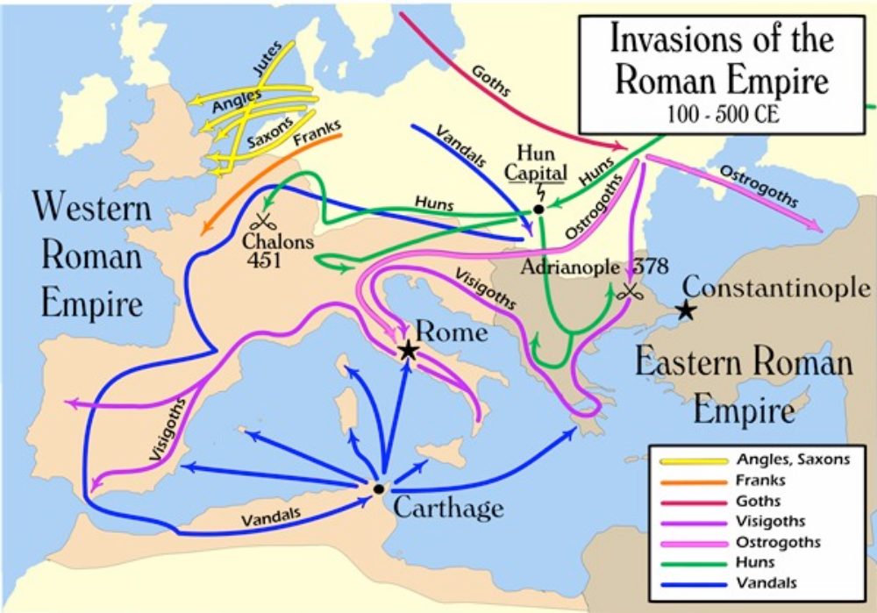

- How would the size of the Roman Empire contribute to its fall?
- What does this map show as the main reason for the fall of the Roman Empire?
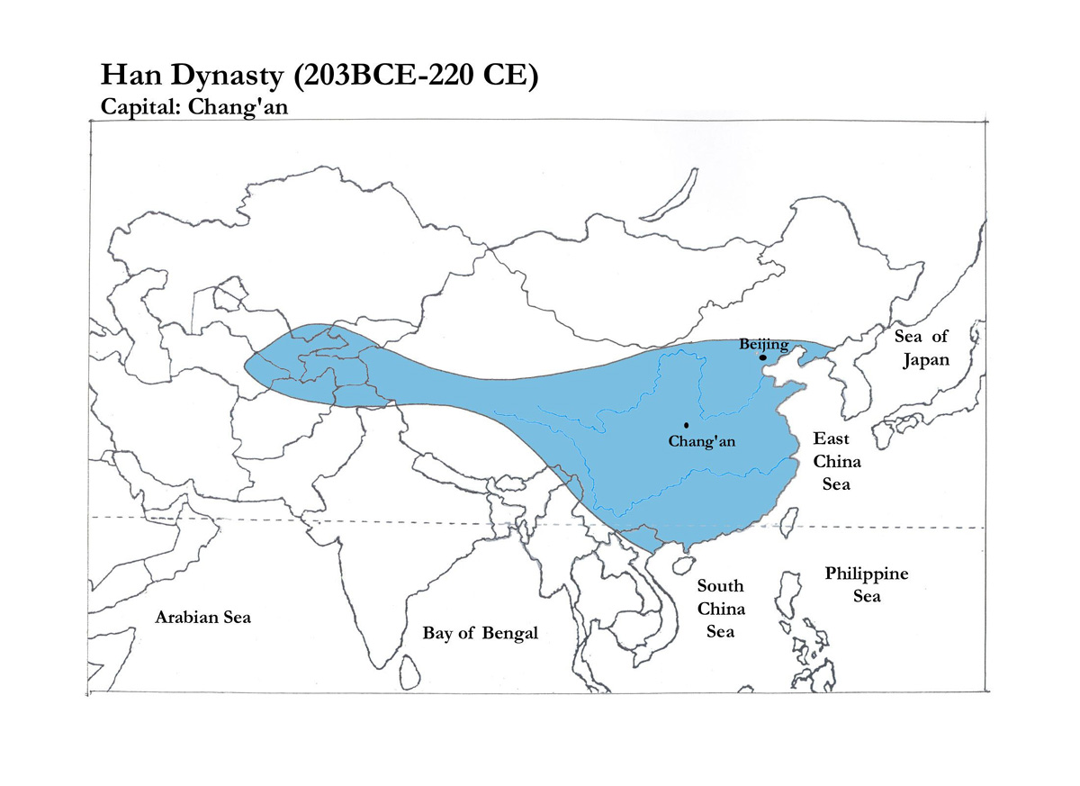
Document 7:

- How would the size of the Han Empire contribute to its fall?

Document 8:
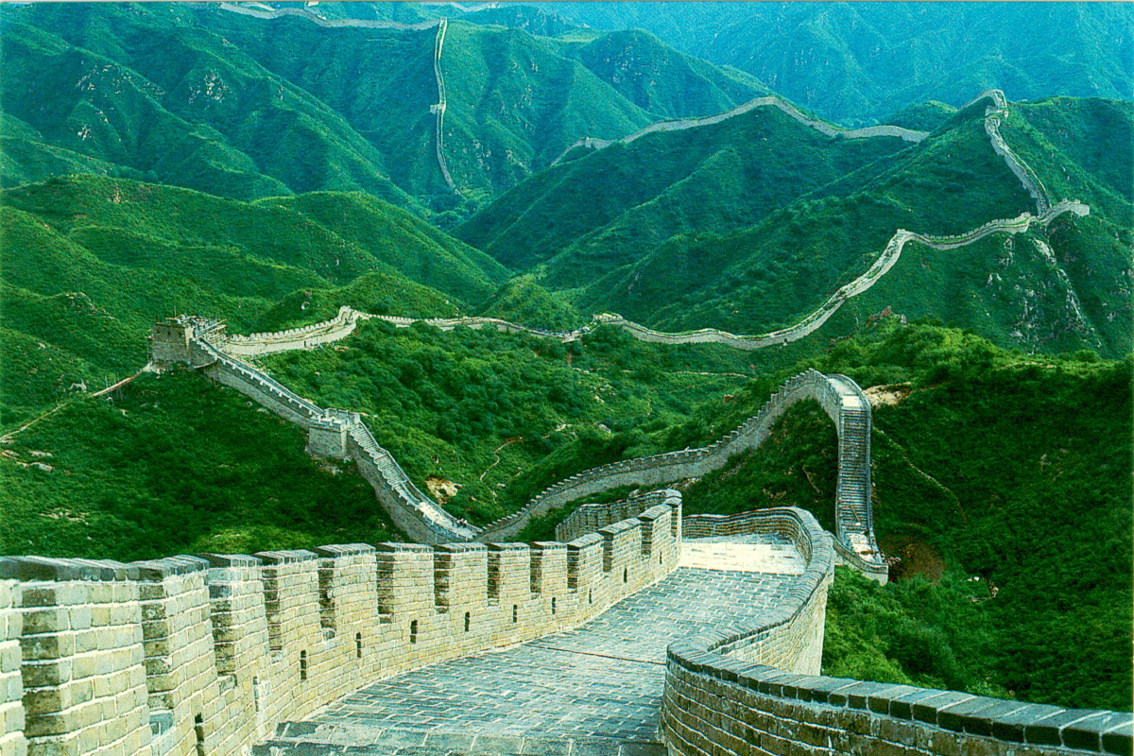

The Great Wall of China

- What is the relation of the Great Wall of China to the geography of China?
- What would be the purpose of building such a barrier?

Document 9:

“…men and women know how to adorn their faces, but there is none who knows how to adorn his character…”

- Gu Kaizhi, Admonitions of the Instructress to the Palace Ladies
- What does this quote demonstrate about the society of classical China?

Document 10:

- What would Dong Zhongshu’s suggestions have done for the people of China?
“Dong Zhongshu proposed to (Emperor) Wudi a remedy for the economic crisis: reduce the taxes on the poor; reduce the unpaid labor that peasants had to perform for the state; abolish the government's monopoly on salt and iron; and improve the distribution of farm lands by limiting the amount of land that any one family could own. Nothing came of Dong Zhongshu's suggestions. Wudi wanted peasants to prosper, but he was often deceived by the gentry bureaucrats who governed at the local level. The drive for reform was being led by a Confucianist, but the Confucianist gentry did not rally against their own economic interests. Wudi's only substantial response to the economic decline was to levy higher taxes on the wealthy and to send spies around to catch attempts at tax evasion. He chose to ignore land redistribution, not wishing to offend wealthy landowners, believing that he needed their cooperation to finance his military campaigns.”

- China, a Macro History by Ray Huang, 1990
- Why did Zhongshu’s suggestions go unheeded?
- Why did the emperor choose to ignore Zhongshu’s suggestions?
- How might the emperor’s actions be viewed in regards to the Mandate of Heaven?

