Zhou Dynasty and Confucianism

Add dates of the Chinese Dynasties to your timeline.
Shang Dynasty: 1532 B.C.- 1027 B.C. Zhou Dynasty: 1027 B.C.-256 B.C.
Qin Dynasty: 221 B.C- 206 B.C. Han Dynasty: 206 B.C. -220 B.C.

Around 1700 B.C. the Shang family seized power in China and became the ruling dynasty. The Shang built the first cities and ruled with the help of powerful nobles. The Shang also developed a system of calligraphy (picture writing) that is still used in China today!

The Zhou Come to Power: In 1027 B.C., the Shang were conquered, marking the beginning of the Zhou Dynasty (pronounced joh). The new Zhou ruler justified his rule as the Mandate of Heaven; the Chinese believe that their ruler was chosen to rule by heaven, and that heaven would also overthrow a bad ruler. Scholars taught that if a ruler became selfish and thought of himself first, before the people, then heaven would bring floods, riots, and revolts to end his reign. Then a new ruling family would emerge.

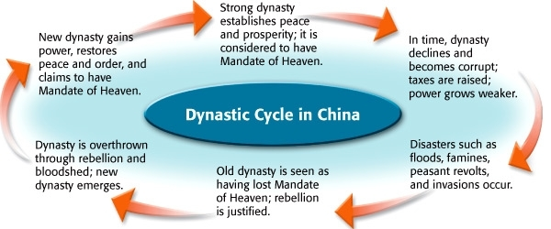

Feudalism: After coming to power, the Zhou conquered neighboring peoples and made them a part of China, this created a huge empire. The Zhou rulers established a political system called feudalism in which land was given to nobles in exchange for military service. As the Zhou continued to grow, some nobles became too powerful for the rulers to control and China was plunged into civil war. This time period is known as the Period of Warring States, and lasted for almost 500 years. One person that lived during this time of civil war was Confucius.
Technology: Even through the Period of Warring States, the Zhou had many technological achievements. The advancements of iron technology allowed the Zhou to create weapons that were much stronger; this allowed them to conquer neighboring groups. They also used iron tools in farming, which lead to an increase in food production and a larger population. The Zhou maintained a road and canal system to facilitate trade, silk was the most valuable item traded.

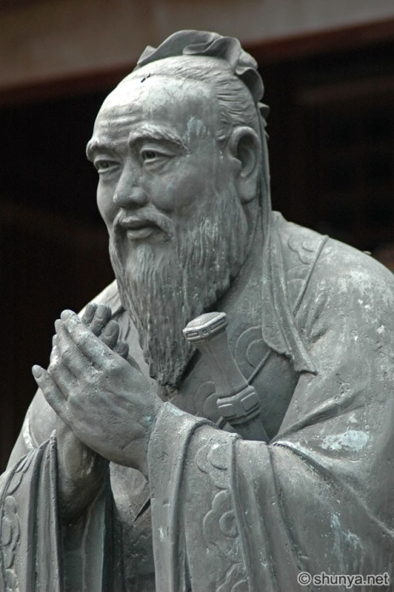
“The superior man is modest in his speech, but exceeds in his actions.”
Confucianism: is a philosophy that places great importance on traditional values such as obedience and order. Confucius also stressed the importance of the family, where children should show respect and devotion to their parents, known as filial piety. For Confucius, the family served as a model for society, emphasizing duties, good deeds, and a civilized way of life. Another main belief of Confucianism is the 5 basic relationships, where there is a superior and inferior in each relationship (ex. Ruler-subject, Father-son) and the inferior must show loyalty and obedience.

Confucius believed that education could transform a peasant into a gentleman trained for government service; this laid the groundwork for a bureaucracy, a large group of trained civil servants (government workers). Confucius’s teachings were collected in a book called the Analects; even though Confucianism has had a huge and long lasting impact on China, it is a philosophy or code of ethics, not a religion.

