The Classical Era in the East – Classical India

IMPORTANT IDEAS
- The Aryans introduced Hinduism and the caste system to India, creating hereditary social classes.
- Although Buddhism began in India, it spread rapidly throughout South, Central Southeast, and East Asia. Asoka, a Mauryan ruler, adopted Buddhism.
- The Gupta Empire was marked by a "Golden Age of Hindu Culture,” which saw growth in learning, the arts, literature, the sciences, and mathematics.

THE EMPIRES OF INDIA
THE ARYAN INVASION


You have already learned that an early river valley civilization arose along the Indus River and then suddenly collapsed. The Dravidian people living in this region were then conquered by the Aryans. Many historians believe that the Aryans came from Central Asia, across the mountain passes through the Himalayas, and arrived in India about 1500 BC. Other historians believe that Aryan culture developed locally.

The Aryans were nomadic peoples who lived by herding cattle and by fighting. They developed iron weapons and horse-drawn chariots which enabled them to conquer their neighbors. Over the next several centuries, Aryan tribes moved into the Ganges River valley, pushing the Dravidian people farther south.

By 900 B.C., the Aryans had formed city-states in the major river valleys. Each city-state was ruled by its own ruler. The Aryans developed their own form of writing, known as Sanskrit. Knowledge of Sanskrit became a sign of education and wealth since it was only taught to members of the higher castes.

HINDUISM

The Aryans also brought a new religion to India, known as Hinduism.

Like many religions, Hinduism provided it believers with an entire way of life. It served as a guide, explaining everything a person should do from birth to death. Hinduism had no single holy book, but various Hindu writings provided guidance. Two texts containing the major beliefs of Hinduism were the Upanishads and the Bhagavad-Gita.

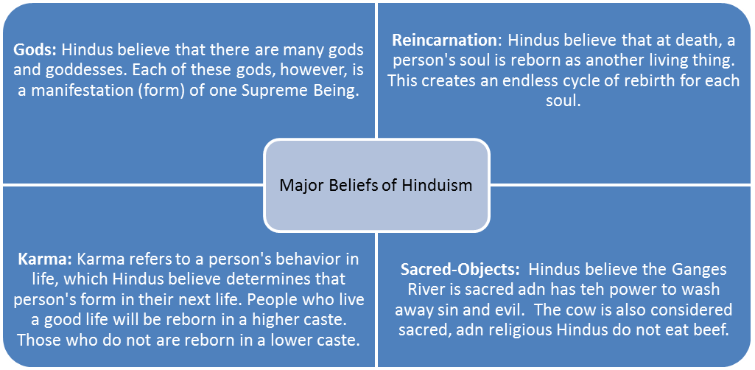
THE CASTE SYSTEM:
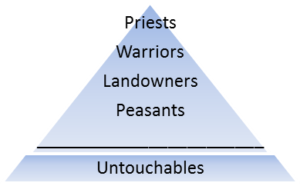
The mixing of Aryan and Dravidian peoples led to a new social order. To secure their status, the Aryans put into effect new social and religious rules. These rules allowed only Aryans to occupy the higher social classes – such as priests, warriors and landowners. Under this system, people were divided into five hereditary classes, known as castes, shown in the triangle to the right.
Caste lines were rigid and based on birth. Under the caste system, people lacked all social mobility (the ability to change social classes). People were not permitted to marry outside their caste. Untouchables performed the lowliest tasks, such as handling dead bodies or sweeping streets. They were completely outside the social order.
Applying What You Have Learned
Answer the following question on your own paper:

- How was the hereditary caste system closely connected to Hindu beliefs in reincarnation?

BUDDHISM
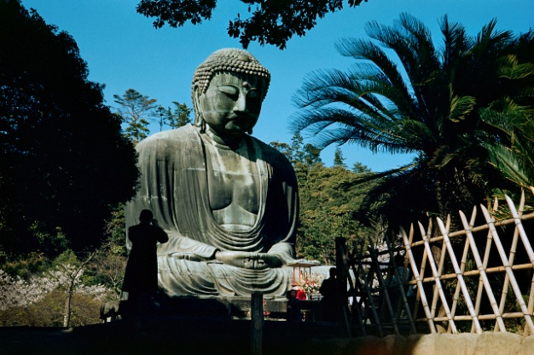
The religion of Buddhism began in India around 500 BC. Siddhartha Gautama (563 – 487 BC) lived his youth in comfort and luxury as a wealthy prince in Nepal. One day, he looked beyond the palace walls and was shocked by all the human suffering he saw around him. This prompted him to leave his wealth, his wife and his two children and set out in search of truth.
After six years of searching, he realized in a flash of insight that all suffering was caused by selfish desires. To end this suffering, a person must come to accept the world as it is and to block or his or her own selfish desires. Gautama became known as the “Buddha” or “Enlightened One.”
Major Beliefs of Buddhism
Basic Philosophy: Buddhism is based on a philosophy of self-denial and meditation. Buddhists also believe in reincarnations. | Gods and Holy Books: Buddhists do not believe in a single Supreme Being (God). They also do not have a holy book. Their basic beliefs are found in books called Sutras. | Four Noble Truths: These truths explain life's meaning. They explain that pain and suffering is caused by human desire for material wealth and selfish pleasures. Only by giving up wrongful desires can a person find peace and harmony. | Eightfold Path: To give up selfish human desires, Buddhists believe one should follow this path: have the right goals, right perspectives, be aware, act in a worthy manner, speak truthfully, live righteously, respect all living things, and meditate. | Nirvana: By following the Eightfold Path, an individual can escape the soul's endless reincarnations and achieve Nirvana - a state of eternal peace and bliss.

THE SPREAD OF BUDDHISM:
Buddhism quickly attracted many followers. Missionaries helped spread Buddhist beliefs throughout all of India. Buddhism began to spread southwards from Northern India to Sri Lanka, Burma, Thailand, Indochina, and other Southeast Asian countries. It moved northwards into the Himalayan kingdoms of Bhutan and Nepal, Tibet, Mongolia and other parts of Central Asia. Buddhism also spread into China, Korea, and Japan. It was popular among many groups because it rejected the caste system.
Applying What You Have Learned
Answer the following questions on your own paper.
- Acting as an Amateur Historian: The main ideas of Buddhism are summarized in the “Four Noble Truths.”
  - All life is suffering.
  - Suffering is caused by our craving (or wanting things).
  - Suffering can only be stopped by ending our craving.
  - Only a carefully disciplined and moral life, such as a life of concentration and meditation, can end our craving.
According to the “Four Noble Truths,” how can we end our suffering?

- What beliefs did Buddhism borrow from Hinduism?
- How did the spread of Buddhism in the East compare to the spread of Christianity in the West?
THE MAURYAN EMPIRE (321 BC – 232 AD)
Shortly after Alexander the Great invaded northwestern India saw the rise of one of the greatest Hindu empires. King Chandragupta challenged the Greeks and established the powerful Mauryan Empire in India, which stretched from Afghanistan to the Ganges. His grandson
Asoka (269 B.c.-232 B.C.) was the next great ruler of India.
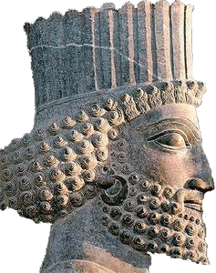
Asoka began his reign by fighting a series of wars to enlarge his empire. After eight years of nearly constant warfare, Asoka grew horrified by the bloodshed of battle. This prompted him to renounce violence and to convert to Buddhism.

Asoka decided to win his people’s loyalty by acts of kindness and by promoting their welfare and happiness. He decreed that peole of all religions should live peacefully with one another. He improved roads, built hospitals, and sent teachers throughout the empire to encourage education. To promote Buddhism, he built Buddhist shrines throughout India and sent missionaries to other lands. Despite his successes, after Asoka’s death the Mauryan Empire began to fall apart.

THE GUPTA EMPIRE (320 AD – 535 AD)
In 320 AD, a new ruling family, the Gupta, emerged. They united the territory around the Ganges River. Gupta emperors encouraged peace, prosperity and trade with foreign lands, especially China.

The two centuries of Gupta rule are sometimes referred to as the “Golden Age of Hindu Culture.” A “golden age” is a period marked by peace and stability accompanied by strides in the arts and literature. Gupta emperors built universities and supported learning, the arts, and literature. Gupta artists painted colorful murals, while writers composed poems and plays written in Sanskrit.
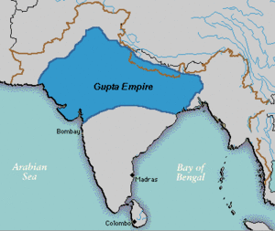
Indian scholars excelled at the sciences and mathematics. Gupta mathematicians developed the concept of zero, the idea of infinity and the decimal system. Arabic numerals, used throughout the world today, were first developed in India during this period. Gupta astronomers put forward the idea that the Earth was not flat, but round and rotated on its own axis. These astronomers calculated the solar year and the shape and movement of bodies in space with remarkable accuracy. In the file of medicine, Gupta physicians set bones and performed minor skin grafts. This prosperous period drew to a close around 500 AD. The Huns, a warlike tribe from Central Asia, invaded northern India, causing the Gupta Empire to disintegrate into smaller states.

Applying What You Have Learned
Answer the following questions on your own paper.

- How did Buddhist beliefs affect the policies of King Asoka?
- What were some of the important cultural contributions of the Gupta Empire?

