History II Spring

Gandhi Times
Created by: Veronica Oliver

“Nonviolence is the greatest force at the disposal of mankind. It is mightier than the
mightiest weapon of destruction devised by the
ingenuity of man.”

The Life of Gandhi

Mohandas K. Gandhi was born in 1869 to Hindu parents in Western India. He entered an arranged marriage with when he was 13 years old. His family later sent him to London to study law, and in 1891 he was admitted to the Inner Temple, and passed the bar becoming a lawyer. Gandhi next moved to South Africa where he worked to improve the rights of immigrant Indians who were treated as second- class citizens. It was there that he developed his
creed of passive resistance against injustice, and
satyagraha, meaning truth force. Gandhi was frequently jailed as a result of his protests. Before he returned to India with his wife and children
in 1915, he had radically changed the lives of
Indians living in Southern Africa.

India Lessons

The unique life of Gandhi and his inspiration to world

Page #1 The Life of Gandhi
Reading

Page #2 The Life of Gandhi
Reading

Page #3 Gandhi Video

Questions

Page #4 Gandhi Class Notes

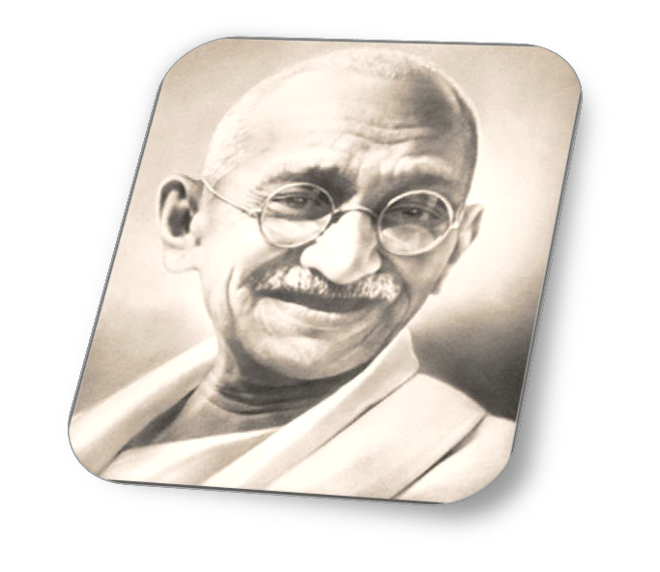

Continue on Page 2

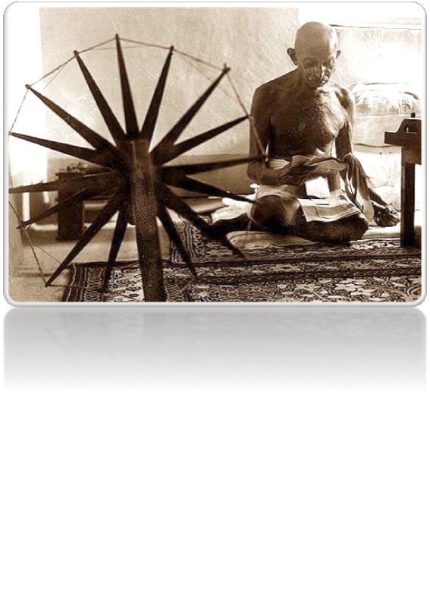

The Life of Mohanda Gandhi

In India, Gandhi took the lead in the struggle for independence from Britain. He never wavered in
his belief in nonviolent protest and religious
tolerance. When the Muslims and Hindus committed acts of violence, whether against the British, or against each other, he fasted until the fighting ceased. Independence, when it came in
1947, was not a military victory, but a triumph of human will. To Gandhi's despair, however, the country was partitioned into Hindu India and Muslim Pakistan. The last two months of his life were spent trying to end the appalling violence, which ensued, leading him to fast to the brink of death, an act which finally quelled the riots. In January 1948, at the age of 79, he was killed by an assassin as he walked through a crowed garden in New Delhi to take evening prayers.

Questions:

1.) Name 3 things Gandhi accomplished

2.) What does satyagraha mean?

3.) What did Gandhi hope to accomplish by fasting?

4.) How did Gandhi die?

5.) How did Gandhi attempt to end violence?

6.) What does Gandhi have in common with other modern nationalist leaders that we have studied?
2

“The Words of Gandhi” “Gandhi Talks:”

“Nonviolence is the greatest force at the disposal of mankind. It is mightier than the mightiest weapon of destruction devised by the ingenuity of man.”

“Pellentesque eget mauris et magna sollicitudin lacinia. Duis lectus?”

“The Words of Gandhi”
In the space below, please provide an explain (put in your own words) what Gandhi is saying?
"Gandhi Talks: First Talking Picture
Ever Made by India’s famous Leader"

1. How does the journalist describe
Gandhi?

2. What is your first impression of
Gandhi?

3. How do his responses to the questions reflect his attitude of nonviolence?

4. Why would the interviewer ask about Gandhi’s choice of clothing?

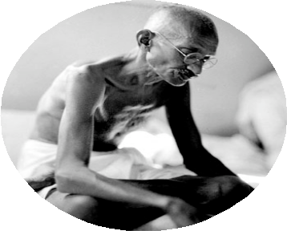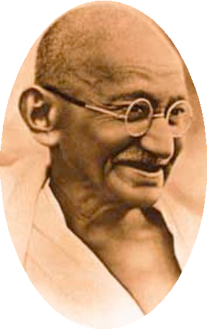

3

Who is Gandhi & what were his methods?

The Partition of India!

Violence between Hindus & Muslims
Leader of…

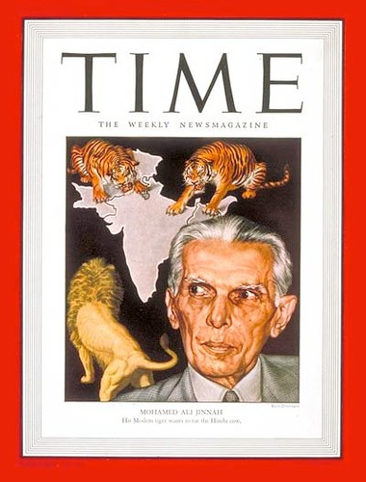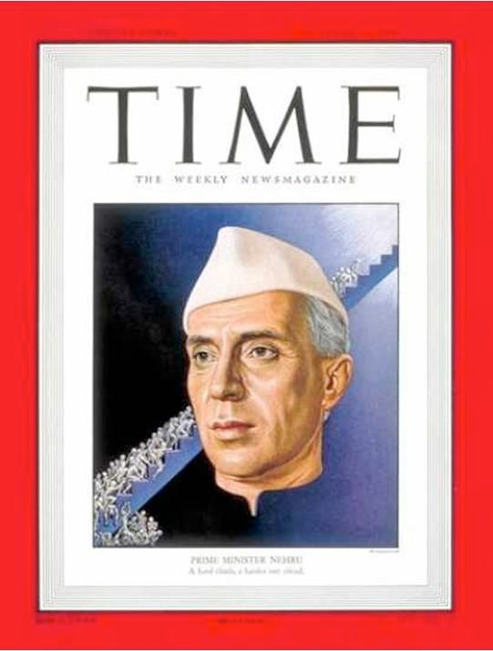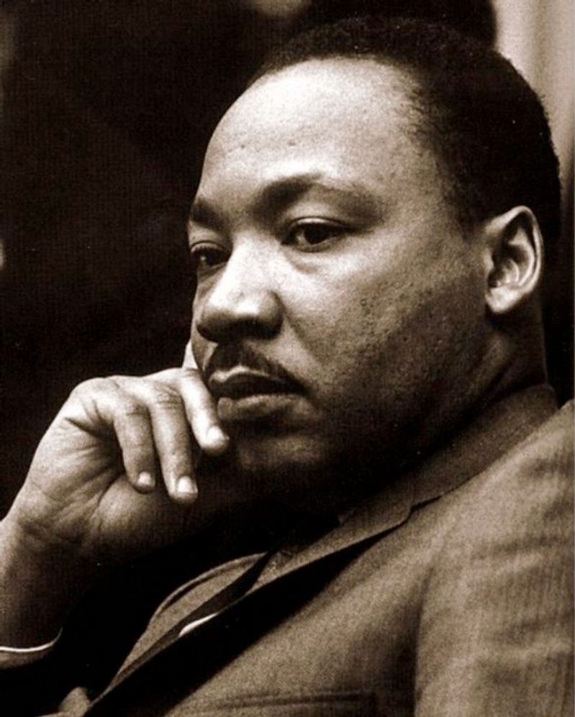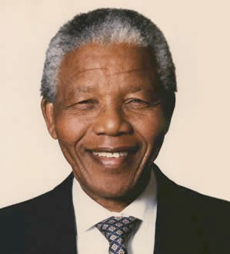
Spring 2012

Who are the world leaders that were
influenced by Gandhi’s non-violent approach? Leader of…

4

