Renaissance, Reformation, Scientific Revolution Vocabulary

Renaissance: (1300-1600) period in European history during which renewed interest in classical culture led to changes in art, learning, and views of the world  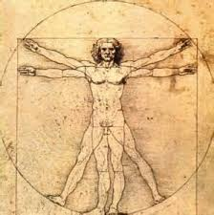 | Vernacular: the everyday language of people in a region or country  Ex. “He wrote in the vernacular to reach a larger audience.”  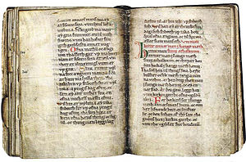
Humanism: Renaissance intellectual movement in which thinkers studied classical texts and focused on human potential and achievements  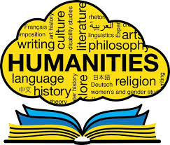 | Perspective: artistic technique that creates the appearance of three dimensions on a flat surface  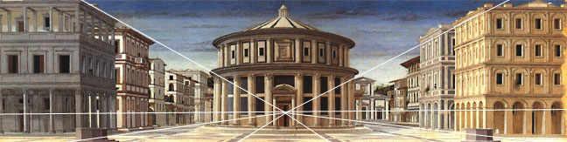
Patron: a person who supports artists, especially financially  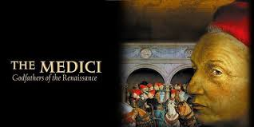 | Secular: concerned with worldly rather than spiritual matters  
Printing Press: a machine for reproducing written material by pressing paper against arrangements of inked type   | Gutenberg Bible: the first full-sized book printed with movable type and a printing press  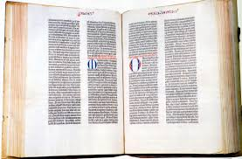
Reformation: 16th century movement for religious reform, leading to the founding of Christian churches that rejected the pope’s authority   | Indulgence: a pardon releasing a person from punishments due for a sin  

Protestant: a member of a Christian church founded on the principles of the Reformation   | Lutheran: a member of a Protestant church founded on the teachings of Martin Luther  
Annul: to cancel or put an end to   | Anglican: relating to the church of England  
Predestination: the doctrine that God has decided all things beforehand, including which people will be eternally saved  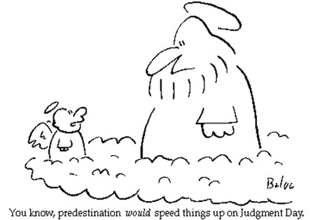 | Calvinism: a body of religious teachings based on the ideas of the reformer John Calvin  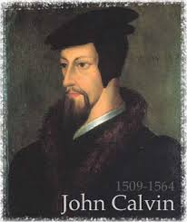
Catholic Reformation: 16th century movement in which the Roman Catholic Church sought to reform itself in response to the Protestant Reformation  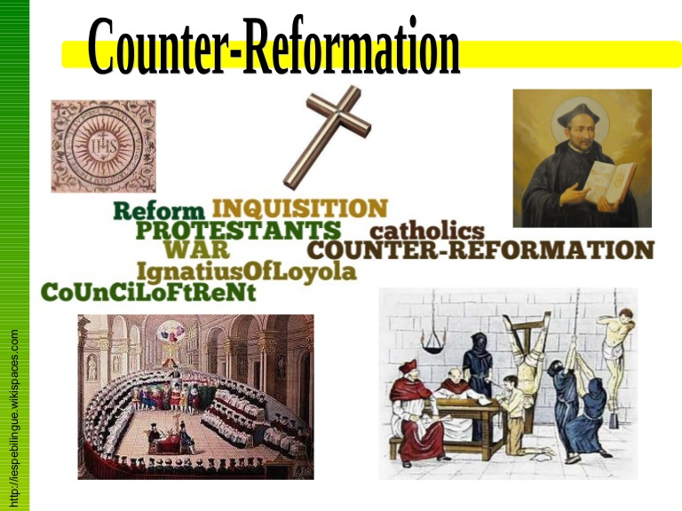 | Scientific Revolution: ( mid 1500’s) a major change in European thought in which study of natural world began to be characterized by careful observation and questioning of accepted beliefs  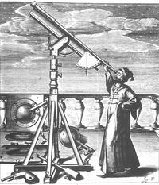
Heliocentric Theory: the idea that the earth and the other planets revolve around the sun  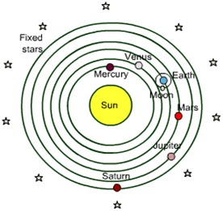 | Scientific Method: logical procedure for gathering information about the natural world, in which experimentation and observation are used to test hypotheses  

