World History (1914 Present) Name

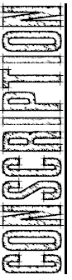Total War on the Home Front during World War I

 | IMAGE: Based on the images, how were factories impacted by World War I? | • | 1. In what ways did the government become involved in the  economy during the war?  2. What happened to unemployment during the war?  3. How were neutral countries affected by the war?
 | IMAGE: According to  the chart, which country mobilized the  most soldiers?  What is the poster requiring men to do? | • | 1. What is conscription? Why was it necessary during the  war?  2. Which men had to register for the draft?  3. Why do you think that people stopped volunteering to join the army by 1916?
 | IMAGE: What are  these posters trying to get people to do? | • | 1. What is propaganda?  2. What types of things did propaganda posters ask civilians to do during the war?  3. Why were civilians so important to the war effort?

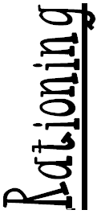 | IMAGE: What are the  common themes among these posters? | • | 1. What is rationing?  2. In what ways were civilians impacted by rationing?  3. How was World War I different from all other wars, in regards to the level of commitment that was asked of the civilians?
Role of  Women | IMAGE: According to  the images, how could women support the war effort? | • | 1. In what types of work were women employed in during the  war?  2. What roles did women play in the military?  3. How were women affected when the war ended?
 | IMAGE: Based on the statistics, which side should have won the war? Why?  What is the goal of the propaganda poster? | • | 1. How did the role of government change during the WWI?  2. How did governments attempt to pay for the war?  3. What was the total “cost” of the war?
Media | Directions – For each poster answer the following questions…  1. Identify what country the propaganda poster is from. Identify any important dates or years if they are present in the poster.  2. What images do you see in the poster? What is the poster asking the reader to do?  3. Describe the negative images in the poster? The positive images?  4. How are these images used to motivate or stir up emotions?  5. If relevant, how is the enemy portrayed in the poster?  6. Below, explain the message of the poster.

