African Gold/Salt Trade
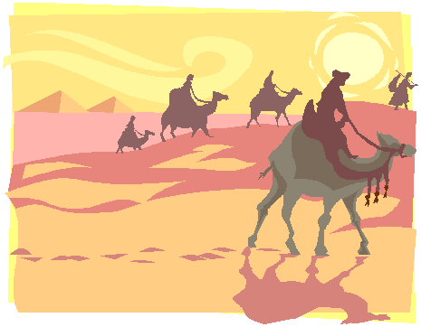

Trade carried across the Sahara Desert by merchant caravans, which brought blocks of salt to West Africa in exchange for gold.

Alliance System

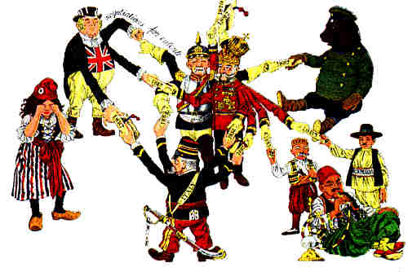

(1879 – 1914)
The Triple Alliance (Germany, Austria-Hungary, Italy) and Triple Entente (Britain, France, Russia) sought to preserve the balance of power, but dragged their members into World War I.

Al-Qaeda

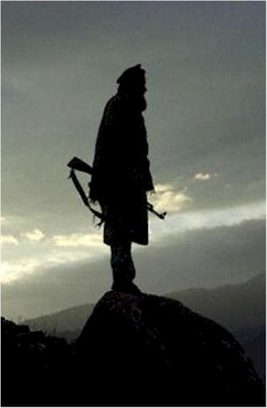

(1988 – Present)
Terrorist organization formed by Osama bin Laden.

Archimedes

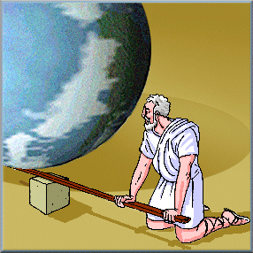

(287 – 212 BC)
Greek mathematician who studied density, levers, and pulleys and invented a screw pump device.

Armenians

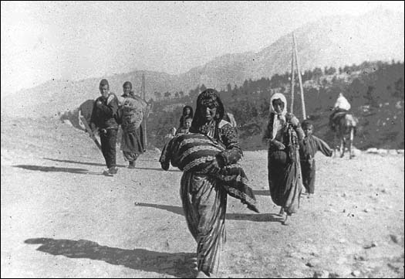

Christians in the Ottoman Empire who faced genocide during World War I.

Arms Race

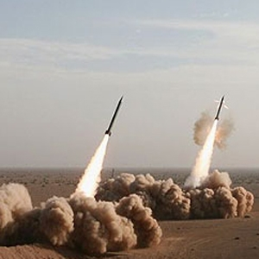

Any race to develop better weapons, such as the race between the United States and the Soviet Union to develop more powerful nuclear bombs.

Thomas Aquinas

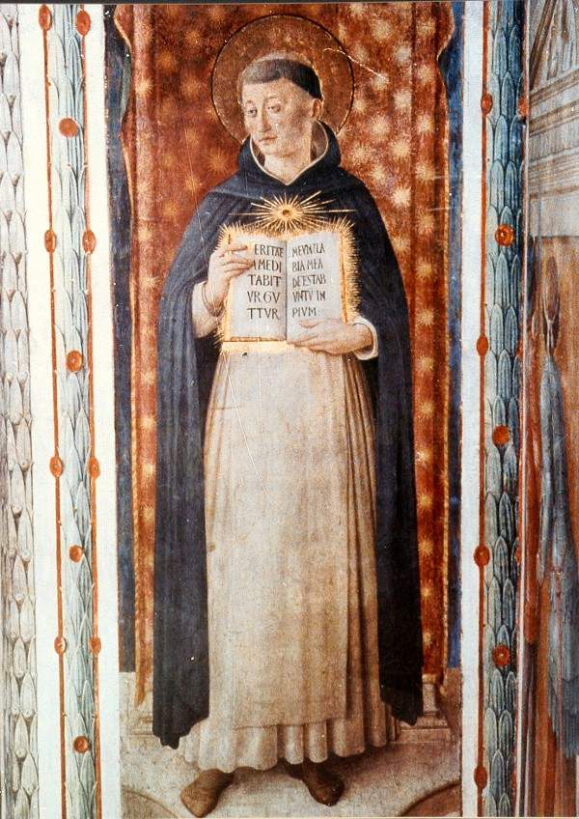

(1225 – 1274)
Catholic thinker who believed in natural laws based on reason and in the right to defy unjust laws.

Atlantic Slave Trade

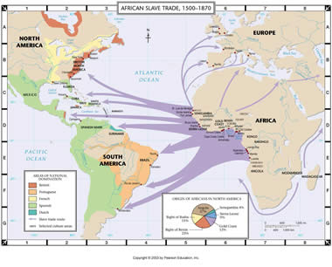

(16th – 19th Centuries)
Captured Africans were transported across the Atlantic under horrific conditions to labor in the Americas in mines and plantations.

Atomic Bomb

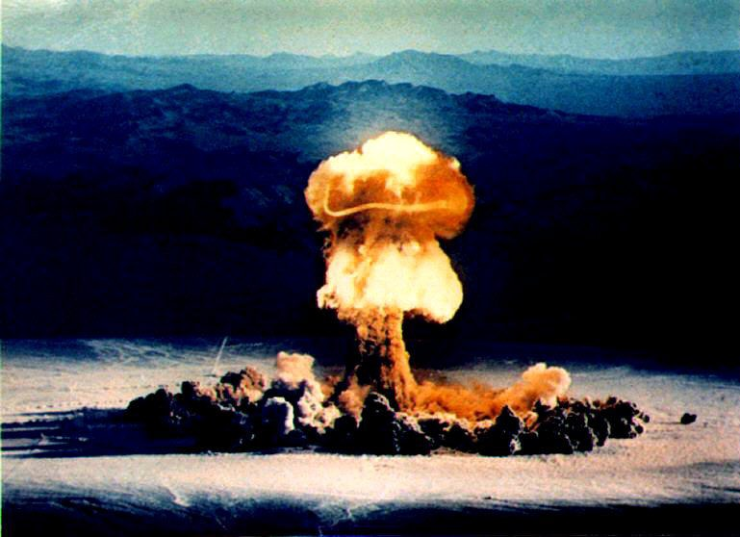

American scientists developed a bomb based on atomic energy, which was used against the Japanese cities of Hiroshima and Nagasaki.

Balkans

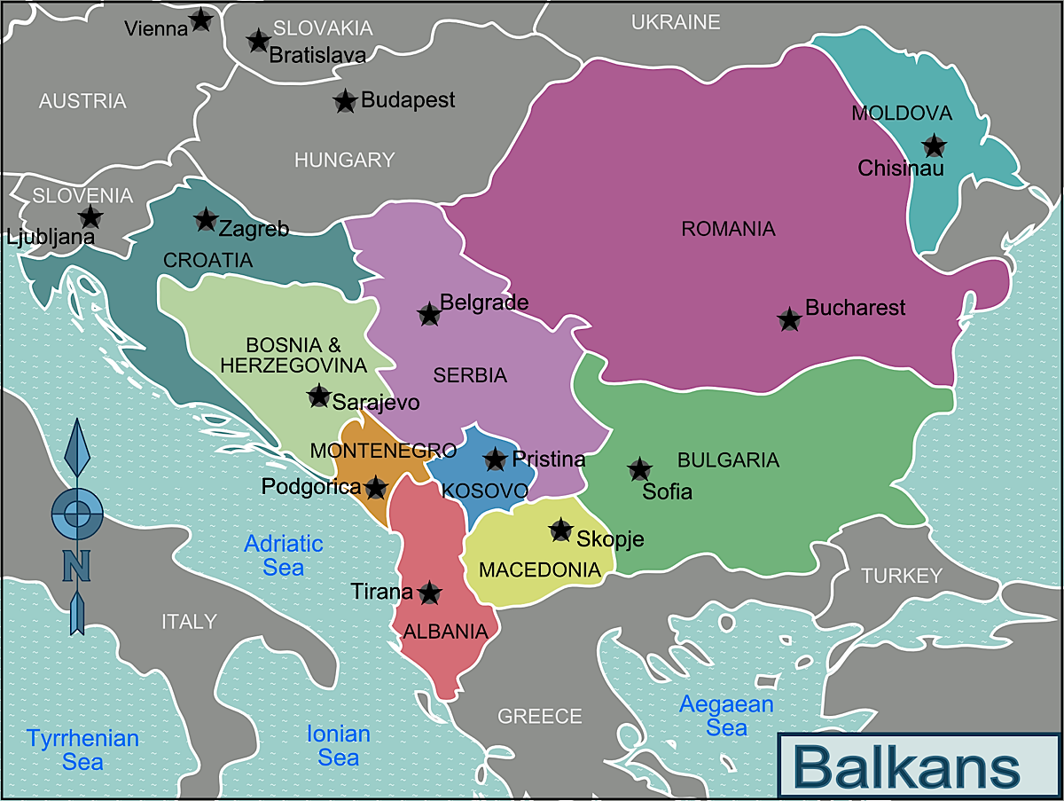

Mountainous region of southeastern Europe that provided the spark igniting World War I. In the 1990’s the Balkans experienced “ethnic cleansing” by Serbs against Muslims.

Aztec Civilization

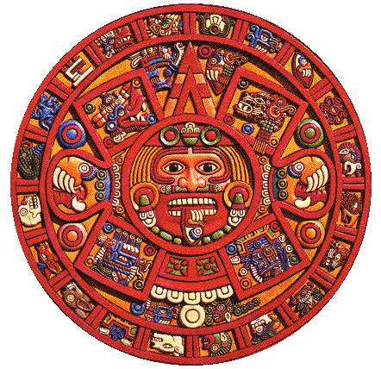
A complex pre-Columbian civilization in Central Mexico with a highly complex social organization, a yearly calendar, and a tradition of human sacrifices.

Black Death

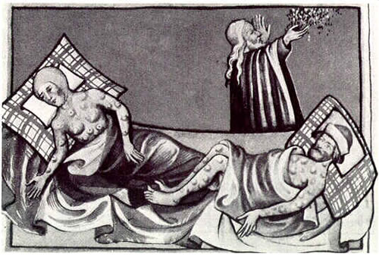
(circa 1350)
A disease carried on ships from Asia to Europe that killed millions of people and helped to end serfdom in Europe.

William Blackstone

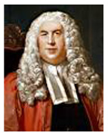

(1730 – 1780)
English jurist who explained the common law, and who defined the rights of individuals under English law.

Bolsheviks

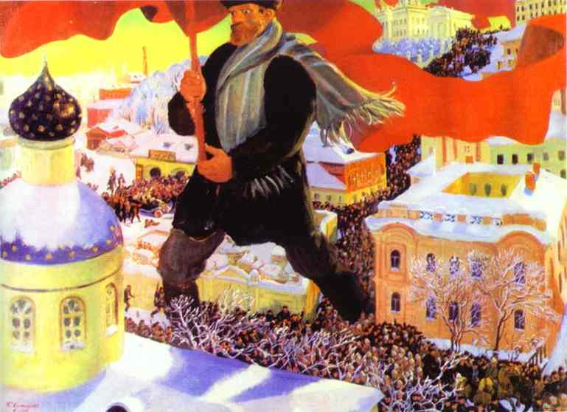

Party of Lenin that won the support of the people by promising “Peace, Bread, and Land,” and which led the “October” Revolution of 1917 in Russia.

Símon Bolivar

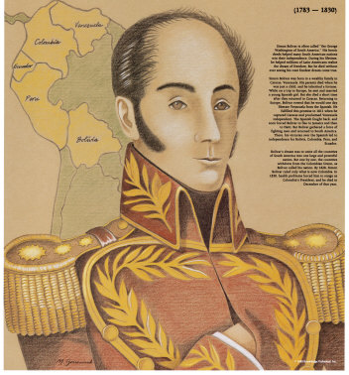
(1723 – 1780)
Leader for independence who defeated Spanish forces in South America, liberating Venezuela, Colombia, Ecuador, Peru, and Bolivia.

Napoleon Bonaparte

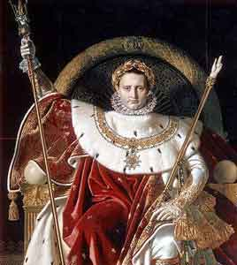
(1769 – 1821)
General during the French Revolution, who seized power in 1799, declared himself emperor in 1804, and conquered much of Europe.

Robert Boyle
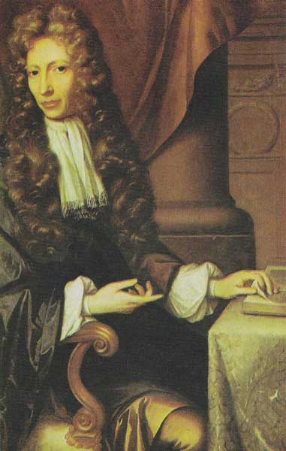

(1627 – 1691)
Irish chemist who conducted experiments on gases at different temperatures. He is sometimes known as the “Father of Chemistry.”

Byzantine Empire

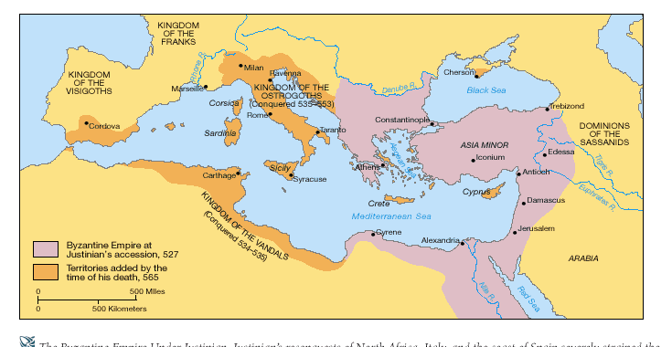
(330 – 1453)
Eastern part of the Roman Empire that survived the fall of Rome, with its capital at Constantinople. It developed Eastern Orthodox Christianity and the Justinian Code.

Buddhism

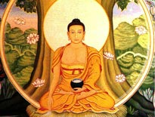
A religion based on the idea of self-denial taught by Gautama Buddha. Buddhists try to follow the Four Noble Truths and the Eightfold Path.

John Calvin

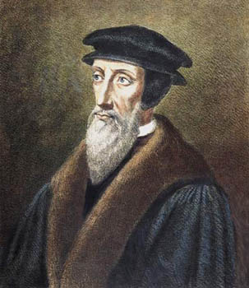

(1509 – 1564)
He began a new Protestant Church in Geneva based on belief in predestination, faith as the key to salvation, and a strict moral code.

Christianity

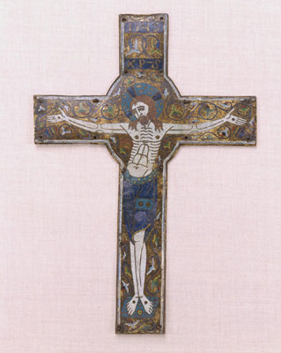
Religion based on the teachings of Jesus, who preached forgiveness, mercy and sympathy for the poor. Christians believe Jesus was the son of God who sacrificed himself to save mankind.

Cold War

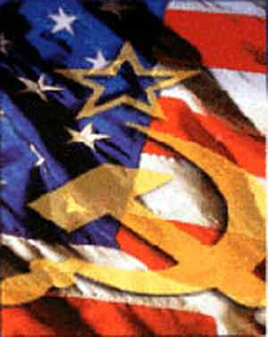
(1945 – 1990)
Conflict between the two “Superpowers” with competing economic and political systems. The United States and the Soviet Union never directly engaged each other in open warfare.

Winston Churchill

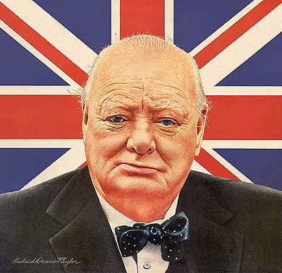

(1874 – 1963)
British Prime Minister who opposed Hitler and inspired the British people with his public broadcasts during World War II.

Columbian Exchange

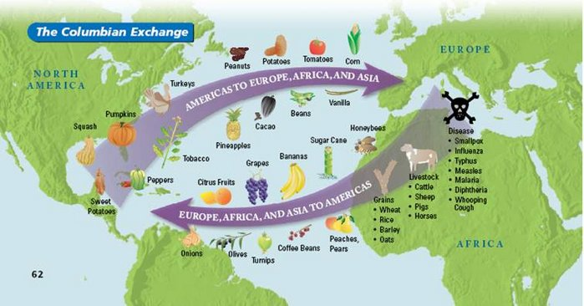

(post-1492)
Exchange of products and ideas between Native Americans and Europe that developed out of the “encounter” by Columbus.

Commercial Revolution

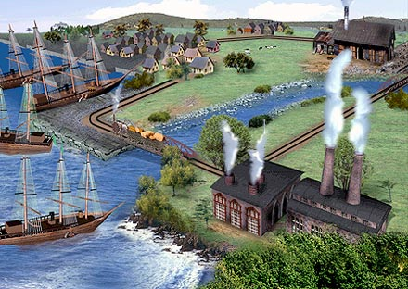

(17th – 18th Centuries)
The transition from the local economies of the Middle Ages to an economy based on overseas trade, the extension of banking and credit, and mercantilist policies.

Nicolas Copernicus

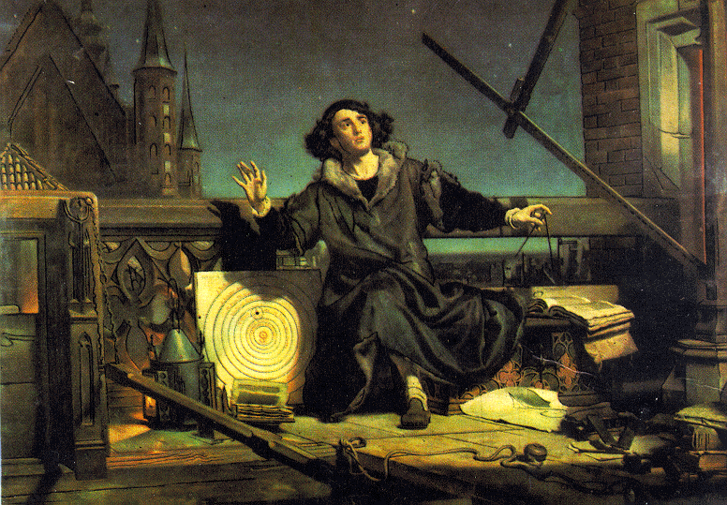

(1473 – 1543)
Polish astronomer who believed that the Earth orbited the sun. His work was banned by the Church.

Confucianism

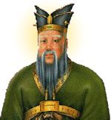

Belief system established by Confucius, emphasizing traditional values such as obedience and order. Filial Piety or respect for elders is also valued.

Crusades

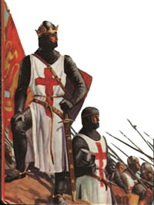
(1095 – 1272)
A war requested by the Pope for Christians to recapture the Holy Land from Muslims. The Crusades led to greatly increased trade between Europe and the Middle East.

Marie Curie

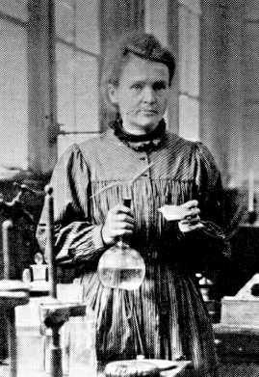

(1867 – 1934)
Polish-born chemist and physicist who conducted early experiments with radioactivity. Curie became the first woman to win a Nobel Prize.

Declaration of the Rights of Man

(1789)
Issued by the National Assembly during the French Revolution. It states that government rests on the consent of the people, and people have certain protected rights.

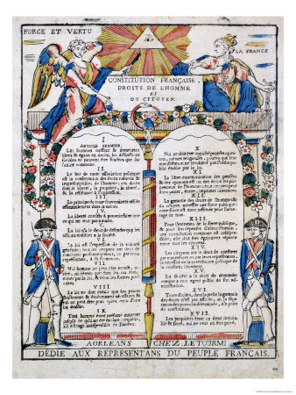

Darfur

An area in the Sudan in Africa that has experiences acts of genocide.

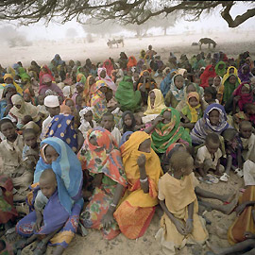

Thomas Edison

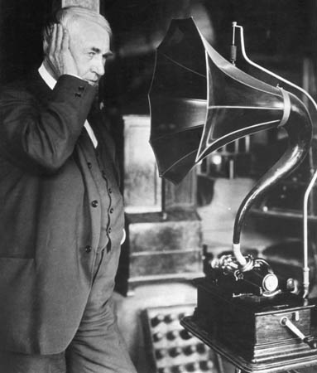

(1847 – 1931) Creative American inventor of the electric light bulb, phonograph, and motion pictures.

Albert Einstein

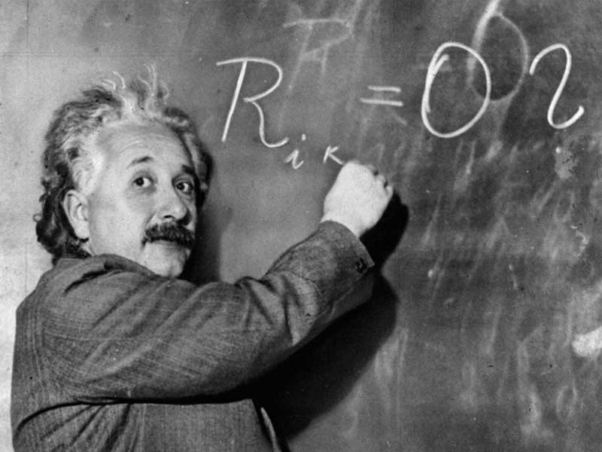
(1879 – 1933)
Jewish physicist who discovered that time and space were relative. He fled Nazi Germany and recommended development of an atomic bomb.

English Bill of Rights

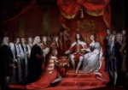

(1689)
After the Glorious Revolution of 1688, William and Mary signed this document agreeing to many rights for their subjects.

Elizabeth I

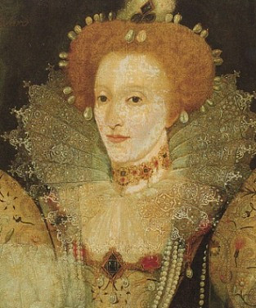

(1533 – 1603)
English queen who created a strong, centralized monarchy based on national unity and a sharing of power between monarchy and Parliament.

English Civil War

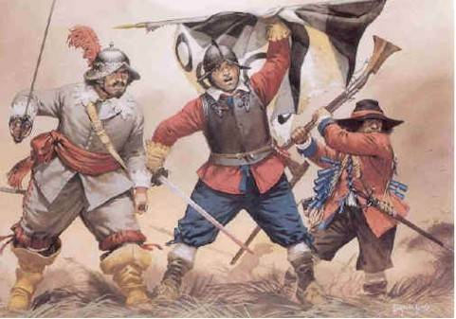

(1642 – 1649)
A war between the English Parliament and Charles I, which established Parliament’s supremacy over the monarchy.

Enlightenment

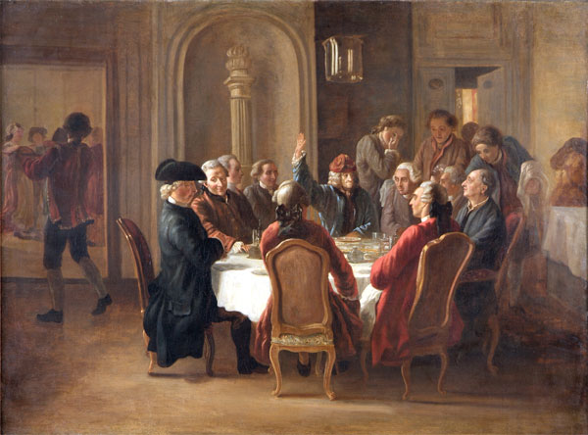
(18th Century)
Movement that applied reason and scientific laws to understand nature and society. Enlightenment thinkers questioned hereditary privilege and absolutism.

European Imperialism

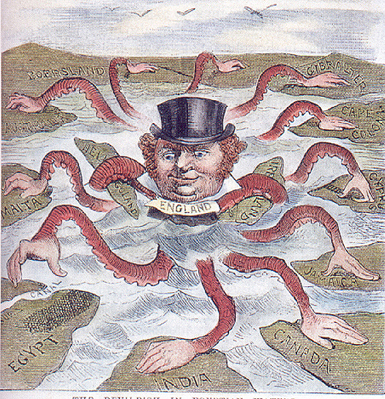

(19th Century)
The political and economic control by European powers of areas in Africa, Asia, and the Pacific.

Eratosthenes

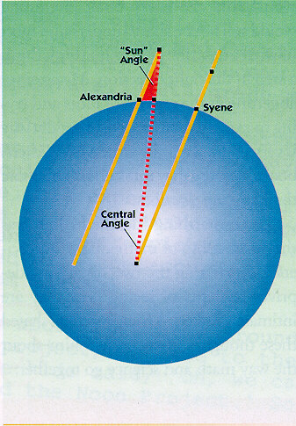
(276 – 195 BC)
Greek geographer who showed that the Earth was round and also calculated the size of its circumference.

Fascism

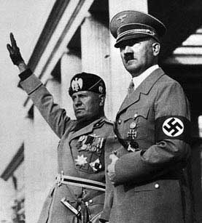
(20th Century)
Political system that developed in Germany, Italy, and Spain after World War I, marked by intense nationalism, belief in an all-powerful leader, and militarism.

Fourteen Points

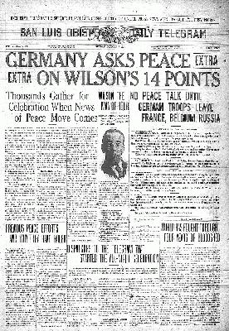
(1918)
War aims announced by President Woodrow Wilson, which included creating new nation-states in Eastern Europe and a League of Nations.

French Revolution

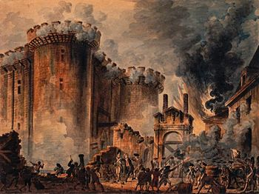
(1789 – 1799)
Revolution that overthrew the French monarchy, ended hereditary privilege, and made France more democratic. It was accompanied by violence and war.

Free Enterprise System

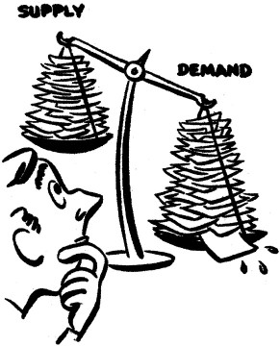

An economic system in which basic economic questions are answered by the free actions of producers and consumers.

Galileo Galilei

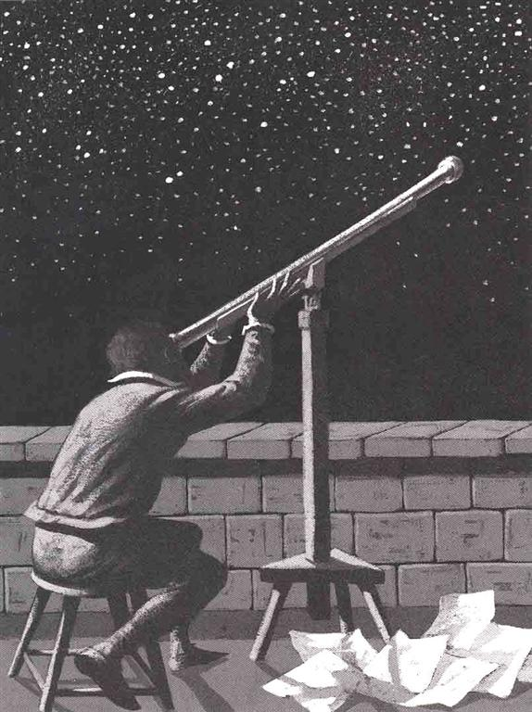

(1564 – 1642)
Italian scientist who studied motion. His observations with a telescope confirmed the Copernican theory. He was tried and convicted by the Church.

Indira Gandhi

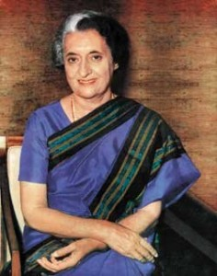

(1917 – 1984)
The daughter of Nehru and the fir5st woman elected as India’s Prime Minister. She was later assassinated.

Genocide

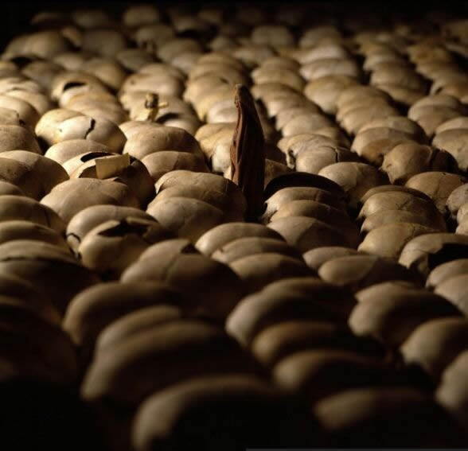
An effort to murder an entire people or nationality. Attempts of genocide occurred in Armenia during World War I, the Holocaust during World War II, and more recently in Rwanda, Burundi, Darfur, and Kosovo.

Mohandas Gandhi

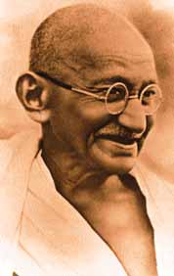

(1869 – 1948)
Leader who achieved Indian independence through non-violent, passive resistance to the British.

Globalization

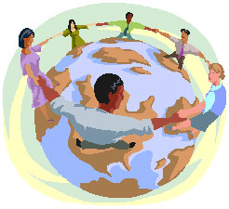

(Present)
Creation of a global economy and society through improved communications, transportation, and trade.

Glorious Revolution

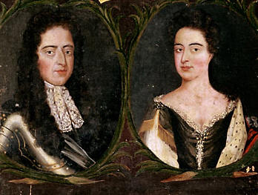
(1688)
A revolution in Britain in which James II was overthrown and the new king and queen agreed to the Bill of Rights of 1689, granting their subjects certain rights.

Great Depression

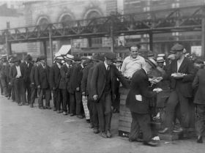

(1932 – 1939)
A devastating economic downturn that saw stock prices fall, business fail and large scale unemployment in America and Europe.

Mikhail Gorbachev

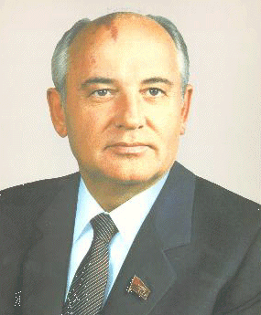

(b. 1931)
His reforms led to the election of non-Communist governments in Eastern Europe and the dissolution of the Soviet Union.

Great Schism

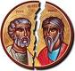

(1378 – 1417)
Split that occurred in the Catholic Church with two Popes, one in Avignon and the other in Rome. The Schism caused many to question the Church’s authority.

Greek Civilization

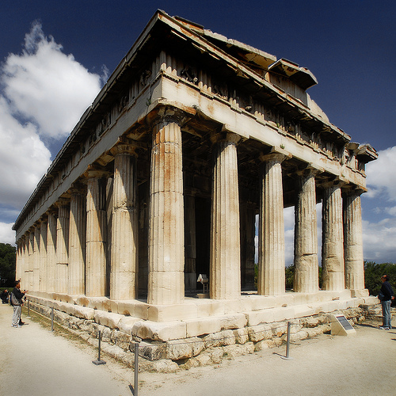
Ancient Greek city-states, especially Athens, made major contributions to art, architecture, philosophy, literature, drama, and history.

Hammurabi’s Code

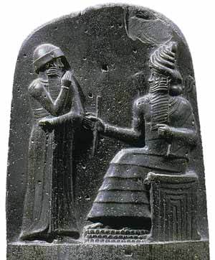

(circa 1700 BC)
Developed by the Babylonians, it is the earliest known written law code. It promoted justice but treated social classes differently.

Gupta Empire

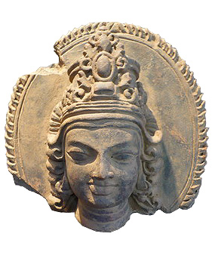
(320 – 550)
An empire in India characterized by peace, prosperity, and trade. Often referred to as the Golden Age of Hindu Culture.

Han Dynasty

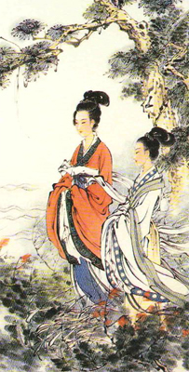

(206 BC – 220 AD)
Han invented paper and lead-glazed ceramics, gave examinations to candidates for imperial service, and increased trade over the Silk Road.

Hinduism
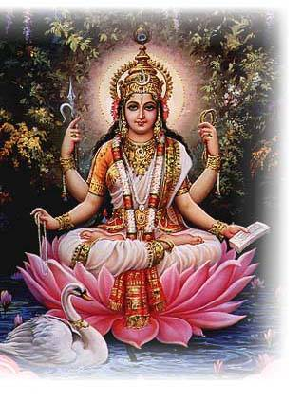

Religion in India that believes in many gods and goddesses, reincarnation, and that a person’s behavior in life determines his or her form or caste in the next life.

Thomas Hobbes

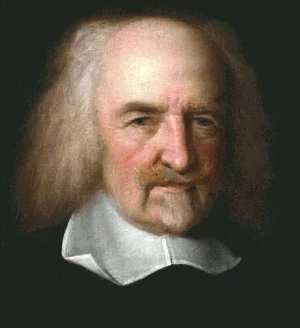

(1588 – 1679)
Englishman who wrote that man is “nasty and brutish” in nature and needs a central authority to keep order, or society would break down.

Adolf Hitler

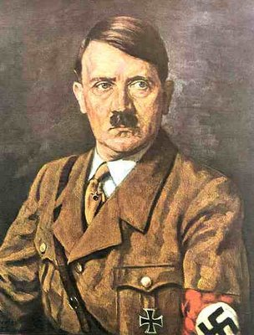
(1889 – 1945)
Nazi Party leader who established a totalitarian state in Germany. His policies took Germany into a devastating war in 1939 and led to the deaths of millions of Jews in the Holocaust.

Holocaust

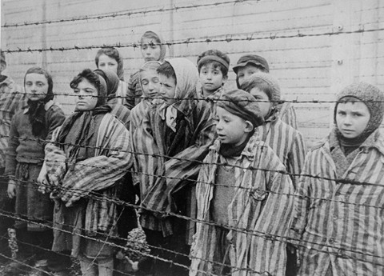
(1938 – 1945)
The genocide of Jews and other minorities during World War II by the Nazis, in concentration camps like Auschwitz.

Human Rights

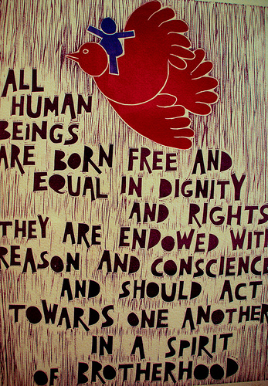
Rights that all people possess, such as the right to meet their needs without being persecuted.

Inca Civilization

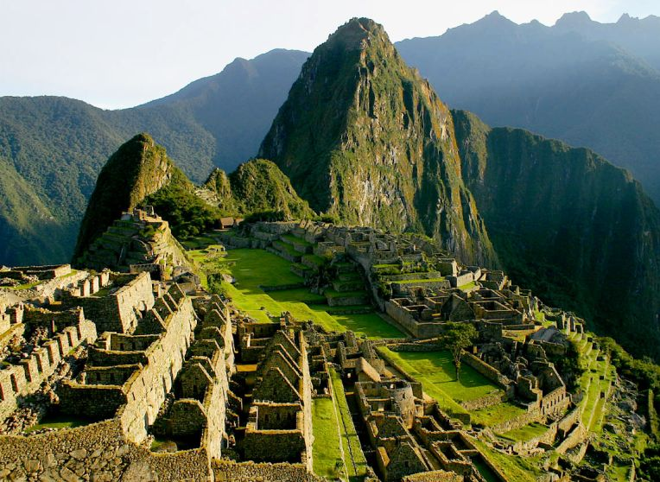
A pre-Columbian civilization in the Andes Mountains. The Inca excelled at engineering, and developed new food crops like potatoes.

Hundred Years’ War

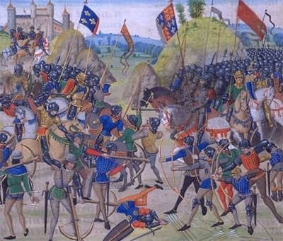
(1337 – 1453)
War between England and France over succession to the French throne. It strengthened royal power and brought an end to feudalism..

Industrial Revolution

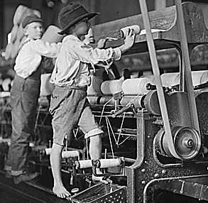

(Late 18th – Early 19th centuries)
Began in England. Changed the way goods were made, moving production from the home to factories and from hand to machine.

Islam

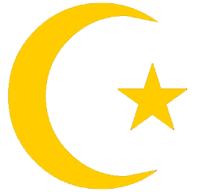

Religion founded by Mohammed, based on five pillars: faith in one God (Allah), prayer fives times a day, charity, fasting, and making a pilgrimage to Mecca at least once.

John Paul II

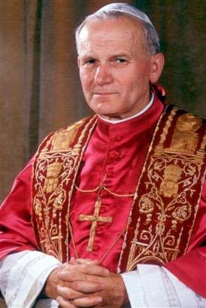

(1920 – 2005)
In 1978, this Pole became the first non-Italian Pope in 400 years. He helped end Communism in Eastern Europe.

Israel
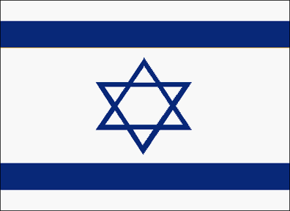

In 1948, the United Nations partitioned Palestine into two states – Israel and Palestine. Five neighboring Arab nations immediately declared war against Israel.

Justinian’s Code of Laws

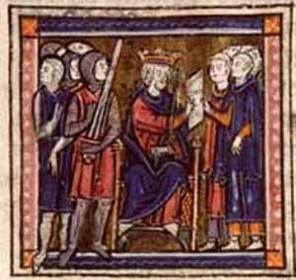

(529)
Emperor Justinian collected all existing Roman laws and organized them into a single code.

Korean War

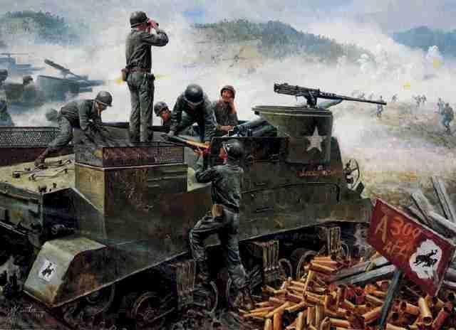
(1950 – 1953)
Communist North Korea invaded South Korea. The United States and other U.N. countries intervened and forced the Communists back. The Armistice left Korea as before.

League of Nations

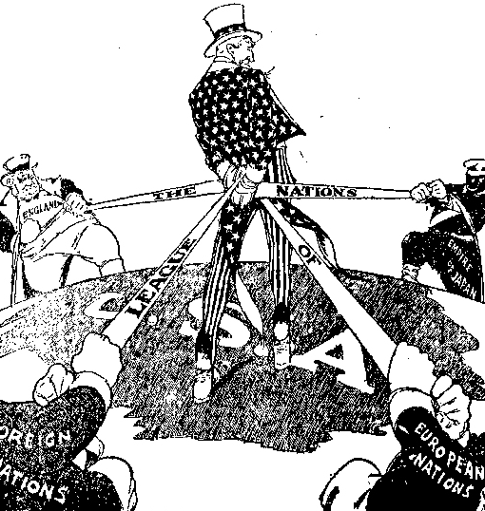
(1920 – 1946)
International organization proposed by Wilson and created by the Versailles Treaty to promote disarmament and prevent future wars. It failed to stop war.

Las Madres de la Plaza de Mayo

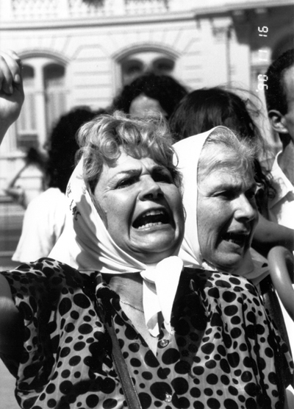

Mothers who demanded the Argentine government reveal the whereabouts of children who mysteriously disappeared in the 1980’s.

Limited Monarchy

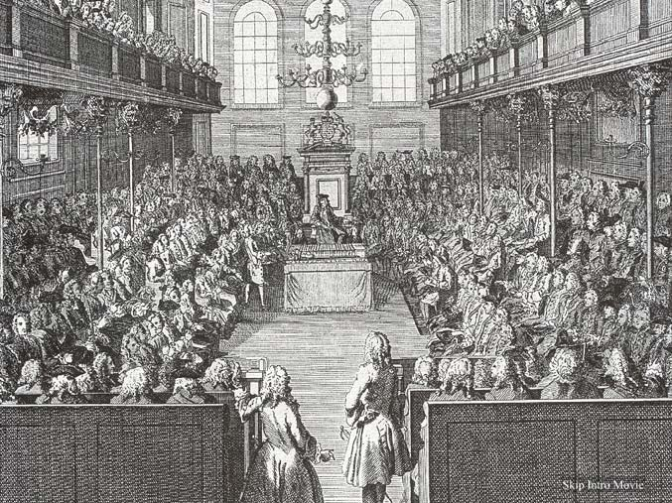

A system of government that emerged in England in which the monarch was made to share power with an elected parliament.

John Locke

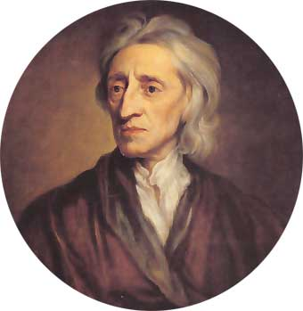

(1632 – 1704)
Englishman who wrote that people enter into a social contract, and that government power comes from the people it governs, who have the right to overthrow an abusive government.

Nelson Mandela

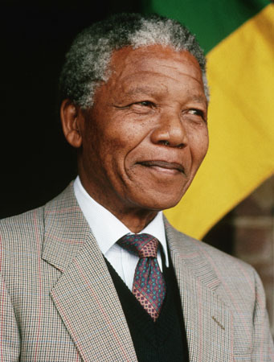
(1918 – Present)
Leader imprisoned for speaking out against apartheid. After being released from prison, he became South Africa’s first black President, and kept the country together under majority rule.

Magna Carta

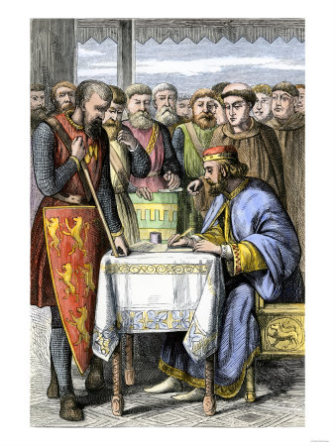
(1215)
King John of England guaranteed free men the right to a trial by jury and also agreed that consent by a council of nobles would be needed for any new taxes.

Manorialism

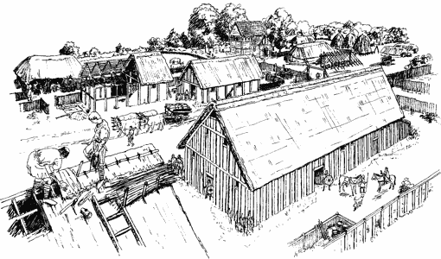
Economic system of feudal Europe, consisting of the lord’s house and his serfs. Each manor was self-sufficient and produced its own food, clothing, and shelter.

Karl Marx

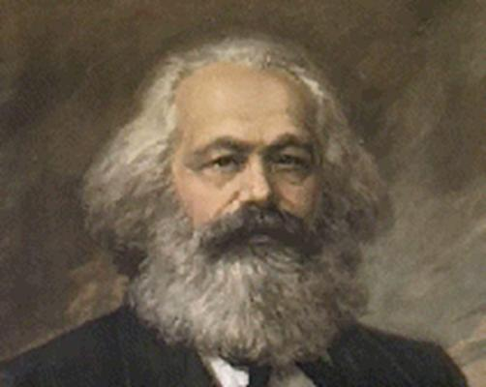
(1818 – 1883)
Critic of capitalism, whose ideas became the basis of communism; believed workers would eventually overthrow their capitalist bosses.

Maya Civilization

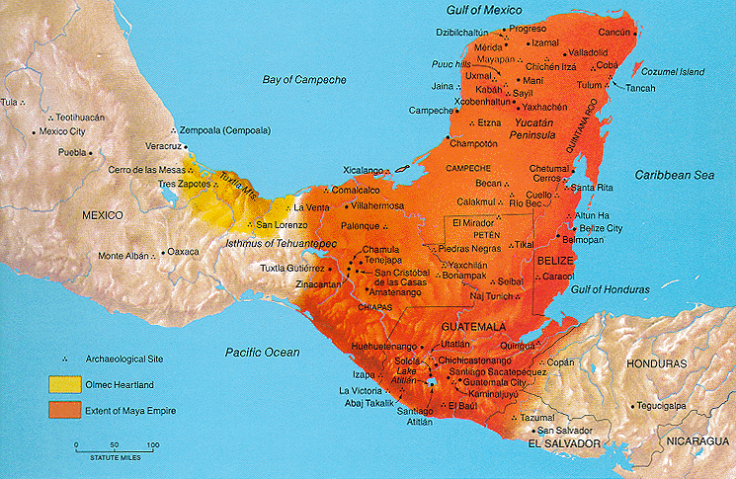
Complex pre-Columbian civilization in Guatemala and the Yucatan. They cultivated corn and have achievements in building and creation of a numbering system.

Mauryan Empire

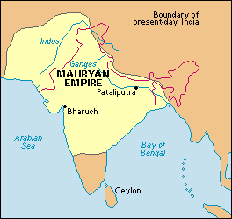
(321 – 185 BC)
Hindu empire established by India. Emperor Asoka converted to Buddhism and improved roads, built hospitals, and encouraged education.;

Golda Meir

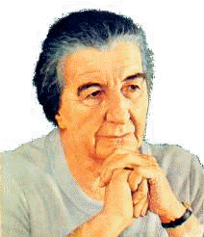
(1898 – 1978)
First woman to become Prime Minister of Israel.

Militarism

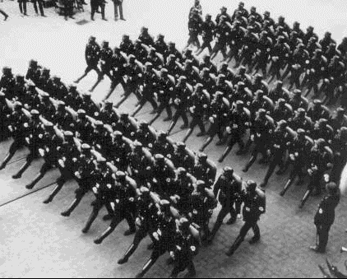
This occurs when civilians adopt military values and goals and become over-reliant on military advisors. Militarism contributed to the outbreak of World War I.

Monarchy

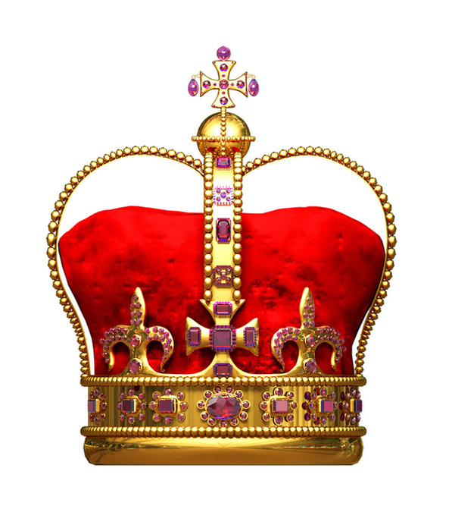

A system of government in which political power is inherited.

Ming Dynasty

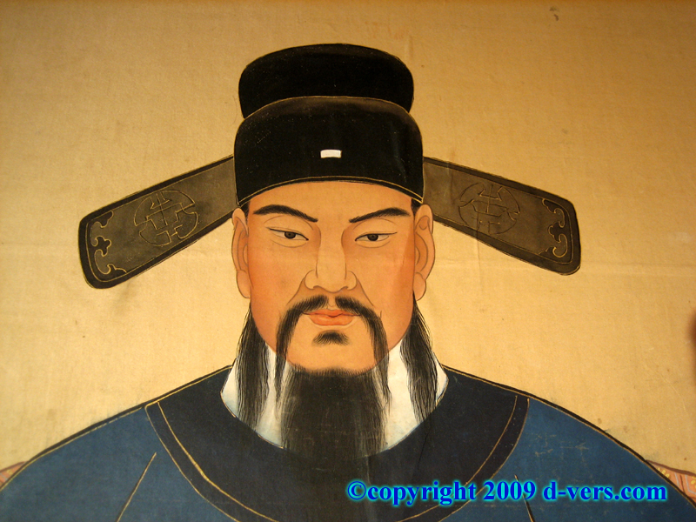
(1368 – 1644)
Dynasty that followed the Mongols. The Ming moved China’s capital to Beijing and ruled for 300 year of peace and prosperity.

Monotheism

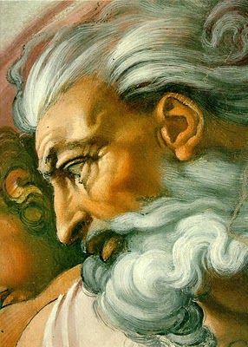

Belief in one God, shared by Judaism, Christianity, and Islam.

Baron Charles
de Montesquieu

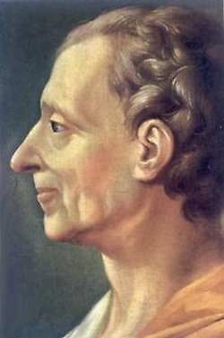

(1689 – 1733)
Argued for separation of powers in The Spirit of Laws.

Napoleonic Wars

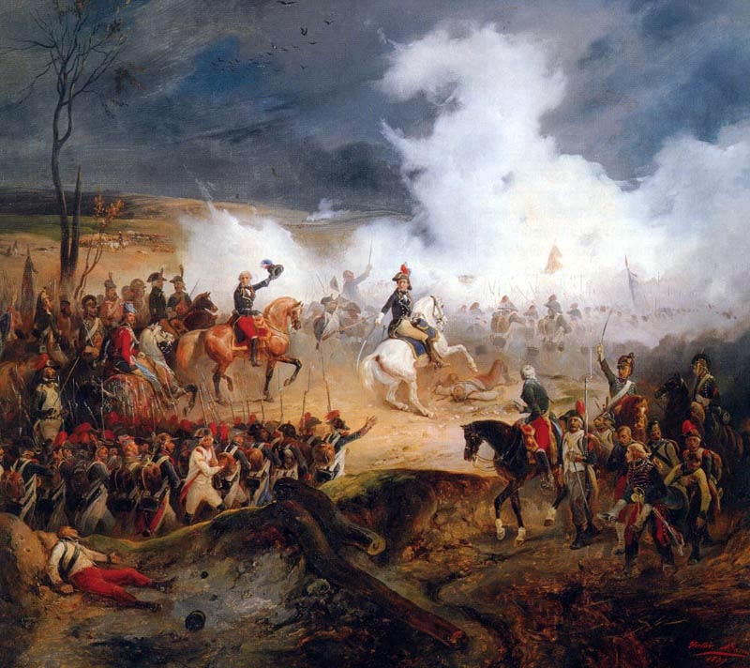

(1796 – 1815)
Wars between Napoleon and the rest of Europe, which helped spread the ideas of the French Revolution.

Benito Mussolini

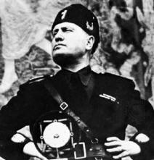

(1883 – 1945)
Leader who turned Italy into a Fascist state by controlling the press, abolishing unions, and outlawing strikes.

Nationalism

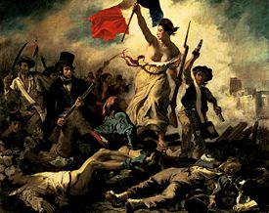

Belief that each nationality is entitled to its own government and national homeland. The French Revolution ignited the spirit of nationalism in Europe. Nationalism was a cause of World War I.

Neolithic Revolution

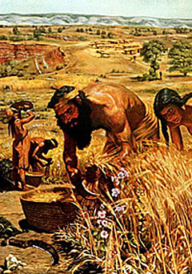

(circa 8,000 BC)
The change that occurred when people learned how to plant and grow crops, and herd animals.

Normandy Landing

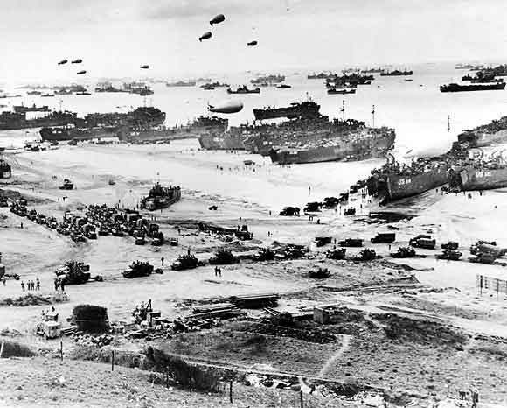
(June 1944)
Allied troops, in the largest amphibious assault in history, landed at Normandy in an attempt to retake France from the Nazis.

Isaac Newton

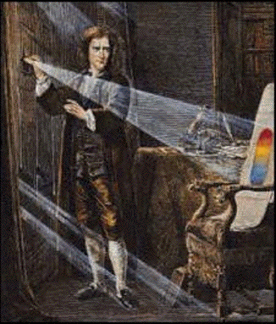
(1643 – 1727)
Scientist who discovered the laws of gravity, raising hopes that the universe acted according to certain fixed and fundamental laws.

October Revolution of 1917

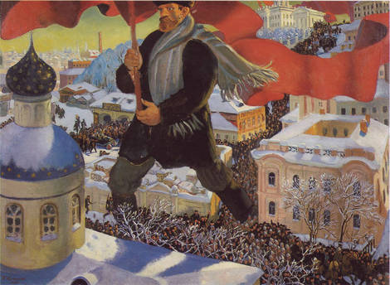
The Bolsheviks seized power by force in a second revolution in 1917. Once in power, they changed Russia to a Communist nation.

Oligarchy

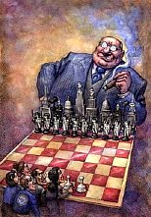

Rule by a few.

Panama Canal

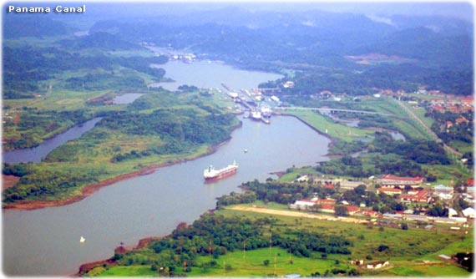
Built across the Isthmus of Panama by the United States to provide a short water route between the Atlantic and Pacific Oceans.

Ottomans

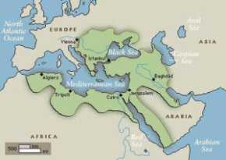
(1299 – 1923)
A nomadic group of Turkish people from Central Asia who emerged as the rulers of the Islamic world in the 13th century. They conquered Constantinople in 1453.

Louis Pasteur
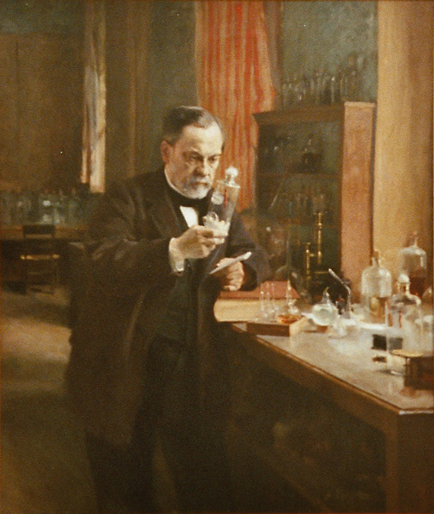

(1822 – 1895)
Scientist who found that most diseases are caused by germs. He developed new vaccines and a method to kill germs by heating, known as pasteurization.

Pearl Harbor

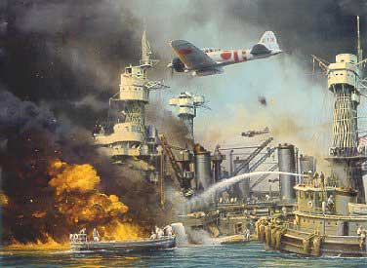

(December 7, 1941)
A surprise attack by the Japanese navy on the U.S. fleet at Pearl Harbor which brought the Untied States into World War II.

Printing Press

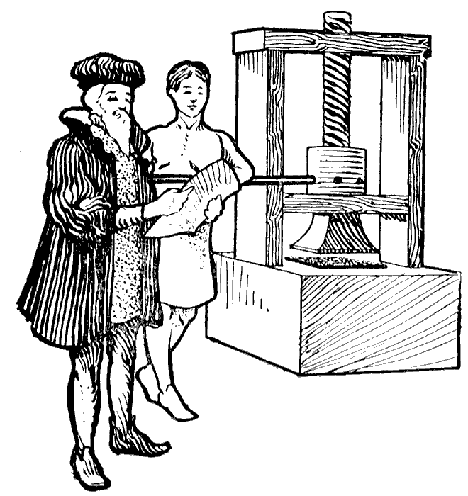

Johann Gutenberg invented a printing press with movable type in 1450 in Mainz, Germany, which later helped spread the ideas of the Reformation.

Popular Sovereignty
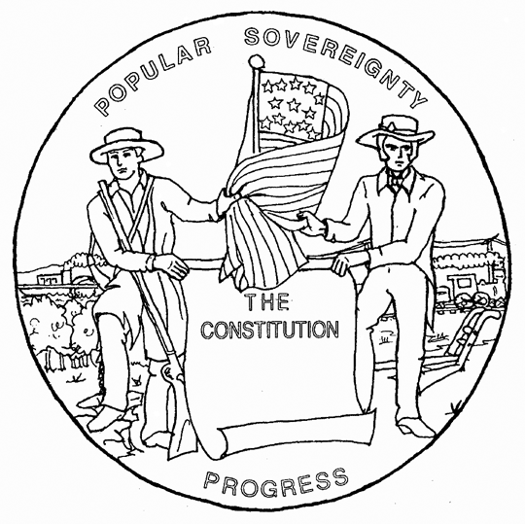

A system of government in which ultimate power rests on the consent of the people being governed.

Protestant Reformation

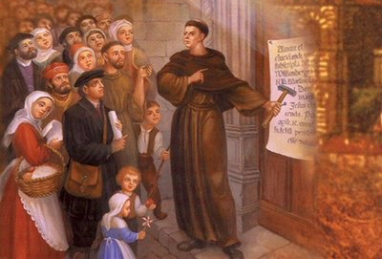

(16th Century)
Movement begun in Germany by Martin Luther in 1517 in which many Christians left the Catholic Church for Protestant Churches.

Pythagoras
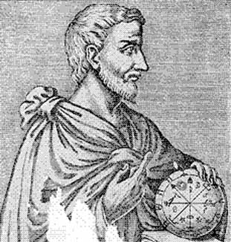

(570 – 495 BC)
Greek mathematician noted for advances in geometry.

Radical Islamic Fundamentalism

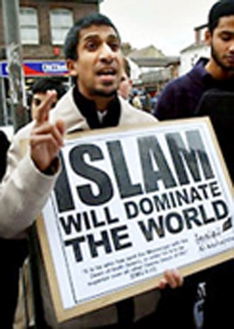

(Post-1979)
Reaction by radical Muslims against Western values. They seek a return to strict adherence to Islamic values and laws.

Qin Dynasty

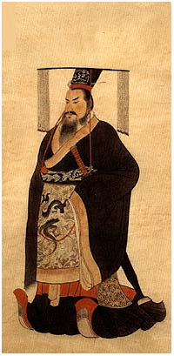

(221 – 206 BC)
Shi Huangdi became China’s first emperor. He unified China, built roads and canals, and constructed the Great Wall to protect his empire.

Renaissance

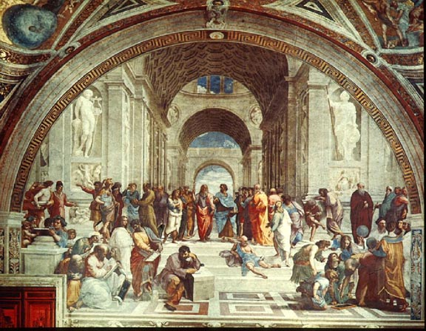
(15th – 16th Centuries)
A rebirth of European culture that began in the Italian city-states, with a spirit of inquiry, a rediscovery of classical learning, and improvements in painting and architecture.

Republic

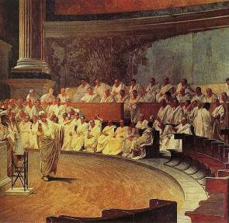

A system of government by representatives.

Fall of the Roman Empire

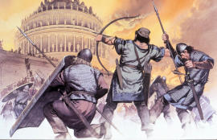

Fell in 476 AD when it was overrun by invading barbarian tribes. Its fall was followed by a period of great turmoil in Europe.

Roman Civilization

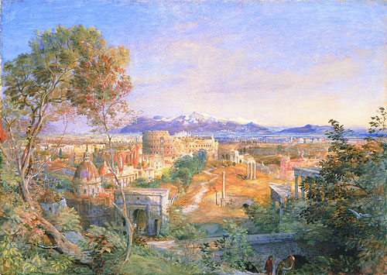
Civilization that arose around Rome, absorbed Greek learning, and ruled much of Western Europe and the Mediterranean world; known for its engineering skills, laws, and Christianity.

Jean Jacques Rousseau

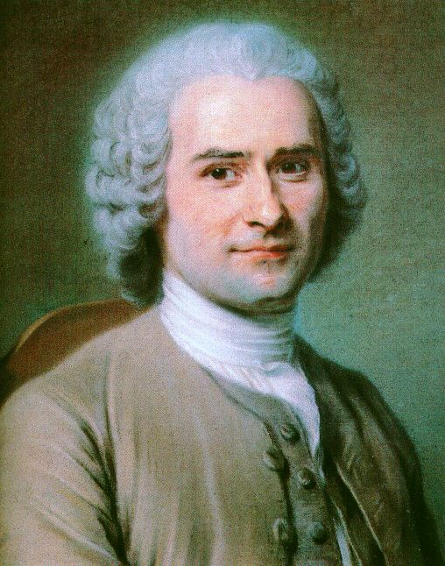

(1712 – 1778)
Stated that government should follow the peoples’ “general will.” His writings inspired the democratic ideals of the French Revolution.

Rwanda

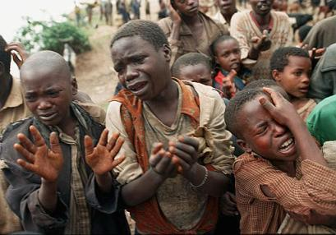

(1990’s) African nation that experienced genocide against its Tutsi population, carried out by Hutus.

September 11, 2001
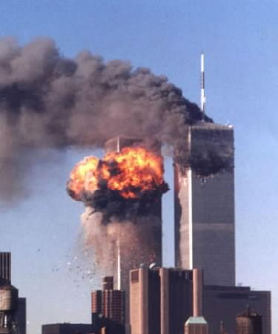

Al-Qaeda terrorists, living in the U.S., hijacked several commercial airliners and crashed them into the Pentagon and World Trade Center.

Scientific Revolution

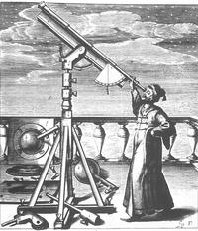
(17th Century)
Rejected traditional Church teachings. Introduced scientific method in which people observed nature and tested hypotheses.

Natan Sharansky

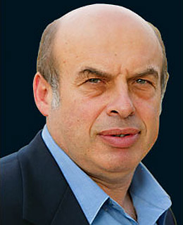

Russian dissident and founder of the Refusenik Movement. He was imprisoned in 1977 for speaking out for greater human rights in the Soviet Union.

Sikhism

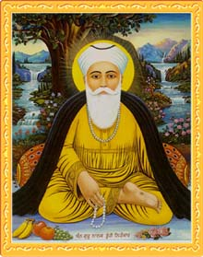

Religion that developed in Northern India. Sikhs believe in one God, which can only be known through meditation.

Adam Smith

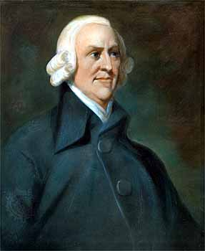

(1723 – 1790)
In his book, The Wealth of Nations, Smith attacked mercantilism and explained how competition and the division of labor guided a free-market system based on self-interest.

Silk Road

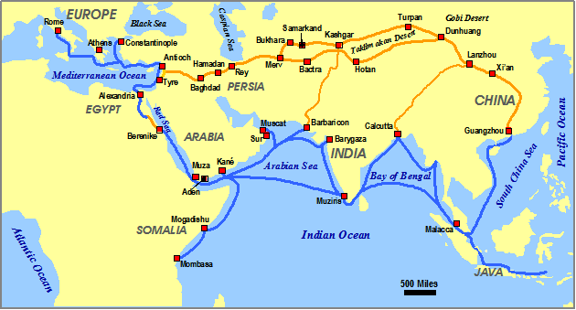

Trade route that connected China and Europe from the time of the Roman Empire onwards. China exported silk, porcelain and tea.

Socialism

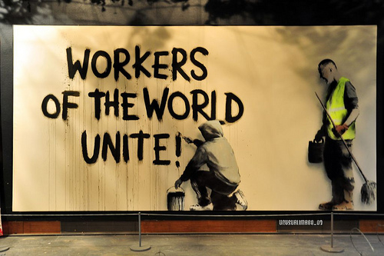
Movement that believes workers should have the government pass laws to curb abuses of workers and that government should even take over some businesses.

Song Dynasty

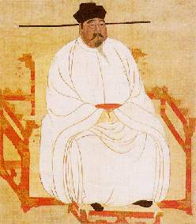

(960 – 1279)
Period of great social and economic progress in China, marked by the first use of paper currency and standardized coins.

Suez Canal

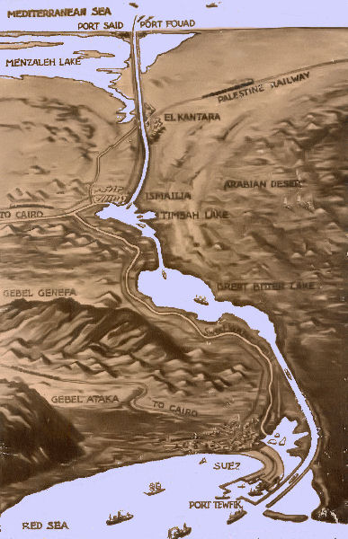

Completed in 1869, the canal provided a shorter route from Europe to East Africa, India and East Asia. It served as a lifeline between Britain and India.

Joseph Stalin

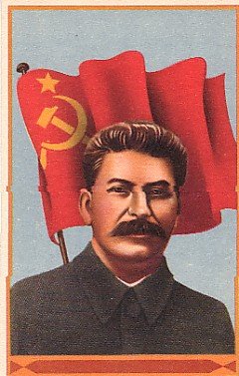
(1878 – 1953)
Communist leader following Lenin, who purged government of his opponents, changed the Soviet economy, established a totalitarian state, resisted Hitler, and started the Cold War.

Tang Dynasty

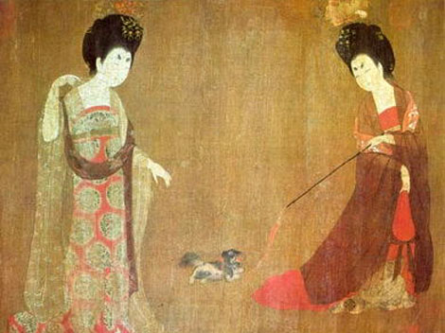

(618 – 907)
Tang rulers suppressed peasant uprisings, reunited China, revived traditional feudal relationships, and brought peace and prosperity.

Ten Commandments

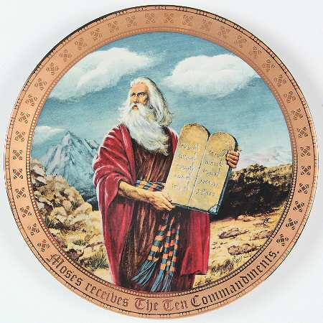

Commandments in the Jewish religion prohibiting stealing, murder, and other forms of immoral behavior.

Terrorism

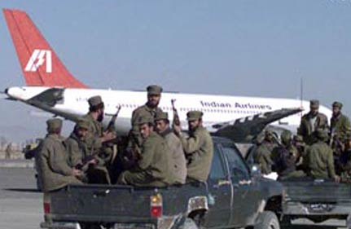

The use of acts of violence against innocent civilians, such as hijacking planes and attacking schools, in order to make demands on a hostile government.

Mother Teresa

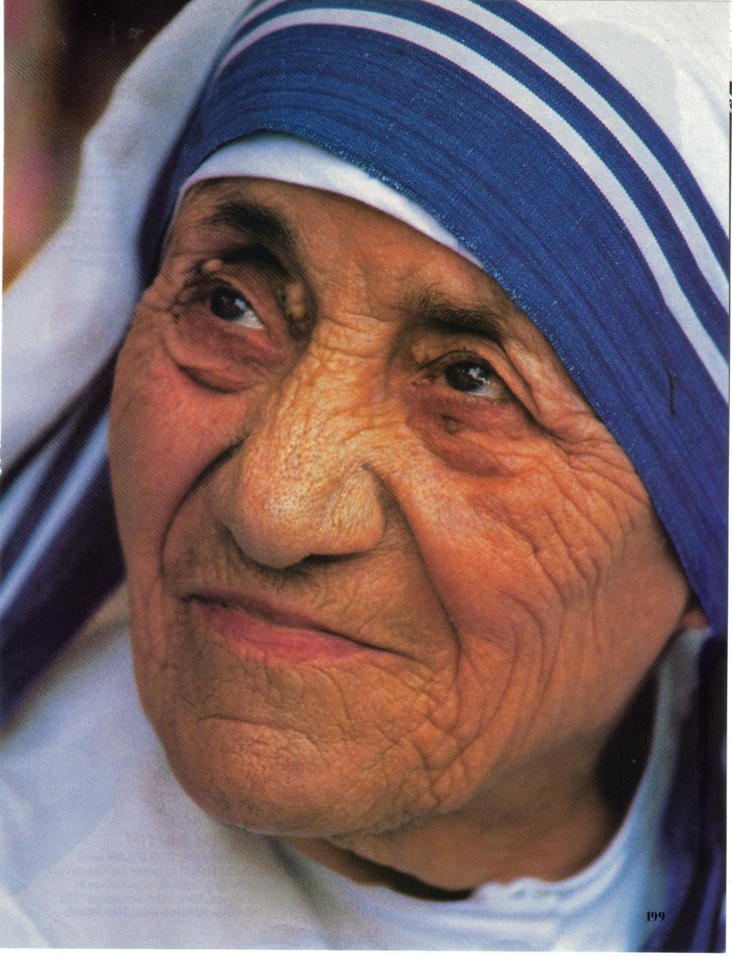

(1912 – 1997)
A Catholic nun who devoted her life to helping poor and homeless people in India, who were living on the streets. Awarded the Nobel Peace Prize.

Margaret Thatcher

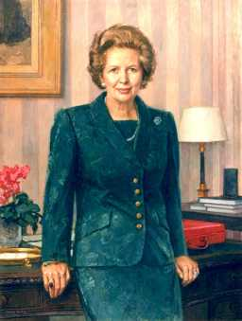

(b. 1925)
First woman elected Prime Minister of Great Britain.

Theocracy

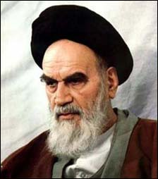

A society governed by religious leaders; for example, present-day Iran.

Hedeki Tojo

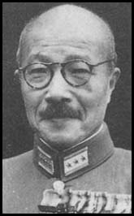

(1884- 1948)
General who led the Japanese government during World War II; Tojo convinced the emperor to launch a surprise attack against the United States.

Tiananmen Square

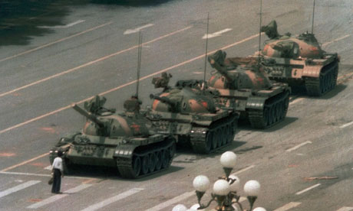
(1989)
Chinese students were fired on by tanks while leading peaceful demonstrations for greater personal freedom and democracy

Totalitarianism

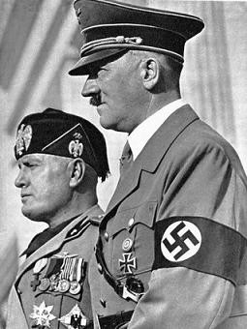

A government that controls all aspects of life.

Trench Warfare

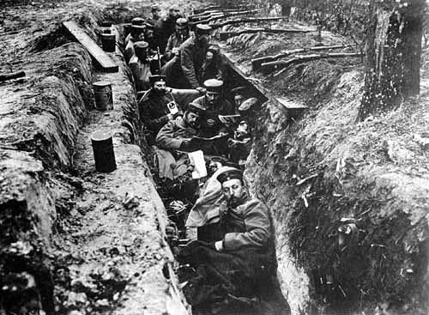

(1914 – 1918)
Form of combat during World War I in which both sides, facing machine-gun fire, dug ditches to create fortified positions.

Versailles Treaty

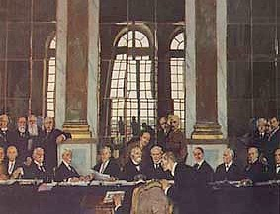

(1919)
Treaty between Allied Powers and Germany, ending World War I.

United Nations

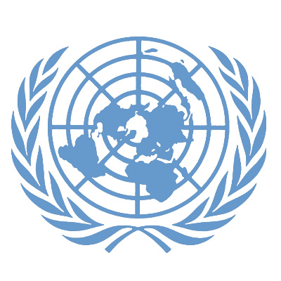
(1945 – Present)
International organization launched in 1945. Its purpose is to maintain world peace while encouraging cooperation among nations.

Queen Victoria

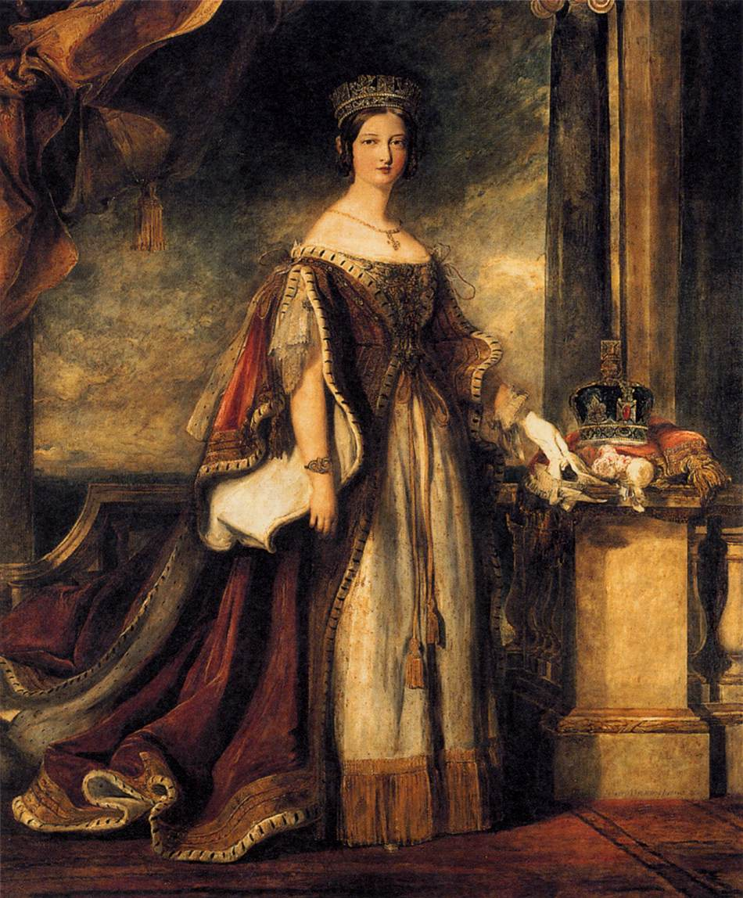

Monarch who doubled Britain’s size and who favored social reforms.

Vietnam War

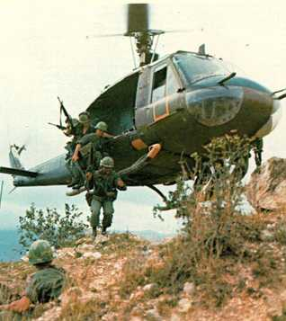
(1956 – 1975)
War between Communist North Vietnam and U.S.-supported South Vietnam. Began when the Viet Cong launched guerilla warfare against South Vietnam.

Lech Walesa

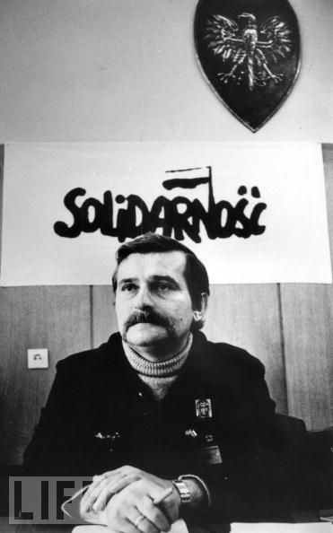

(b. 1943)
Polish union leader who organized the Solidarity Movement. He led a workers’ strike that led to free elections and the end of Communist rule in Poland.

Voltaire

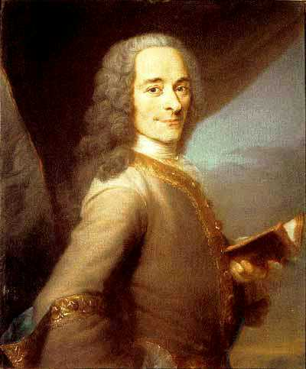
(1694 – 1778)
Enlightenment thinker whose views on religious toleration and intellectual freedom influenced leaders of the American and French Revolutions.

James Watt

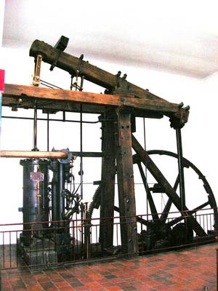

(1736 – 1819)
Scottish inventor who improved the steam engine, thus making steam power available to run machines in factories.

William Wilberforce

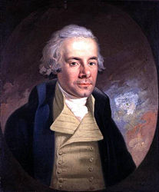

(1759 – 1833)
Reformer who led the fight to abolish the slave trade and slavery.

World War II

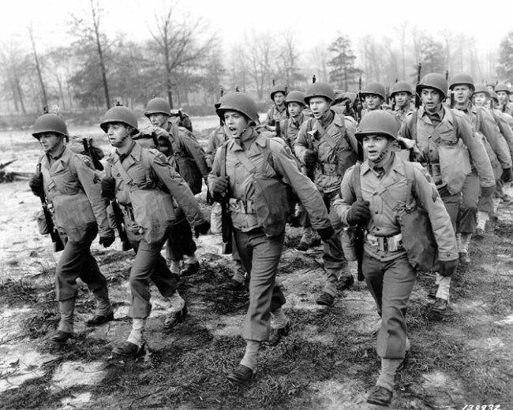

(1939 – 1945)
The most destructive conflict in history in which an estimated 70 million were killed. Hitler launched this war in Europe by invading Poland in 1939.

World War I

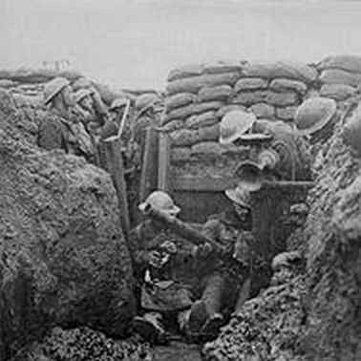

(1914 – 1918)
Assassination of Archduke Ferdinand set off a chain reaction that involved most nations of Europe and later the Untied States.

Mao Zedong

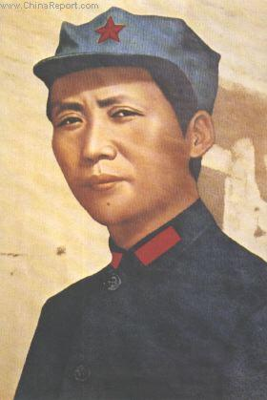

(1893 – 1976)
Chinese Communist leader who drove the Nationalist Chinese out of China in 1949. He instituted brutal measures to achieve Communist control of China, including the Great Leap Forward and the Cultural Revolution.

Zhou Dynasty
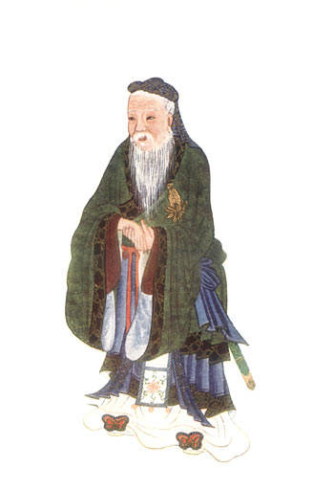

(1027 – 256 BC)
Zhou rulers justified their rule as the Mandate of Heaven – if a ruler was selfish and ruthless, Heaven would overthrow him.

